Julia Data Science

Jose Storopoli

Rik Huijzer

Lazaro Alonso

Table of Contents

# Preface

There are many programming languages and each and every one of them has its strengths and weaknesses. Some languages are very quick, but verbose. Other languages are very easy to write in, but slow. This is known as the *two-language* problem and Julia aims at circumventing this problem. Even though all three of us come from different fields, we all found the Julia language more effective for our research than languages that we’ve used before. We discuss some of our arguments in Section 2. However, compared to other languages, Julia is one of the newest languages around. This means that the ecosystem around the language is sometimes difficult to navigate through. It’s difficult to figure out where to start and how all the different packages fit together. That is why we decided to create this book! We wanted to make it easier for researchers, and especially our colleagues, to start using this awesome language.

As discussed above, each language has its strengths and weaknesses. In our opinion, data science is definitely a strength of Julia. At the same time, all three of us used data science tools in our day to day life. And, probably, you want to use data science too! That is why this book has a focus on data science.

In the next part of this section, we emphasize the **“data” part of data science** and why data skills are, and will remain, in **high demand** in industry as well as in academia. We make an argument for **incorporating software engineering practices into data science** which should reduce friction when updating and sharing code with collaborators. Most data analyses are collaborative endeavors; that is why these software practices will help you.

### Data is Everywhere

**Data is abundant** and will be even more so in the near future. A report from late 2012 concluded that, from 2005 to 2020, the amount of data stored digitally will **grow by a factor of 300, from 130 exabytes**[1] **to a whopping 40,000 exabytes** (Gantz & Reinsel, 2012). This is equal to 40 trillion gigabytes and, to put it into perspective, more than **5.2 terabytes for every living human currently on this planet!** In 2020, on average, every person created **1.7 MB of data per second** (Domo, 2018). A recent report predicted that almost **two thirds (65%) of national GDPs will have undergone digitization by 2022** (Fitzgerald et al., 2020).

Every profession will be impacted by the increasing availability of data and data’s increased importance (Chen et al., 2014; Khan et al., 2014). Data is used to communicate and build knowledge, and to make decisions. This is why data skills are important. If you become comfortable with handling data, you will become a valuable researcher or professional. In other words, you will become **data literate**.

## What is Data Science?

Data science is not only machine learning and statistics, and it’s not all about prediction. Alas, it is not even a discipline fully contained within STEM (Science, Technology, Engineering, and Mathematics) fields (Meng, 2019). But one thing that we can assert with high confidence is that data science is always about **data**. Our aims of this book are twofold:

* We focus on the backbone of data science: **data**.
* We use the **Julia** programming language to process the data.

We cover why Julia is an extremely effective language for data science in Section 2. For now, let’s turn our attention towards data.

### Data Literacy

According to [Wikipedia](https://en.wikipedia.org/wiki/Data_literacy), the formal definition of **data literacy is “the ability to read, understand, create, and communicate data as information.”**. We also like the informal idea that, being data literate, you won’t feel overwhelmed by data, but instead can use it to make the right decisions. Data literacy can be seen as a highly competitive skill to possess. In this book we’ll cover two aspects of data literacy:

1. **Data Manipulation** with DataFrames.jl (Section 4). In this chapter you will learn how to:
   1. Read CSV and Excel data into Julia.
   2. Process data in Julia, that is, learn how to answer data questions.
   3. Filter and subset data.
   4. Handle missing data.
   5. Join multiple data sources together.
   6. Group and summarize data.
   7. Export data out of Julia to CSV and Excel files.
2. **Data Visualization** with Makie.jl (Section 5). In these chapter you will learn how to:
   1. Plot data with different Makie.jl backends.
   2. Save visualizations in several formats such as PNG or PDF.
   3. Use different plotting functions to make diverse data visualizations.
   4. Customize visualizations with attributes.
   5. Use and create new plotting themes.
   6. Add $\LaTeX$ elements to plots.
   7. Manipulate color and palettes.
   8. Create complex figure layouts.

## Software Engineering

Unlike most books on data science, this book lays more emphasis on properly **structuring code**. The reason for this is that we noticed that many data scientists simply place their code into one large file and run all the statements sequentially. You can think of this like forcing book readers to always read it from beginning to end, without being allowed to revisit earlier sections or jump to interesting sections right away. This works fine for small and simple projects, but, as the project becomes bigger or more complex, more problems will start to arise. For example, in a well-written book, the book is split into distinctly-named chapters and sections which contain several references to other parts in the book. The software equivalent of this is **splitting code into functions**. Each function has a name and some contents. By using functions, you can tell the computer at any point in your code to jump to some other place and continue from there. This allows you to more easily re-use code between projects, update code, share code, collaborate, and see the big picture. Hence, with functions, you can **save time**.

So, while reading this book, you will eventually get used to reading and using functions. Another benefit of having good software engineering skills is that it will allow you to more easily read the source code of the packages that you’re using, which could be greatly beneficial when you are debugging your code or wondering how exactly the package that you’re using works. Finally, you can rest assured that we did not invent this emphasis on functions ourselves. In industry, it is common practice to encourage developers to use **“functions instead of comments”**. This means that, instead of writing a comment for humans and some code for the computer, the developers write a function which is read by both humans and computers.

Also, we’ve put much effort into sticking to a consistent style guide. Programming style guides provide guidelines for writing code; for example, about where there should be whitespace and what names should be capitalized or not. Sticking to a strict style guide might sound pedantic and it sometimes is. However, the more consistent the code is, the easier it is to read and understand the code. To read our code, you don’t need to know our style guide. You’ll figure it out when reading. If you do want to see the details of our style guide, check out Section 6.2.

## Acknowledgements

Many people have contributed directly and indirectly to this book.

Jose Storopoli would like to thank his family, especially his wife for the support and love during the writing and reviewing process. He would also like to thank his colleagues, especially [Fernando Serra](https://orcid.org/0000-0002-8178-7313), [Wonder Alexandre Luz Alves](https://orcid.org/0000-0003-0430-950X) and [André Librantz](https://orcid.org/0000-0001-8599-9009), for their encouragement.

Rik Huijzer would first like to thank his PhD supervisors at the University of Groningen, [Peter de Jonge](https://www.rug.nl/staff/peter.de.jonge/), [Ruud den Hartigh](https://www.rug.nl/staff/j.r.den.hartigh/) and [Frank Blaauw](https://frankblaauw.nl/) for their support. Second, he would like to thank his parents and girlfriend for being hugely supportive during the holiday and all the weekends and evenings that were involved in this book.

Lazaro Alonso would like to thank his wife and daughters for their encouragement to get involved in this project.

# Why Julia?

The world of data science is filled with different open source programming languages.

Industry has, mostly, adopted Python and academia R. **Why bother learning another language?** To answer this question, we will address two common backgrounds:

1. **Did not program before** – see Section 2.1.
2. **Did program before** – see Section 2.2.

## For Non-Programmers

In the first background, we expect the common underlying story to be the following.

Data science has captivated you, making you interested in learning what is it all about and how can you use it to build your career in academia or industry. Then, you try to find resources to learn this new craft and you stumble into a world of intricate acronyms: pandas, dplyr, data.table, numpy, matplotlib, ggplot2, bokeh, and the list goes on and on.

Out of the blue you hear a name: “Julia.” What is this? How is it any different from other tools that people tell you to use for data science?

Why should you dedicate your precious time into learning a language that is almost never mentioned in any job listing, lab position, postdoc offer, or academic job description? The answer is that **Julia is a fresh approach** to both programming and data science. Everything that you do in Python or in R, you can do it in Julia with the advantage of being able to write readable[2], fast, and powerful code. Therefore, the Julia language is gaining traction, and for good reasons.

So, **if you don’t have any programming background knowledge, we highly encourage you to take up Julia** as a first programming language and data science framework.

## For Programmers

In the second background, the common underlying story changes a little bit. You are someone who knows how to program and probably does this for a living. You are familiar with one or more languages and can easily switch between them. You’ve heard about this new flashy thing called “data science” and you want to jump on the bandwagon. You begin to learn how to do stuff in numpy, how to manipulate DataFrames in pandas and how to plot things in matplotlib. Or maybe you’ve learned all that in R by using the tidyverse and tibbles, data.frames, %>% (pipes) and geom_*…

Then, from someone or somewhere you become aware of this new language called “Julia.” Why bother? You are already proficient in Python or R and you can do everything that you need. Well, let us contemplate some plausible scenarios.

**Have you ever in Python or R:**

1. Done something and were unable to achieve the performance that you needed? Well, **in Julia, Python or R minutes can be translated to seconds**[3]. We reserved Section 2.4 for displaying successful Julia use cases in both academia and industry.
2. Tried to do something different from numpy/dplyr conventions and discovered that your code is slow and you’ll probably have to learn dark magic[4] to make it faster? **In Julia you can do your custom different stuff without loss of performance**.
3. Had to debug code and somehow you see yourself reading Fortran or C/C++ source code and having no idea what you are trying to accomplish? **In Julia you only read Julia code, no need to learn another language to make your original language fast**. This is called the “two-language problem” (see Section 2.3.2). It also covers the use case for when “you had an interesting idea and wanted to contribute to an open source package and gave up because almost everything is not in Python or R but in C/C++ or Fortran”[5].
4. Wanted to use a data structure defined in another package and found that doesn’t work and that you’ll probably need to build an interface[6]. **Julia allows users to easily share and reuse code from different packages.** Most of Julia user-defined types and functions work right out of the box[7] and some users marvelled upon discovering how their packages are being used by other libraries in ways that they could not have imagined. We have some examples in Section 2.3.3.
5. Needed to have a better project management, with dependencies and version control tightly controlled, manageable, and replicable? **Julia has an amazing project management solution and a great package manager**. Unlike traditional package managers, which install and manage a single global set of packages, Julia’s package manager is designed around “environments”: independent sets of packages that can be local to an individual project or shared between projects. Each project maintains its own independent set of package versions.

If we got your attention by exposing somewhat familiar or plausible situations, you might be interested to learn more about this newcomer called Julia.

Let’s proceed then!

## What Julia Aims to Accomplish?

***NOTE:*** In this section we will explain the details of what makes Julia shine as a programming language. If it becomes too technical for you, you can skip and go straight to Section 4 to learn about tabular data with DataFrames.jl.

The Julia programming language (Bezanson et al., 2017) is a relatively new language, first released in 2012, and aims to be **both easy and fast**. It “runs like C[8] but reads like Python” (Perkel, 2019). It was made for scientific computing, capable of handling **large amounts of data and computation** while still being fairly **easy to manipulate, create, and prototype code**.

The creators of Julia explained why they created Julia in a [2012 blogpost](https://julialang.org/blog/2012/02/why-we-created-julia/). They said:

We are greedy: we want more. We want a language that’s open source, with a liberal license. We want the speed of C with the dynamism of Ruby. We want a language that’s homoiconic, with true macros like Lisp, but with obvious, familiar mathematical notation like Matlab. We want something as usable for general programming as Python, as easy for statistics as R, as natural for string processing as Perl, as powerful for linear algebra as Matlab, as good at gluing programs together as the shell. Something that is dirt simple to learn, yet keeps the most serious hackers happy. We want it interactive and we want it compiled.

Most users are attracted to Julia because of the **superior speed**. After all, Julia is a member of a prestigious and exclusive club. The [**petaflop club**](https://www.hpcwire.com/off-the-wire/julia-joins-petaflop-club/) is comprised of languages who can exceed speeds of **one petaflop**[9] **per second at peak performance**. Currently only C, C++, Fortran, and Julia belong to the [petaflop club](https://www.nextplatform.com/2017/11/28/julia-language-delivers-petascale-hpc-performance/).

But, speed is not all that Julia can deliver. The **ease of use**, **Unicode support**, and a language that makes **code sharing effortless** are some of Julia’s features. We’ll address all those features in this section, but we want to focus on the Julia code sharing feature for now.

The Julia ecosystem of packages is something unique. It enables not only code sharing but also allows sharing of user-created types. For example, Python’s pandas uses its own Datetime type to handle dates. The same with R tidyverse’s lubridate package, which also defines its own datetime type to handle dates. Julia doesn’t need any of this, it has all the date stuff already baked into its standard library. This means that other packages don’t have to worry about dates. They just have to extend Julia’s DateTime type to new functionalities by defining new functions and do not need to define new types. Julia’s Dates module can do amazing stuff, but we are getting ahead of ourselves now. Let’s talk about some other features of Julia.

### Julia Versus Other Programming Languages

In Figure 1, a highly opinionated representation is shown that divides the main open source and scientific computing languages in a 2x2 diagram with two axes: **Slow-Fast** and **Easy-Hard**. We’ve omitted closed source languages because there are many benefits to allowing other people to run your code for free as well as being able to inspect the source code in case of issues.

We’ve put C++ and FORTRAN in the hard and fast quadrant. Being static languages that need compilation, type checking, and other professional care and attention, they are really hard to learn and slow to prototype. The advantage is that they are **really fast** languages.

R and Python go into the easy and slow quadrant. They are dynamic languages that are not compiled and they execute in runtime. Because of this, they are really easy to learn and fast to prototype. Of course, this comes with a disadvantage: they are **really slow** languages.

Julia is the only language in the easy and fast quadrant. We don’t know any other serious language that would want to be hard and slow, so this quadrant is left empty.

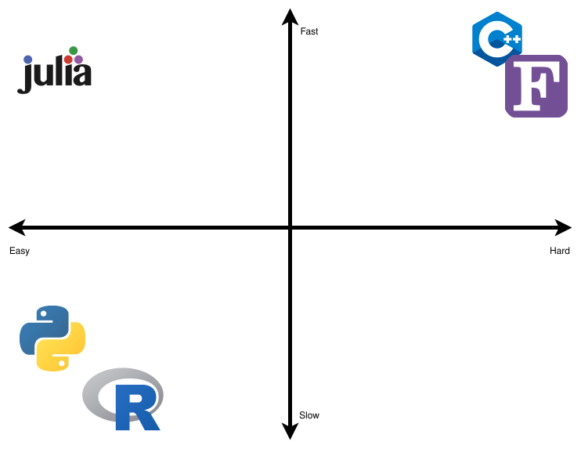

Figure 1: Scientific Computing Language Comparisons: logos for FORTRAN, C++, Python, R and Julia.

**Julia is fast! Very fast!** It was designed for speed from the beginning. It accomplishes this by multiple dispatch. Basically, the idea is to generate very efficient LLVM[10] code. LLVM code, also known as LLVM instructions, are very low-level, that is, very close to the actual operations that your computer is executing. So, in essence, Julia converts your hand written and easy to read code to LLVM machine code which is very hard for humans to read, but easy for computers to read. For example, if you define a function taking one argument and pass an integer into the function, then Julia will create a *specialized* MethodInstance. The next time that you pass an integer to the function, Julia will look up the MethodInstance that was created earlier and refer execution to that. Now, the **great** trick is that you can also do this inside a function that calls a function. For example, if some data type is passed into function f and f calls function g and the data types passed to g are known and always the same, then the generated function g can be hardcoded into function f! This means that Julia doesn’t even have to lookup MethodInstances any more, and the code can run very efficiently. The trade-off, here, is that there are cases where earlier assumptions about the hardcoded MethodInstances are invalidated. Then, the MethodInstance has to be recreated which takes time. Also, the trade-off is that it takes time to infer what can be hardcoded and what not. This explains why it can often take very long before Julia does the first thing: in the background, it is optimizing your code.

The compiler in turns does what it does best: it optimizes machine code[11]. You can find [benchmarks](https://julialang.org/benchmarks/) for Julia and several other languages here. Figure 2 was taken from [Julia’s website benchmarks section[12]](https://julialang.org/benchmarks/). As you can see Julia is **indeed** fast.

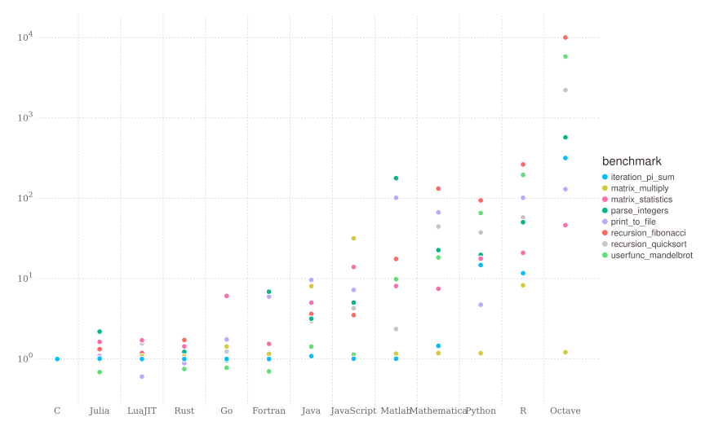

Figure 2: Julia versus other programming languages.

We really believe in Julia. Otherwise, we wouldn’t be writing this book. We think that Julia is the **future of scientific computing and scientific data analysis**. It enables the user to develop rapid and powerful code with a simple syntax. Usually, researchers develop code by prototyping using a very easy, but slow, language. Once the code is assured to run correctly and fulfill its goal, then begins the process of converting the code to a fast, but hard, language. This is known as the “Two-Language Problem” and we discuss next.

### The Two-Language Problem

The “Two-Language Problem” is a very typical situation in scientific computing where a researcher devises an algorithm or a solution to tackle a desired problem or analysis at hand. Then, the solution is prototyped in an easy to code language (like Python or R). If the prototype works, the researcher would code in a fast language that would not be easy to prototype (C++ or FORTRAN). Thus, we have two languages involved in the process of developing a new solution. One which is easy to prototype but is not suited for implementation (mostly due to being slow). And another which is not so easy to code, and consequently not easy to prototype, but suited for implementation because it is fast. Julia avoids such situations by being the **same language that you prototype (ease of use) and implement the solution (speed)**.

Also, Julia lets you use **Unicode characters as variables or parameters**. This means no more using sigma or sigma_i, and instead just use $σ$ or $σᵢ$ as you would in mathematical notation. When you see code for an algorithm or for a mathematical equation, you see almost the same notation and idioms. We call this feature **“One-To-One Code and Math Relation”** which is a powerful feature.

We think that the “Two-Language problem” and the “One-To-One Code and Math Relation” are best described by one of the creators of Julia, Alan Edelman, in a [TEDx Talk](https://youtu.be/qGW0GT1rCvs) (TEDx Talks, 2020).

### Multiple Dispatch

Multiple dispatch is a powerful feature that allows us to extend existing functions or to define custom and complex behavior for new types. Suppose that you want to define two new structs to denote two different animals:

abstract type Animal end  
struct Fox <: Animal  
 weight::Float64  
end  
struct Chicken <: Animal  
 weight::Float64  
end

Basically, this says “define a fox which is an animal” and “define a chicken which is an animal.” Next, we might have one fox called Fiona and a chicken called Big Bird.

fiona = Fox(4.2)  
big_bird = Chicken(2.9)

Next, we want to know how much they weight together, for which we can write a function:

combined_weight(A1::Animal, A2::Animal) = A1.weight + A2.weight

combined_weight (generic function with 1 method)

And we want to know whether they go well together. One way to implement that is to use conditionals:

function naive_trouble(A::Animal, B::Animal)  
 if A isa Fox && B isa Chicken  
 return true  
 elseif A isa Chicken && B isa Fox  
 return true  
 elseif A isa Chicken && B isa Chicken  
 return false  
 end  
end

naive_trouble (generic function with 1 method)

Now, let’s see whether leaving Fiona and Big Bird together would give trouble:

naive_trouble(fiona, big_bird)

true

Okay, so this sounds right. Writing the naive_trouble function seems to be easy enough. However, using multiple dispatch to create a new function trouble can have their benefits. Let’s create our new function as follows:

trouble(F::Fox, C::Chicken) = true  
trouble(C::Chicken, F::Fox) = true  
trouble(C1::Chicken, C2::Chicken) = false

trouble (generic function with 3 methods)

After defining these methods, trouble gives the same result as naive_trouble. For example:

trouble(fiona, big_bird)

true

And leaving Big Bird alone with another chicken called Dora is also fine

dora = Chicken(2.2)  
trouble(dora, big_bird)

false

So, in this case, the benefit of multiple dispatch is that you can just declare types and Julia will find the correct method for your types. Even more so, for many cases when multiple dispatch is used inside code, the Julia compiler will actually optimize the function calls away. For example, we could write:

function trouble(A::Fox, B::Chicken, C::Chicken)  
 return trouble(A, B) || trouble(B, C) || trouble(C, A)  
end

Depending on the context, Julia can optimize this to:

function trouble(A::Box, B::Chicken, C::Chicken)  
 return true || false || true  
end

because the compiler **knows** that A is a Fox, B is a chicken and so this can be replaced by the contents of the method trouble(F::Fox, C::Chicken). The same holds for trouble(C1::Chicken, C2::Chicken). Next, the compiler can optimize this to:

function trouble(A::Box, B::Chicken, C::Chicken)  
 return true  
end

Another benefit of multiple dispatch is that when someone else now comes by and wants to compare the existing animals to their animal, a Zebra, then that’s possible. In their package, they can define a Zebra:

struct Zebra <: Animal  
 weight::Float64  
end

and also how the interactions with the existing animals would go:

trouble(F::Fox, Z::Zebra) = false  
trouble(Z::Zebra, F::Fox) = false  
trouble(C::Chicken, Z::Zebra) = false  
trouble(Z::Zebra, F::Fox) = false

trouble (generic function with 6 methods)

Now, we can see whether Marty (our zebra) is safe with Big Bird:

marty = Zebra(412)  
trouble(big_bird, marty)

false

Even better, we can also calculate **the combined weight of zebra’s and other animals without defining any extra function at our side**:

combined_weight(big_bird, marty)

414.9

So, in summary, the code that was written with only Fox and Chicken in mind works even for types that it **has never seen before**! In practise, this means that Julia makes it often easy to re-use code from other projects.

If you are excited as much as we are by multiple dispatch, here are two more in-depth examples. The first is a [fast and elegant implementation of a one-hot vector](https://storopoli.io/Bayesian-Julia/pages/1_why_Julia/#example_one-hot_vector) by Storopoli (2021). The second is an interview with [Christopher Rackauckas](https://www.chrisrackauckas.com/) at [Tanmay Bakshi YouTube’s Channel](https://youtu.be/moyPIhvw4Nk?t=2107) (see from time 35:07 onwards) (tanmay bakshi, 2021). Chris mentions that, while using [DifferentialEquations.jl](https://diffeq.sciml.ai/dev/), a package that he developed and currently maintains, a user filed an issue that his GPU-based quaternion ODE solver didn’t work. Chris was quite surprised by this request since he would never have expected that someone would combine GPU computations with quaternions and solving ODEs. He was even more surprised to discover that the user made a small mistake and that it all worked. Most of the merit is due to multiple dispatch and high user code/type sharing.

To conclude, we think that multiple dispatch is best explained by one of the creators of Julia: [Stefan Karpinski at JuliaCon 2019](https://youtu.be/kc9HwsxE1OY).

## Julia in the Wild

In Section 2.3, we explained why we think Julia is such a unique programming language. We showed simple examples about the main features of Julia. If you would like to have a deep dive on how Julia is being used, we have some **interesting use cases**:

1. NASA uses Julia in a supercomputer to analyze the [“Largest Batch of Earth-Sized Planets Ever Found”](https://exoplanets.nasa.gov/news/1669/seven-rocky-trappist-1-planets-may-be-made-of-similar-stuff/) and achieve a whopping **1,000x speedup** to catalog 188 million astronomical objects in 15 minutes.
2. [The Climate Modeling Alliance (CliMa)](https://clima.caltech.edu/) is using mostly Julia to **model climate in the GPU and CPU**. Launched in 2018 in collaboration with researchers at Caltech, the NASA Jet Propulsion Laboratory, and the Naval Postgraduate School, CliMA is utilizing recent progress in computational science to develop an Earth system model that can predict droughts, heat waves, and rainfall with unprecedented precision and speed.
3. [US Federal Aviation Administration (FAA) is developing an **Airborne Collision Avoidance System (ACAS-X)** using Julia](https://youtu.be/19zm1Fn0S9M). This is a nice example of the “Two-Language Problem” (see Section 2.3). Previous solutions used Matlab to develop the algorithms and C++ for a fast implementation. Now, FAA is using one language to do all this: Julia.
4. [**175x speedup** for Pfizer’s pharmacology models using GPUs in Julia](https://juliacomputing.com/case-studies/pfizer/). It was presented as a [poster](https://chrisrackauckas.com/assets/Posters/ACoP11_Poster_Abstracts_2020.pdf) in the 11th American Conference of Pharmacometrics (ACoP11) and [won a quality award](https://web.archive.org/web/20210121164011/https://www.go-acop.org/abstract-awards).
5. [The Attitude and Orbit Control Subsystem (AOCS) of the Brazilian satellite Amazonia-1 is **written 100% in Julia**](https://discourse.julialang.org/t/julia-and-the-satellite-amazonia-1/57541) by Ronan Arraes Jardim Chagas (<https://ronanarraes.com/>).
6. [Brazil’s national development bank (BNDES) ditched a paid solution and opted for open-source Julia modeling and gained a **10x speedup**.](https://youtu.be/NY0HcGqHj3g)

If this is not enough, there are more case studies in [Julia Computing website](https://juliacomputing.com/case-studies/).

# Julia Basics

***NOTE:*** In this chapter we cover the basics of Julia as a programming language. Please note that this is not *strictly necessary* for you to use Julia as a tool for data manipulation and data visualization. Having a basic understanding of Julia will definitely make you more *effective* and *efficient* in using Julia. However, if you prefer to get started straight away, you can jump to Section 4 to learn about tabular data with DataFrames.jl.

This is going to be a very brief and *not* an in-depth overview of the Julia language. If you are already familiar and comfortable with other programming languages, we highly encourage you to read Julia’s documentation (<https://docs.julialang.org/>). The docs are an excellent resource for taking a deep dive into Julia. It covers all the basics and corner cases, but it can be cumbersome, especially if you aren’t familiar with software documentation.

We’ll cover the basics of Julia. Imagine that Julia is a fancy feature-loaded car, such as a brand-new Tesla. We’ll just explain to you how to “drive the car, park it, and how to navigate in traffic.” If you want to know what “all the buttons in the steering wheel and dashboard do,” this is not the resource you are looking for.

## Language Syntax

Julia is a **dynamic-typed language** with a just-in-time compiler. This means that you don’t need to compile your program before you run it, like you would do in C++ or FORTRAN. Instead, Julia will take your code, guess types where necessary, and compile parts of code just before running it. Also, you don’t need to explicitly specify each type. Julia will guess types for you on the go.

The main differences between Julia and other dynamic languages such as R and Python are the following. First, Julia **allows the user to specify type declarations**. You already saw some types declarations in *Why Julia?* (Section 2): they are those double colons :: that sometimes come after variables. However, if you don’t want to specify the type of your variables or functions, Julia will gladly infer (guess) them for you.

Second, Julia allows users to define function behavior across many combinations of argument types via multiple dispatch. We also covered multiple dispatch in Section 2.3. We defined a different type behavior by defining new function signatures for argument types while using the same function name.

### Variables

Variables are values that you tell the computer to store with a specific name, so that you can later recover or change its value. Julia has several types of variables but, in data science, we mostly use:

* Integers: Int64
* Real Numbers: Float64
* Boolean: Bool
* Strings: String

Integers and real numbers are stored by using 64 bits by default, that’s why they have the 64 suffix in the name of the type. If you need more or less precision, there are Int8 or Int128 types, for example, where higher means more precision. Most of the time, this won’t be an issue so you can just stick to the defaults.

We create new variables by writing the variable name on the left and its value in the right, and in the middle we use the = assignment operator. For example:

name = "Julia"  
age = 9

9

Note that the return output of the last statement (age) was printed to the console. Here, we are defining two new variables: name and age. We can recover their values by typing the names given in the assignment:

name

Julia

If you want to define new values for an existing variable, you can repeat the steps in the assignment. Note that Julia will now override the previous value with the new one. Supposed, Julia’s birthday has passed and now it has turned 10:

age = 10

10

We can do the same with its name. Suppose that Julia has earned some titles due to its blazing speed. We would change the variable name to the new value:

name = "Julia Rapidus"

Julia Rapidus

We can also do operations on variables such as addition or division. Let’s see how old Julia is, in months, by multiplying age by 12:

12 * age

120

We can inspect the types of variables by using the typeof function:

typeof(age)

Int64

The next question then becomes: “What else can I do with integers?” There is a nice handy function methodswith that spits out every function available, along with its signature, for a certain type. Here, I will restrict the output to the first 5 rows:

first(methodswith(Int64), 5)

[1] connect(manager::Distributed.ClusterManager, pid::Int64, config::Distributed.WorkerConfig) in Distributed at /opt/hostedtoolcache/julia/1.6.3/x64/share/julia/stdlib/v1.6/Distributed/src/managers.jl:516  
[2] ft_latex_sn(m_digits::Int64) in PrettyTables at /home/runner/.julia/packages/PrettyTables/6VdCp/src/predefined_formatters.jl:137  
[3] ft_latex_sn(m_digits::Int64, columns::AbstractVector{Int64}) in PrettyTables at /home/runner/.julia/packages/PrettyTables/6VdCp/src/predefined_formatters.jl:139  
[4] ft_printf(ftv_str::String, column::Int64) in PrettyTables at /home/runner/.julia/packages/PrettyTables/6VdCp/src/predefined_formatters.jl:28  
[5] ft_round(digits::Int64) in PrettyTables at /home/runner/.julia/packages/PrettyTables/6VdCp/src/predefined_formatters.jl:78

### User-defined Types

Having variables around without any sort of hierarchy or relationships is not ideal. In Julia, we can define that kind of structured data with a struct (also known as a composite type). Inside each struct, you can specify a set of fields. They differ from the primitive types (e.g. integer and floats) that are by default defined already inside the core of Julia language. Since most structs are user-defined, they are known as user-defined types.

For example, let’s create a struct to represent scientific open source programming languages. We’ll also define a set of fields along with the corresponding types inside the struct:

struct Language  
 name::String  
 title::String  
 year_of_birth::Int64  
 fast::Bool  
end

To inspect the field names you can use the fieldnames and pass the desired struct as an argument:

fieldnames(Language)

(:name, :title, :year_of_birth, :fast)

To use structs, we must instantiate individual instances (or “objects”), each with its own specific values for the fields defined inside the struct. Let’s instantiate two instances, one for Julia and one for Python:

julia = Language("Julia", "Rapidus", 2012, true)  
python = Language("Python", "Letargicus", 1991, false)

Language("Python", "Letargicus", 1991, false)

One thing to note with structs is that we can’t change their values once they are instantiated. We can solve this with a mutable struct. Also, note that mutable objects will, generally, be slower and more error prone. Whenever possible, make everything *immutable*. Let’s create a mutable struct.

mutable struct MutableLanguage  
 name::String  
 title::String  
 year_of_birth::Int64  
 fast::Bool  
end  
  
julia_mutable = MutableLanguage("Julia", "Rapidus", 2012, true)

MutableLanguage("Julia", "Rapidus", 2012, true)

Suppose that we want to change julia_mutable’s title. Now, we can do this since julia_mutable is an instantiated mutable struct:

julia_mutable.title = "Python Obliteratus"  
  
julia_mutable

MutableLanguage("Julia", "Python Obliteratus", 2012, true)

### Boolean Operators and Numeric Comparisons

Now that we’ve covered types, we can move to boolean operators and numeric comparison.

We have three boolean operators in Julia:

* !: **NOT**
* &&: **AND**
* ||: **OR**

Here are a few examples with some of them:

!true

false

(false && true) || (!false)

true

(6 isa Int64) && (6 isa Real)

true

Regarding numeric comparison, Julia has three major types of comparisons:

1. **Equality**: either something is *equal* or *not equal* another
   * == “equal”
   * != or ≠ “not equal”
2. **Less than**: either something is *less than* or *less than or equal to*
   * < “less than”
   * <= or ≤ “less than or equal to”
3. **Greater than**: either something is *greater than* or *greater than or equal to*
   * > “greater than”
   * >= or ≥ “greater than or equal to”

Here are some examples:

1 == 1

true

1 >= 10

false

It evens works between different types:

1 == 1.0

true

We can also mix and match boolean operators with numeric comparisons:

(1 != 10) || (3.14 <= 2.71)

true

### Functions

Now that we already know how to define variables and custom types as structs, let’s turn our attention to **functions**. In Julia, a function **maps argument’s values to one or more return values**. The basic syntax goes like this:

function function_name(arg1, arg2)  
 result = stuff with the arg1 and arg2  
 return result  
end

The function declaration begins with the keyword function followed by the function name. Then, inside parentheses (), we define the arguments separated by a comma ,. Inside the function, we specify what we want Julia to do with the parameters that we supplied. All variables that we define inside a function are deleted after the function returns. This is nice because it is like an automatic cleanup. After all the operations in the function body are finished, we instruct Julia to return the final result with the return statement. Finally, we let Julia know that the function definition is finished with the end keyword.

There is also the compact **assignment form**:

f_name(arg1, arg2) = stuff with the arg1 and arg2

It is the **same function** as before but with a different, more compact, form. As a rule of thumb, when your code can fit easily on one line of up to 92 characters, then the compact form is suitable. Otherwise, just use the longer form with the function keyword. Let’s dive into some examples.

#### Creating new Functions

Let’s create a new function that adds numbers together:

function add_numbers(x, y)  
 return x + y  
end

add_numbers (generic function with 1 method)

Now, we can use our add_numbers function:

add_numbers(17, 29)

46

And it works also with floats:

add_numbers(3.14, 2.72)

5.86

Also, we can define custom behavior by specifying type declarations. Suppose that we want to have a round_number function that behaves differently if its argument is either a Float64 or Int64:

function round_number(x::Float64)  
 return round(x)  
end  
  
function round_number(x::Int64)  
 return x  
end

round_number (generic function with 2 methods)

We can see that it is a function with multiple methods:

methods(round_number)

# 2 methods for generic function "round_number":  
[1] round_number(x::Float64) in Main at none:1  
[2] round_number(x::Int64) in Main at none:5

There is one issue: what happens if we want to round a 32-bit float Float32? Or a 8-bit integer Int8?

If you want something to function on all float and integer types, you can use an **abstract type** as the type signature, such as AbstractFloat or Integer:

function round_number(x::AbstractFloat)  
 return round(x)  
end

round_number (generic function with 3 methods)

Now, it works as expected with any float type:

x_32 = Float32(1.1)  
round_number(x_32)

1.0

***NOTE:*** We can inspect types with the supertypes and subtypes functions.

Let’s go back to our Language struct that we defined above. This is an example of multiple dispatch. We will extend the Base.show function that prints the output of instantiated types and structs.

By default, a struct has a basic output, which you saw above in the python case. We can define a new Base.show method to our Language type, so that we have some nice printing for our programming languages instances. We want to clearly communicate programming languages’ names, titles, and ages in years. The function Base.show accepts as arguments a IO type named io followed by the type you want to define custom behavior:

Base.show(io::IO, l::Language) = print(  
 io, l.name, " ",  
 2021 - l.year_of_birth, ", years old, ",  
 "has the following titles: ", l.title  
)

Now, let’s see how python will output:

python

Python 30, years old, has the following titles: Letargicus

#### Multiple Return Values

A function can, also, return two or more values. See the new function add_multiply below:

function add_multiply(x, y)  
 addition = x + y  
 multiplication = x * y  
 return addition, multiplication  
end

add_multiply (generic function with 1 method)

In that case, we can do two things:

1. We can, analogously as the return values, define two variables to hold the function return values, one for each return value:

* return_1, return_2 = add_multiply(1, 2)  
  return_2
* 2

1. Or we can define just one variable to hold the function’s return values and access them with either first or last:

* all_returns = add_multiply(1, 2)  
  last(all_returns)
* 2

#### Keyword Arguments

Some functions can accept keyword arguments instead of positional arguments. These arguments are just like regular arguments, except that they are defined after the regular function’s arguments and separated by a semicolon ;. For example, let’s define a logarithm function that by default uses base $e$ (2.718281828459045) as a keyword argument. Note that, here, we are using the abstract type Real so that we cover all types derived from Integer and AbstractFloat, being both themselves subtypes of Real:

AbstractFloat <: Real && Integer <: Real

true

function logarithm(x::Real; base::Real=2.7182818284590)  
 return log(base, x)  
end

logarithm (generic function with 1 method)

It works without specifying the base argument as we supplied a **default argument value** in the function declaration:

logarithm(10)

2.3025850929940845

And also with the keyword argument base different from its default value:

logarithm(10; base=2)

3.3219280948873626

#### Anonymous Functions

Often we don’t care about the name of the function and want to quickly make one. What we need are **anonymous functions**. They are used a lot in Julia’s data science workflow. For example, when using DataFrames.jl (Section 4) or Makie.jl (Section 5), sometimes we need a temporary function to filter data or format plot labels. That’s when we use anonymous functions. They are especially useful when we don’t want to create a function, and a simple in-place statement would be enough.

The syntax is simple. We use the -> operator. On the left of -> we define the parameter name. And on the right of -> we define what operations we want to perform on the parameter that we defined on the left of ->. Here is an example. Suppose that we want to undo the log transformation by using an exponentiation:

map(x -> 2.7182818284590^x, logarithm(2))

2.0

Here, we are using the map function to conveniently map the anonymous function (first argument) to logarithm(2) (the second argument). As a result, we get back the same number, because logarithm and exponentiation are inverse (at least in the base that we’ve chosen – 2.7182818284590)

### Conditional If-Else-Elseif

In most programming languages, the user is allowed to control the computer’s flow of execution. Depending on the situation, we want the computer to do one thing or another. In Julia we can control the flow of execution with if, elseif, and else keywords. These are known as conditional statements.

The if keyword prompts Julia to evaluate an expression and, depending on whether it’s true or false, execute certain portions of code. We can compound several if conditions with the elseif keyword for complex control flow. Finally, we can define an alternative portion to be executed if anything inside the if or elseifs is evaluated to true. This is the purpose of the else keyword. Finally, like all the previous keyword operators that we saw, we must tell Julia when the conditional statement is finished with the end keyword.

Here’s an example with all the if-elseif-else keywords:

a = 1  
b = 2  
  
if a < b  
 "a is less than b"  
elseif a > b  
 "a is greater than b"  
else  
 "a is equal to b"  
end

a is less than b

We can even wrap this in a function called compare:

function compare(a, b)  
 if a < b  
 "a is less than b"  
 elseif a > b  
 "a is greater than b"  
 else  
 "a is equal to b"  
 end  
end  
  
compare(3.14, 3.14)

a is equal to b

### For Loop

The classical for loop in Julia follows a similar syntax as the conditional statements. You begin with a keyword, in this case for. Then, you specify what Julia should “loop” for, i.e., a sequence. Also, like everything else, you must finish with the end keyword.

So, to make Julia print every number from 1 to 10, you can use the following for loop:

for i in 1:10  
 println(i)  
end

### While Loop

The while loop is a mix of the previous conditional statements and for loops. Here, the loop is executed every time the condition is true. The syntax follows the same form as the previous one. We begin with the keyword while, followed by a statement that evaluates to true or false. As usual, you must end with the end keyword.

Here’s an example:

n = 0  
  
while n < 3  
 global n += 1  
end  
  
n

3

As you can see, we have to use the global keyword. This is because of **variable scope**. Variables defined inside conditional statements, loops, and functions exist only inside them. This is known as the *scope* of the variable. Here, we had to tell Julia that the n inside while loop is in the global scope with the global keyword.

Finally, we also used the += operator which is a nice shorthand for n = n + 1.

## Native Data Structures

Julia has several native data structures. They are abstractions of data that represent some form of structured data. We will cover the most used ones. They hold homogeneous or heterogeneous data. Since they are collections, they can be *looped* over with the for loops.

We will cover String, Tuple, NamedTuple, UnitRange, Arrays, Pair, Dict, Symbol.

When you stumble across a data structure in Julia, you can find methods that accept it as an argument with the methodswith function. In Julia, the distinction between methods and functions is as follows. Every function can have multiple methods like we have shown earlier. The methodswith function is nice to have in your bag of tricks. Let’s see what we can do with a String for example:

first(methodswith(String), 5)

[1] getaddrinfo(host::String, T::Type{var"#s814"} where var"#s814"<:Sockets.IPAddr) in Sockets at /opt/hostedtoolcache/julia/1.6.3/x64/share/julia/stdlib/v1.6/Sockets/src/addrinfo.jl:130  
[2] getalladdrinfo(host::String) in Sockets at /opt/hostedtoolcache/julia/1.6.3/x64/share/julia/stdlib/v1.6/Sockets/src/addrinfo.jl:66  
[3] join_multicast_group(sock::Sockets.UDPSocket, group_addr::String) in Sockets at /opt/hostedtoolcache/julia/1.6.3/x64/share/julia/stdlib/v1.6/Sockets/src/Sockets.jl:761  
[4] join_multicast_group(sock::Sockets.UDPSocket, group_addr::String, interface_addr::Union{Nothing, String}) in Sockets at /opt/hostedtoolcache/julia/1.6.3/x64/share/julia/stdlib/v1.6/Sockets/src/Sockets.jl:761  
[5] leave_multicast_group(sock::Sockets.UDPSocket, group_addr::String) in Sockets at /opt/hostedtoolcache/julia/1.6.3/x64/share/julia/stdlib/v1.6/Sockets/src/Sockets.jl:780

### Broadcasting Operators and Functions

Before we dive into data structures, we need to talk about broadcasting (also known as *vectorization*) and the “dot” operator ..

We can broadcast mathematical operations like * (multiplication) or + (addition) using the dot operator. For example, broadcasted addition would imply a change from + to .+:

[1, 2, 3] .+ 1

[2, 3, 4]

It also works automatically with functions. (Technically, the mathematical operations, or infix operators, are also functions, but that is not so important to know.) Remember our logarithm function?

logarithm.([1, 2, 3])

[0.0, 0.6931471805599569, 1.0986122886681282]

#### Functions with a bang !

It is a Julia convention to append a bang ! to names of functions that modify one or more of their arguments. This convention warns the user that the function is **not pure**, i.e., that it has *side effects*. A function with side effects is useful when you want to update a large data structure or variable container without having all the overhead from creating a new instance.

For example, we can create a function that adds 1 to each element in a vector V:

function add_one!(V)  
 for i in 1:length(V)  
 V[i] += 1  
 end  
 return nothing  
end

my_data = [1, 2, 3]  
  
add_one!(my_data)  
  
my_data

[2, 3, 4]

### String

**Strings** are represented delimited by double quotes:

typeof("This is a string")

String

We can also write a multiline string:

text = "  
This is a big multiline string.  
As you can see.  
It is still a String to Julia.  
"

This is a big multiline string.  
As you can see.  
It is still a String to Julia.

But it is usually clearer to use triple quotation marks:

s = """  
 This is a big multiline string with a nested "quotation".  
 As you can see.  
 It is still a String to Julia.  
 """

This is a big multiline string with a nested "quotation".  
As you can see.  
It is still a String to Julia.

When using triple-backticks, the indentation and newline at the start is ignored by Julia. This improves code readability because you can indent the block in your source code without those spaces ending up in your string.

#### String Concatenation

A common string operation is **string concatenation**. Suppose that you want to construct a new string that is the concatenation of two or more strings. This is accomplished in Julia either with the * operator or the join function. This symbol might sound like a weird choice and it actually is. For now, many Julia codebases are using this symbol, so it will stay in the language. If you’re interested, you can read a discussion from 2015 about it at <https://github.com/JuliaLang/julia/issues/11030>.

hello = "Hello"  
goodbye = "Goodbye"  
  
hello * goodbye

HelloGoodbye

As you can see, we are missing a space between hello and goodbye. We could concatenate an additional " " string with the *, but that would be cumbersome for more than two strings. That’s where the join function comes in handy. We just pass as arguments the strings inside the brackets [] and the separator:

join([hello, goodbye], " ")

Hello Goodbye

#### String Interpolation

Concatenating strings can be convoluted. We can be much more expressive with **string interpolation**. It works like this: you specify whatever you want to be included in your string with the dollar sign $. Here’s the example before but now using interpolation:

"$hello $goodbye"

Hello Goodbye

It even works inside functions. Let’s revisit our test function from Section 3.1.5:

function test_interpolated(a, b)  
 if a < b  
 "$a is less than $b"  
 elseif a > b  
 "$a is greater than $b"  
 else  
 "$a is equal to $b"  
 end  
end  
  
test_interpolated(3.14, 3.14)

3.14 is equal to 3.14

#### String Manipulations

There are several functions to manipulate strings in Julia. We will demonstrate the most common ones. Also, note that most of these functions accept a [Regular Expression (RegEx)](https://docs.julialang.org/en/v1/manual/strings/#Regular-Expressions) as arguments. We won’t cover RegEx in this book, but you are encouraged to learn about them, especially if most of your work uses textual data.

First, let us define a string for us to play around with:

julia_string = "Julia is an amazing opensource programming language"

Julia is an amazing opensource programming language

1. occursin, startswith and endswith: A conditional (returns either true or false) if the first argument is a:
   * **substring** of the second argument
   * occursin("Julia", julia_string)
   * true
   * **prefix** of the second argument
   * startswith("Julia", julia_string)
   * false
   * **suffix** of the second argument
   * endswith("Julia", julia_string)
   * false
2. lowercase, uppercase, titlecase and lowercasefirst:

* lowercase(julia_string)
* julia is an amazing opensource programming language
* uppercase(julia_string)
* JULIA IS AN AMAZING OPENSOURCE PROGRAMMING LANGUAGE
* titlecase(julia_string)
* Julia Is An Amazing Opensource Programming Language
* lowercasefirst(julia_string)
* julia is an amazing opensource programming language

1. replace: introduces a new syntax, called the Pair

* replace(julia_string, "amazing" => "awesome")
* Julia is an awesome opensource programming language

1. split: breaks up a string by a delimiter:

* split(julia_string, " ")
* SubString{String}["Julia", "is", "an", "amazing", "opensource", "programming", "language"]

#### String Conversions

Often, we need to **convert** between types in Julia. To convert a number to a string we can use the string function:

my_number = 123  
typeof(string(my_number))

String

Sometimes, we want the opposite: convert a string to a number. Julia has a handy function for that: parse.

typeof(parse(Int64, "123"))

Int64

Sometimes, we want to play safe with these conversions. That’s when tryparse function steps in. It has the same functionality as parse but returns either a value of the requested type, or nothing. That makes tryparse handy when we want to avoid errors. Of course, you would need to deal with all those nothing values afterwards.

tryparse(Int64, "A very non-numeric string")

nothing

### Tuple

Julia has a data structure called **tuple**. They are really *special* in Julia because they are often used in relation to functions. Since functions are a important feature in Julia, every Julia user should know the basics of tuples.

A tuple is a **fixed-length container that can hold multiple different types**. A tuple is an **immutable object**, meaning that it cannot be modified after instantiation. To construct a tuple, use parentheses () to delimit the beginning and end, along with commas , as delimiters between values:

my_tuple = (1, 3.14, "Julia")

(1, 3.14, "Julia")

Here, we are creating a tuple with three values. Each one of the values is a different type. We can access them via indexing. Like this:

my_tuple[2]

3.14

We can also loop over tuples with the for keyword. And even apply functions to tuples. But we can **never change any value of a tuple** since they are **immutable**.

Remember functions that return multiple values back in Section 3.1.4.2? Let’s inspect what our add_multiply function returns:

return_multiple = add_multiply(1, 2)  
typeof(return_multiple)

Tuple{Int64, Int64}

This is because return a, b is the same as return (a, b):

1, 2

(1, 2)

So, now you can see why they are often related.

One more thing about tuples. **When you want to pass more than one variable to an anonymous function, guess what you would need to use? Once again: tuples!**

map((x, y) -> x^y, 2, 3)

8

Or, even more than two arguments:

map((x, y, z) -> x^y + z, 2, 3, 1)

9

### Named Tuple

Sometimes, you want to name the values in tuples. That’s when **named tuples** comes in. Their functionality is pretty much same as tuples: they are **immutable** and can hold **any type of value**.

The construction of named tuples is slightly different from that of tuples. You have the familiar parentheses () and the comma , value separator. But now you **name the values**:

my_namedtuple = (i=1, f=3.14, s="Julia")

(i = 1, f = 3.14, s = "Julia")

We can access a named tuple’s values via indexing like regular tuples or, alternatively, **access by their names** with the .:

my_namedtuple.s

Julia

To finish our discussion of named tuples, there is one important *quick* syntax that you’ll see a lot in Julia code. Often Julia users create a named tuple by using the familiar parenthesis () and commas ,, but without naming the values. To do so you **begin the named tuple construction by specifying first a semicolon ; before the values**. This is especially useful when the values that would compose the named tuple are already defined in variables or when you want to avoid long lines:

i = 1  
f = 3.14  
s = "Julia"  
  
my_quick_namedtuple = (; i, f, s)

(i = 1, f = 3.14, s = "Julia")

### Ranges

A **range** in Julia represents an interval between start and stop boundaries. The syntax is start:stop:

1:10

1:10

As you can see, our instantiated range is of type UnitRange{T} where T is the type inside the UnitRange:

typeof(1:10)

UnitRange{Int64}

And, if we gather all the values, we get:

[x for x in 1:10]

[1, 2, 3, 4, 5, 6, 7, 8, 9, 10]

We can also construct ranges for other types:

typeof(1.0:10.0)

StepRangeLen{Float64, Base.TwicePrecision{Float64}, Base.TwicePrecision{Float64}}

Sometimes, we want to change the default interval stepsize behavior. We can do that by adding a stepsize in the range syntax start:step:stop. For example, suppose we want a range of Float64 from 0 to 1 with steps of size 0.2:

0.0:0.2:1.0

0.0:0.2:1.0

If you want to “materialize” a range into a collection, you can use the function collect:

collect(1:10)

[1, 2, 3, 4, 5, 6, 7, 8, 9, 10]

We have an array of the type specified in the range between the boundaries that we’ve set. Speaking of arrays, let’s talk about them.

### Array

In its most basic form, **array**s hold multiple objects. For example, they can hold multiple numbers in one-dimension:

myarray = [1, 2, 3]

[1, 2, 3]

Most of the time you would want **arrays of a single type for performance issues**, but note that they can also hold objects of different types:

myarray = ["text", 1, :symbol]

Any["text", 1, :symbol]

They are the “bread and butter” of data scientist, because arrays are what underlies most of **data manipulation** and **data visualization** workflows.

Therefore, **Arrays are an essential data structure**.

#### Array Types

Let’s start with **array types**. There are several, but we will focus on the two most used in data science:

* Vector{T}: **one-dimensional** array. Alias for Array{T, 1}.
* Matrix{T}: **two-dimensional** array. Alias for Array{T, 2}.

Note here that T is the type of the underlying array. So, for example, Vector{Int64} is a Vector in which all elements are Int64s, and Matrix{AbstractFloat} is a Matrix in which all elements are subtypes of AbstractFloat.

Most of the time, especially when dealing with tabular data, we are using either one- or two-dimensional arrays. They are both Array types for Julia. But, we can use the handy aliases Vector and Matrix for clear and concise syntax.

#### Array Construction

How do we **construct** an array? In this section, we start by constructing arrays in a low-level way. This can be necessary to write high performing code in some situations. However, in most situations, this is not necessary, and we can safely use more convenient methods to create arrays. These more convenient methods will be described later in this section.

The low-level constructor for Julia arrays is the **default constructor**. It accepts the element type as the type parameter inside the {} brackets and inside the constructor you’ll pass the element type followed by the desired dimensions. It is common to initialize vector and matrices with undefined elements by using the undef argument for type. A vector of 10 undef Float64 elements can be constructed as:

my_vector = Vector{Float64}(undef, 10)

[6.92059230343265e-310, 0.0, 6.92059232319054e-310, 6.9205923043844e-310, 0.0, 6.92059232319054e-310, 6.92059230343265e-310, 0.0, 6.92059232319054e-310, 6.92059230343265e-310]

For matrices, since we are dealing with two-dimensional objects, we need to pass two dimension arguments inside the constructor: one for **rows** and another for **columns**. For example, a matrix with 10 rows and 2 columns of undef elements can be instantiated as:

my_matrix = Matrix{Float64}(undef, 10, 2)

10×2 Matrix{Float64}:  
 6.92059e-310 0.0  
 0.0 6.92059e-310  
 6.92059e-310 6.92059e-310  
 6.92059e-310 0.0  
 0.0 6.92059e-310  
 6.92059e-310 6.92059e-310  
 6.92059e-310 0.0  
 0.0 6.92059e-310  
 6.92059e-310 6.92059e-310  
 6.92059e-310 0.0

We also have some **syntax aliases** for the most common elements in array construction:

* zeros for all elements being initialized to zero. Note that the default type is Float64 which can be changed if necessary:
* my_vector_zeros = zeros(10)
* [0.0, 0.0, 0.0, 0.0, 0.0, 0.0, 0.0, 0.0, 0.0, 0.0]
* my_matrix_zeros = zeros(Int64, 10, 2)
* 10×2 Matrix{Int64}:  
   0 0  
   0 0  
   0 0  
   0 0  
   0 0  
   0 0  
   0 0  
   0 0  
   0 0  
   0 0
* ones for all elements being initialized to one:
* my_vector_ones = ones(Int64, 10)
* [1, 1, 1, 1, 1, 1, 1, 1, 1, 1]
* my_matrix_ones = ones(10, 2)
* 10×2 Matrix{Float64}:  
   1.0 1.0  
   1.0 1.0  
   1.0 1.0  
   1.0 1.0  
   1.0 1.0  
   1.0 1.0  
   1.0 1.0  
   1.0 1.0  
   1.0 1.0  
   1.0 1.0

For other elements, we can first instantiate an array with undef elements and use the fill! function to fill all elements of an array with the desired element. Here’s an example with 3.14 ($π$):

my_matrix_π = Matrix{Float64}(undef, 2, 2)  
fill!(my_matrix_π, 3.14)

2×2 Matrix{Float64}:  
 3.14 3.14  
 3.14 3.14

We can also create arrays with **array literals**. For example, here’s a 2x2 matrix of integers:

[[1 2]  
 [3 4]]

2×2 Matrix{Int64}:  
 1 2  
 3 4

Array literals also accept a type specification before the [] brackets. So, if we want the same 2x2 array as before but now as floats, we can do so:

Float64[[1 2]  
 [3 4]]

2×2 Matrix{Float64}:  
 1.0 2.0  
 3.0 4.0

It also works for vectors:

Bool[0, 1, 0, 1]

Bool[0, 1, 0, 1]

You can even **mix and match** array literals with the constructors:

[ones(Int, 2, 2) zeros(Int, 2, 2)]

2×4 Matrix{Int64}:  
 1 1 0 0  
 1 1 0 0

[zeros(Int, 2, 2)  
 ones(Int, 2, 2)]

4×2 Matrix{Int64}:  
 0 0  
 0 0  
 1 1  
 1 1

[ones(Int, 2, 2) [1; 2]  
 [3 4] 5]

3×3 Matrix{Int64}:  
 1 1 1  
 1 1 2  
 3 4 5

Another powerful way to create an array is to write an **array comprehension**. This way of creating arrays is better in most cases: it avoids loops, indexing, and other error-prone operations. You specify what you want to do inside the [] brackets. For example, say we want to create a vector of squares from 1 to 10:

[x^2 for x in 1:10]

[1, 4, 9, 16, 25, 36, 49, 64, 81, 100]

They also support multiple inputs:

[x*y for x in 1:10 for y in 1:2]

[1, 2, 2, 4, 3, 6, 4, 8, 5, 10, 6, 12, 7, 14, 8, 16, 9, 18, 10, 20]

And conditionals:

[x^2 for x in 1:10 if isodd(x)]

[1, 9, 25, 49, 81]

As with array literals, you can specify your desired type before the [] brackets:

Float64[x^2 for x in 1:10 if isodd(x)]

[1.0, 9.0, 25.0, 49.0, 81.0]

Finally, we can also create arrays with **concatenation functions**. Concatenation is a standard term in computer programming and means “to chain together.” For example, we can concatenate strings with “aa” and “bb” to get “aabb”:

"aa" * "bb"

aabb

And, we can concatenate arrays to create new arrays:

* cat: concatenate input arrays along a specific dimension dims
* cat(ones(2), zeros(2), dims=1)
* [1.0, 1.0, 0.0, 0.0]
* cat(ones(2), zeros(2), dims=2)
* 2×2 Matrix{Float64}:  
   1.0 0.0  
   1.0 0.0
* vcat: vertical concatenation, a shorthand for cat(...; dims=1)
* vcat(ones(2), zeros(2))
* [1.0, 1.0, 0.0, 0.0]
* hcat: horizontal concatenation, a shorthand for cat(...; dims=2)
* hcat(ones(2), zeros(2))
* 2×2 Matrix{Float64}:  
   1.0 0.0  
   1.0 0.0

#### Array Inspection

Once we have arrays, the next logical step is to **inspect** them. There are a lot of handy functions that allow the user to have an insight into any array.

It is most useful to know what **type of elements** are inside an array. We can do this with eltype:

eltype(my_matrix_π)

Float64

After knowing its types, one might be interested in **array dimensions**. Julia has several functions to inspect array dimensions:

* length: total number of elements
* length(my_matrix_π)
* 4
* ndims: number of dimensions
* ndims(my_matrix_π)
* 2
* size: this one is a little tricky. By default it will return a tuple containing the array’s dimensions.
* size(my_matrix_π)
* (2, 2)
* You can get a specific dimension with a second argument to size. Here, the the second axis is columns
* size(my_matrix_π, 2)
* 2

#### Array Indexing and Slicing

Sometimes, we want to inspect only certain parts of an array. This is called **indexing** and **slicing**. If you want a particular observation of a vector, or a row or column of a matrix, you’ll probably need to **index an array**.

First, I will create an example vector and matrix to play around:

my_example_vector = [1, 2, 3, 4, 5]  
  
my_example_matrix = [[1 2 3]  
 [4 5 6]  
 [7 8 9]]

Let’s start with vectors. Suppose that you want the second element of a vector. You append [] brackets with the desired **index** inside:

my_example_vector[2]

2

The same syntax follows with matrices. But, since matrices are 2-dimensional arrays, we have to specify *both* rows and columns. Let’s retrieve the element from the second row (first dimension) and first column (second dimension):

my_example_matrix[2, 1]

4

Julia also has conventional keywords for the **first** and **last** elements of an array: begin and end. For example, the second to last element of a vector can be retrieved as:

my_example_vector[end-1]

4

This also works for matrices. Let’s retrieve the element of the last row and second column:

my_example_matrix[end, begin+1]

8

Often, we are not only interested in just one array element, but in a whole **subset of array elements**. We can accomplish this by **slicing** an array. It uses the same index syntax, but with the added colon : to denote the boundaries that we are slicing through the array. For example, suppose we want to get the 2nd to 4th element of a vector:

my_example_vector[2:4]

[2, 3, 4]

We could do the same with matrices. Particularly with matrices if we want to select **all elements** in a following dimension we can do so with just a colon :. For example, to get all the elements in the second row:

my_example_matrix[2, :]

[4, 5, 6]

You can interpret this with something like “take the 2nd row and all the columns.”

It also supports begin and end:

my_example_matrix[begin+1:end, end]

[6, 9]

#### Array Manipulations

There are several ways we could **manipulate** an array. The first would be to manipulate a **singular element of the array**. We just index the array by the desired element and proceed with an assignment =:

my_example_matrix[2, 2] = 42  
my_example_matrix

3×3 Matrix{Int64}:  
 1 2 3  
 4 42 6  
 7 8 9

Or, you can manipulate a certain **subset of elements of the array**. In this case, we need to slice the array and then assign with =:

my_example_matrix[3, :] = [17, 16, 15]  
my_example_matrix

3×3 Matrix{Int64}:  
 1 2 3  
 4 42 6  
 17 16 15

Note that we had to assign a vector because our sliced array is of type Vector:

typeof(my_example_matrix[3, :])

Vector{Int64} (alias for Array{Int64, 1})

The second way we could manipulate an array is to **alter its shape**. Suppose that you have a 6-element vector and you want to make it a 3x2 matrix. You can do this with reshape, by using the array as the first argument and a tuple of dimensions as the second argument:

six_vector = [1, 2, 3, 4, 5, 6]  
tree_two_matrix = reshape(six_vector, (3, 2))  
tree_two_matrix

3×2 Matrix{Int64}:  
 1 4  
 2 5  
 3 6

You can convert it back to a vector by specifying a tuple with only one dimension as the second argument:

reshape(tree_two_matrix, (6, ))

[1, 2, 3, 4, 5, 6]

The third way we could manipulate an array is to **apply a function over every array element**. This is where the “dot” operator ., also known as *broadcasting*, comes in.

logarithm.(my_example_matrix)

3×3 Matrix{Float64}:  
 0.0 0.693147 1.09861  
 1.38629 3.73767 1.79176  
 2.83321 2.77259 2.70805

The dot operator in Julia is extremely versatile. You can even use it to broadcast infix operators:

my_example_matrix .+ 100

3×3 Matrix{Int64}:  
 101 102 103  
 104 142 106  
 117 116 115

An alternative to broadcasting a function over a vector is to use map:

map(logarithm, my_example_matrix)

3×3 Matrix{Float64}:  
 0.0 0.693147 1.09861  
 1.38629 3.73767 1.79176  
 2.83321 2.77259 2.70805

For anonymous functions, map is usually more readable. For example,

map(x -> 3x, my_example_matrix)

3×3 Matrix{Int64}:  
 3 6 9  
 12 126 18  
 51 48 45

is quite clear. However, the same broadcast looks as follows:

(x -> 3x).(my_example_matrix)

3×3 Matrix{Int64}:  
 3 6 9  
 12 126 18  
 51 48 45

Next, map works with slicing:

map(x -> x + 100, my_example_matrix[:, 3])

[103, 106, 115]

Finally, sometimes, and specially when dealing with tabular data, we want to apply a **function over all elements in a specific array dimension**. This can be done with the mapslices function. Similar to map, the first argument is the function and the second argument is the array. The only change is that we need to specify the dims argument to flag what dimension we want to transform the elements.

For example, let’s use mapslice with the sum function on both rows (dims=1) and columns (dims=2):

# rows  
mapslices(sum, my_example_matrix; dims=1)

1×3 Matrix{Int64}:  
 22 60 24

# columns  
mapslices(sum, my_example_matrix; dims=2)

3×1 Matrix{Int64}:  
 6  
 52  
 48

#### Array Iteration

One common operation is to **iterate over an array with a for loop**. The **regular for loop over an array returns each element**.

The simplest example is with a vector.

simple_vector = [1, 2, 3]  
  
empty_vector = Int64[]  
  
for i in simple_vector  
 push!(empty_vector, i + 1)  
end  
  
empty_vector

[2, 3, 4]

Sometimes, you don’t want to loop over each element, but actually over each array index. **We can use the eachindex function combined with a for loop to iterate over each array index**.

Again, let’s show an example with a vector:

forty_twos = [42, 42, 42]  
  
empty_vector = Int64[]  
  
for i in eachindex(forty_twos)  
 push!(empty_vector, i)  
end  
  
empty_vector

[1, 2, 3]

In this example, the eachindex(forty_twos) returns the indices of forty_twos, namely [1, 2, 3].

Similarly, we can iterate over matrices. The standard for loop goes first over columns then over rows. It will first traverse all elements in column 1, from the first row to the last row, then it will move to column 2 in a similar fashion until it has covered all columns.

For those familiar with other programming languages: Julia, like most scientific programming languages, is “column-major.” Column-major means that the elements in the column are stored next to each other in memory[13]. This also means that iterating over elements in a column is much quicker than over elements in a row.

Ok, let’s show this in an example:

column_major = [[1 3]  
 [2 4]]  
  
row_major = [[1 2]  
 [3 4]]

If we loop over the vector stored in column-major order, then the output is sorted:

indexes = Int64[]  
  
for i in column_major  
 push!(indexes, i)  
end  
  
indexes

[1, 2, 3, 4]

However, the output isn’t sorted when looping over the other matrix:

indexes = Int64[]  
  
for i in row_major  
 push!(indexes, i)  
end  
  
indexes

[1, 3, 2, 4]

It is often better to use specialized functions for these loops:

* eachcol: iterates over an array column first
* first(eachcol(column_major))
* [1, 2]
* eachrow: iterates over an array row first
* first(eachrow(column_major))
* [1, 3]

### Pair

Compared to the huge section on arrays, this section on pairs will be brief. **Pair is a data structure that holds two objects** (which typically belong to each other). We construct a pair in Julia using the following syntax:

my_pair = "Julia" => 42

"Julia" => 42

The elements are stored in the fields first and second.

my_pair.first

Julia

my_pair.second

42

But, in most cases, it’s easier use first and last[14]:

first(my_pair)

Julia

last(my_pair)

42

Pairs will be used a lot in data manipulation and data visualization since both DataFrames.jl (Section 4) or Makie.jl (Section 5) take objects of type Pair in their main functions. For example, with DataFrames.jl we’re going to see that :a => :b can be used to rename the column :a to :b.

### Dict

If you understood what a Pair is, then Dict won’t be a problem. For all practical purposes, **Dicts are mappings from keys to values**. By mapping, we mean that if you give a Dict some key, then the Dict can tell you which value belongs to that key. keys and values can be of any type, but usually keys are strings.

There are two ways to construct Dicts in Julia. The first is by passing a vector of tuples as (key, value) to the Dict constructor:

name2number_map = Dict([("one", 1), ("two", 2)])

Dict{String, Int64} with 2 entries:  
 "two" => 2  
 "one" => 1

There is a more readable syntax based on the Pair type described above. You can also pass Pairs of key => values to the Dict constructor:

name2number_map = Dict("one" => 1, "two" => 2)

Dict{String, Int64} with 2 entries:  
 "two" => 2  
 "one" => 1

You can retrieve a Dicts value by indexing it by the corresponding key:

name2number_map["one"]

1

To add a new entry, you index the Dict by the desired key and assign a value with the assignment = operator:

name2number_map["three"] = 3

3

If you want to check if a Dict has a certain key you can use keys and in:

"two" in keys(name2number_map)

true

To delete a key you can use either the delete! function:

delete!(name2number_map, "three")

Dict{String, Int64} with 2 entries:  
 "two" => 2  
 "one" => 1

Or, to delete a key while returning its value, you can use pop!:

popped_value = pop!(name2number_map, "two")

2

Now, our name2number_map has only one key:

name2number_map

Dict{String, Int64} with 1 entry:  
 "one" => 1

Dicts are also used for data manipulation by DataFrames.jl (Section 4) and for data visualization by Makie.jl (Section 5). So, it is important to know their basic functionality.

There is another useful way of constructing Dicts. Suppose that you have two vectors and you want to construct a Dict with one of them as keys and the other as values. You can do that with the zip function which “glues” together two objects (just like a zipper):

A = ["one", "two", "three"]  
B = [1, 2, 3]  
  
name2number_map = Dict(zip(A, B))

Dict{String, Int64} with 3 entries:  
 "two" => 2  
 "one" => 1  
 "three" => 3

For instance, we can now get the number 3 via:

name2number_map["three"]

3

### Symbol

Symbol is actually *not* a data structure. It is a type and behaves a lot like a string. Instead of surrounding the text by quotation marks, a symbol starts with a colon (:) and can contain underscores:

sym = :some_text

:some_text

We can easily convert a symbol to string and vice versa:

s = string(sym)

some_text

sym = Symbol(s)

:some_text

One simple benefit of symbols is that you have to type one character less, that is, :some_text versus "some text". We use Symbols a lot in data manipulations with the DataFrames.jl package (Section 4) and data visualizations with the Makie.jl package (Section 5).

### Splat Operator

In Julia we have the “splat” operator ... which is used in function calls as a **sequence of arguments**. We will occasionally use splatting in some function calls in the **data manipulation** and **data visualization** chapters.

The most intuitive way to learn about splatting is with an example. The add_elements function below takes three arguments to be added together:

add_elements(a, b, c) = a + b + c

add_elements (generic function with 1 method)

Now, suppose that we have a collection with three elements. The naïve way to this would be to supply the function with all three elements as function arguments like this:

my_collection = [1, 2, 3]  
  
add_elements(my_collection[1], my_collection[2], my_collection[3])

6

Here is where we use the “splat” operator ... which takes a collection (often an array, vector, tuple, or range) and converts it into a sequence of arguments:

add_elements(my_collection...)

6

The ... is included after the collection that we want to “splat” into a sequence of arguments. In the example above, the following are the same:

add_elements(my_collection...) == add_elements(my_collection[1], my_collection[2], my_collection[3])

true

Anytime Julia sees a splatting operator inside a function call, it will be converted on a sequence of arguments for all elements of the collection separated by commas.

It also works for ranges:

add_elements(1:3...)

6

## Filesystem

In data science, most projects are undertaken in a collaborative effort. We share code, data, tables, figures and so on. Behind everything, there is the **operating system (OS) filesystem**. In a perfect world, the same program would give the **same** output when running on **different** operating systems. Unfortunately, that is not always the case. One instance of this is the difference between Windows paths, such as C:\\user\john\, and Linux paths, such as /home/john. This is why it is important to discuss **filesystem best practices**.

Julia has native filesystem capabilities that **handle the differences between operating systems**. They are located in the [Filesystem](https://docs.julialang.org/en/v1/base/file/) module from the core Base Julia library.

Whenever you are dealing with files such as CSV, Excel files or other Julia scripts, make sure that your code **works on different OS filesystems**. This is easily accomplished with the joinpath, @__FILE__ and pkgdir functions.

If you write your code in a package, you can use pkgdir to get the root directory of the package. For example, for the Julia Data Science (JDS) package that we use to produce this book:

/home/runner/work/JuliaDataScience/JuliaDataScience

as you can see, the code to produce this book was running on a Linux computer. If you’re using a script, you can get the location of the script file via

root = dirname(@__FILE__)

The nice thing about these two commands is that they are independent of how the user started Julia. In other words, it doesn’t matter whether the user started the program with julia scripts/script.jl or julia script.jl, in both cases the paths are the same.

The next step would be to include the relative path from root to our desired file. Since different OS have different ways to construct relative paths with subfolders (some use forward slashes / while other might use backslashes \), we cannot simply concatenate the file’s relative path with the root string. For that, we have the joinpath function, which will join different relative paths and filenames according to your specific OS filesystem implementation.

Suppose that you have a script named my_script.jl inside your project’s directory. You can have a robust representation of the filepath to my_script.jl as:

joinpath(root, "my_script.jl")

/home/runner/work/JuliaDataScience/JuliaDataScience/my_script.jl

joinpath also handles **subfolders**. Let’s now imagine a common situation where you have a folder named data/ in your project’s directory. Inside this folder there is a CSV file named my_data.csv. You can have the same robust representation of the filepath to my_data.csv as:

joinpath(root, "data", "my_data.csv")

/home/runner/work/JuliaDataScience/JuliaDataScience/data/my_data.csv

It’s a good habit to pick up, because it’s very likely to save problems for you or other people later.

## Julia Standard Library

Julia has a **rich standard library** that is available with *every* Julia installation. Contrary to everything that we have seen so far, e.g. types, data structures and filesystem; you **must load standard library modules into your environment** to use a particular module or function.

This is done via using or import. In this book, we will load code via using:

using ModuleName

After doing this, you can access all functions and types inside ModuleName.

### Dates

Knowing how to handle dates and timestamps is important in data science. As we said in *Why Julia?* (Section 2) section, Python’s pandas uses its own datetime type to handle dates. The same is true in the R tidyverse’s lubridate package, which also defines its own datetime type to handle dates. In Julia packages don’t need to write their own dates logic, because Julia has a dates module in its standard library called Dates.

To begin, let’s load the Dates module:

using Dates

#### Date and DateTime Types

The Dates standard library module has **two types for working with dates**:

1. Date: representing time in days and
2. DateTime: representing time in millisecond precision.

We can construct Date and DateTime with the default constructor either by specifying an integer to represent year, month, day, hours and so on:

Date(1987) # year

1987-01-01

Date(1987, 9) # year, month

1987-09-01

Date(1987, 9, 13) # year, month, day

1987-09-13

DateTime(1987, 9, 13, 21) # year, month, day, hour

1987-09-13T21:00:00

DateTime(1987, 9, 13, 21, 21) # year, month, day, hour, minute

1987-09-13T21:21:00

For the curious, September 13th 1987, 21:21 is the official time of birth of the first author, Jose.

We can also pass Period types to the default constructor. **Period types are the human-equivalent representation of time** for the computer. Julia’s Dates have the following Period abstract subtypes:

subtypes(Period)

DatePeriod

TimePeriod

which divide into the following concrete types, and they are pretty much self-explanatory:

subtypes(DatePeriod)

Day

Month

Quarter

Week

Year

subtypes(TimePeriod)

Hour

Microsecond

Millisecond

Minute

Nanosecond

Second

So, we could alternatively construct Jose’s official time of birth as:

DateTime(Year(1987), Month(9), Day(13), Hour(21), Minute(21))

1987-09-13T21:21:00

#### Parsing Dates

Most of the time, we won’t be constructing Date or DateTime instances from scratch. Actually, we will probably be **parsing strings as Date or DateTime types**.

The Date and DateTime constructors can be fed a string and a format string. For example, the string "19870913" representing September 13th 1987 can be parsed with:

Date("19870913", "yyyymmdd")

1987-09-13

Notice that the second argument is a string representation of the format. We have the first four digits representing year y, followed by two digits for month m and finally two digits for day d.

It also works for timestamps with DateTime:

DateTime("1987-09-13T21:21:00", "yyyy-mm-ddTHH:MM:SS")

1987-09-13T21:21:00

You can find more on how to specify different date formats in the [Julia Dates’ documentation](https://docs.julialang.org/en/v1/stdlib/Dates/#Dates.DateFormat). Don’t worry if you have to revisit it all the time, we ourselves do that too when working with dates and timestamps.

According to [Julia Dates’ documentation](https://docs.julialang.org/en/v1/stdlib/Dates/#Constructors), using the Date(date_string, format_string) method is fine if it’s only called a few times. If there are many similarly formatted date strings to parse, however, it is much more efficient to first create a DateFormat type, and then pass it instead of a raw format string. Then, our previous example becomes:

format = DateFormat("yyyymmdd")  
Date("19870913", format)

1987-09-13

Alternatively, without loss of performance, you can use the string literal prefix dateformat"...":

Date("19870913", dateformat"yyyymmdd")

1987-09-13

#### Extracting Date Information

It is easy to **extract desired information from Date and DateTime objects**. First, let’s create an instance of a very special date:

my_birthday = Date("1987-09-13")

1987-09-13

We can extract anything we want from my_birthday:

year(my_birthday)

1987

month(my_birthday)

9

day(my_birthday)

13

Julia’s Dates module also has **compound functions that return a tuple of values**:

yearmonth(my_birthday)

(1987, 9)

monthday(my_birthday)

(9, 13)

yearmonthday(my_birthday)

(1987, 9, 13)

We can also see the day of the week and other handy stuff:

dayofweek(my_birthday)

7

dayname(my_birthday)

Sunday

dayofweekofmonth(my_birthday)

2

Yep, Jose was born on the second Sunday of September.

***NOTE:*** Here’s a handy tip to just recover weekdays from Dates instances. Just use a filter on dayofweek(your_date) <= 5. For business day you can checkout the [BusinessDays.jl](https://github.com/JuliaFinance/BusinessDays.jl) package.

#### Date Operations

We can perform **operations** in Dates instances. For example, we can add days to a Date or DateTime instance. Notice that Julia’s Dates will automatically perform the adjustments necessary for leap years, and for months with 30 or 31 days (this is known as *calendrical* arithmetic).

my_birthday + Day(90)

1987-12-12

We can add as many as we like:

my_birthday + Day(90) + Month(2) + Year(1)

1989-02-11

In case you’re ever wondering: “What can I do with dates again? What is available?” then you can use methodswith to check it out. We show only the first 20 results here:

first(methodswith(Date), 20)

[1] firstdayofmonth(dt::Date) in Dates at /opt/hostedtoolcache/julia/1.6.3/x64/share/julia/stdlib/v1.6/Dates/src/adjusters.jl:84  
[2] firstdayofquarter(dt::Date) in Dates at /opt/hostedtoolcache/julia/1.6.3/x64/share/julia/stdlib/v1.6/Dates/src/adjusters.jl:157  
[3] firstdayofweek(dt::Date) in Dates at /opt/hostedtoolcache/julia/1.6.3/x64/share/julia/stdlib/v1.6/Dates/src/adjusters.jl:52  
[4] firstdayofyear(dt::Date) in Dates at /opt/hostedtoolcache/julia/1.6.3/x64/share/julia/stdlib/v1.6/Dates/src/adjusters.jl:119  
[5] lastdayofmonth(dt::Date) in Dates at /opt/hostedtoolcache/julia/1.6.3/x64/share/julia/stdlib/v1.6/Dates/src/adjusters.jl:100  
[6] lastdayofquarter(dt::Date) in Dates at /opt/hostedtoolcache/julia/1.6.3/x64/share/julia/stdlib/v1.6/Dates/src/adjusters.jl:180  
[7] lastdayofweek(dt::Date) in Dates at /opt/hostedtoolcache/julia/1.6.3/x64/share/julia/stdlib/v1.6/Dates/src/adjusters.jl:68  
[8] lastdayofyear(dt::Date) in Dates at /opt/hostedtoolcache/julia/1.6.3/x64/share/julia/stdlib/v1.6/Dates/src/adjusters.jl:135  
[9] +(t::Time, dt::Date) in Dates at /opt/hostedtoolcache/julia/1.6.3/x64/share/julia/stdlib/v1.6/Dates/src/arithmetic.jl:20  
[10] +(dt::Date, t::Time) in Dates at /opt/hostedtoolcache/julia/1.6.3/x64/share/julia/stdlib/v1.6/Dates/src/arithmetic.jl:19  
[11] +(dt::Date, y::Year) in Dates at /opt/hostedtoolcache/julia/1.6.3/x64/share/julia/stdlib/v1.6/Dates/src/arithmetic.jl:27  
[12] +(dt::Date, z::Month) in Dates at /opt/hostedtoolcache/julia/1.6.3/x64/share/julia/stdlib/v1.6/Dates/src/arithmetic.jl:54  
[13] +(x::Date, y::Quarter) in Dates at /opt/hostedtoolcache/julia/1.6.3/x64/share/julia/stdlib/v1.6/Dates/src/arithmetic.jl:73  
[14] +(x::Date, y::Week) in Dates at /opt/hostedtoolcache/julia/1.6.3/x64/share/julia/stdlib/v1.6/Dates/src/arithmetic.jl:77  
[15] +(x::Date, y::Day) in Dates at /opt/hostedtoolcache/julia/1.6.3/x64/share/julia/stdlib/v1.6/Dates/src/arithmetic.jl:79  
[16] -(dt::Date, y::Year) in Dates at /opt/hostedtoolcache/julia/1.6.3/x64/share/julia/stdlib/v1.6/Dates/src/arithmetic.jl:35  
[17] -(dt::Date, z::Month) in Dates at /opt/hostedtoolcache/julia/1.6.3/x64/share/julia/stdlib/v1.6/Dates/src/arithmetic.jl:66  
[18] -(x::Date, y::Quarter) in Dates at /opt/hostedtoolcache/julia/1.6.3/x64/share/julia/stdlib/v1.6/Dates/src/arithmetic.jl:74  
[19] -(x::Date, y::Week) in Dates at /opt/hostedtoolcache/julia/1.6.3/x64/share/julia/stdlib/v1.6/Dates/src/arithmetic.jl:78  
[20] -(x::Date, y::Day) in Dates at /opt/hostedtoolcache/julia/1.6.3/x64/share/julia/stdlib/v1.6/Dates/src/arithmetic.jl:80

From this, we can conclude that we can also use the plus + and minus - operator. Let’s see how old Jose is, in days:

today() - my_birthday

12467 days

The **default duration** of Date types is a Day instance. For the DateTime, the default duration is Millisecond instance:

DateTime(today()) - DateTime(my_birthday)

1077148800000 milliseconds

#### Date Intervals

One nice thing about Dates module is that we can also easily construct **date and time intervals**. Julia is clever enough to not have to define the whole interval types and operations that we covered in Section 3.2.5. It just extends the functions and operations defined for range to Date’s types. This is known as multiple dispatch and we already covered this in *Why Julia?* (Section 2).

For example, suppose that you want to create a Day interval. This is easy done with the colon : operator:

Date("2021-01-01"):Day(1):Date("2021-01-07")

2021-01-01

2021-01-02

2021-01-03

2021-01-04

2021-01-05

2021-01-06

2021-01-07

There is nothing special in using Day(1) as the interval, we can **use whatever Period type** as interval. For example, using 3 days as the interval:

Date("2021-01-01"):Day(3):Date("2021-01-07")

2021-01-01

2021-01-04

2021-01-07

Or even months:

Date("2021-01-01"):Month(1):Date("2021-03-01")

2021-01-01

2021-02-01

2021-03-01

Note that the **type of this interval is a StepRange with the Date and concrete Period type** we used as interval inside the colon : operator:

date_interval = Date("2021-01-01"):Month(1):Date("2021-03-01")  
typeof(date_interval)

StepRange{Date, Month}

We can convert this to a **vector** with the collect function:

collected_date_interval = collect(date_interval)

2021-01-01

2021-02-01

2021-03-01

And have all the **array functionalities available**, like, for example, indexing:

collected_date_interval[end]

2021-03-01

We can also **broadcast date operations** to our vector of Dates:

collected_date_interval .+ Day(10)

2021-01-11

2021-02-11

2021-03-11

Similarly, these examples work for DateTime types too.

### Random Numbers

Another important module in Julia’s standard library is the Random module. This module deals with **random number generation**. Random is a rich library and, if you’re interested, you should consult [Julia’s Random documentation](https://docs.julialang.org/en/v1/stdlib/Random/). We will cover *only* three functions: rand, randn and seed!.

To begin, we first load the Random module. Since we know exactly what we want to load, we can just as well explicitly load the methods that we want to use:

using Random: rand, randn, seed!

We have **two main functions that generate random numbers**:

* rand: samples a **random element** of a data structure or type.
* randn: generates a random number that follows a **standard normal distribution** (mean 0 and standard deviation 1) of a specific type.

***NOTE:*** Note that those two functions are already in the Julia Base module. So, you don’t need to import Random if you’re planning to use them.

#### rand

By default, if you call rand without arguments it will return a Float64 in the interval $[0,1)$, which means between 0 inclusive to 1 exclusive:

rand()

0.4001657796915654

You can modify rand arguments in several ways. For example, suppose you want more than 1 random number:

rand(3)

[0.018754201385870806, 0.34863585543588704, 0.2905299203366467]

Or, you want a different interval:

rand(1.0:10.0)

2.0

You can also specify a different step size inside the interval and a different type. Here we are using numbers without the dot . so Julia will interpret them as Int64:

rand(2:2:20)

12

You can also mix and match arguments:

rand(2:2:20, 3)

[18, 2, 16]

It also supports a collection of elements as a tuple:

rand((42, "Julia", 3.14))

Julia

And also arrays:

rand([1, 2, 3])

1

Dicts:

rand(Dict(:one => 1, :two => 2))

:two => 2

To finish off all the rand arguments options, you can specify the desired random number dimensions in a tuple. If you do this, the returned type will be an array. For example, here’s a 2x2 matrix of Float64 numbers between 1.0 and 3.0:

rand(1.0:3.0, (2, 2))

2×2 Matrix{Float64}:  
 3.0 2.0  
 3.0 1.0

#### randn

randn follows the same general principle from rand but now it only returns numbers generated from the **standard normal distribution**. The standard normal distribution is the normal distribution with mean 0 and standard deviation 1. The default type is Float64 and it only allows for subtypes of AbstractFloat or Complex:

randn()

-1.0177596650045748

We can only specify the size:

randn((2, 2))

2×2 Matrix{Float64}:  
 -0.149111 0.250022  
 -1.22475 2.22954

#### seed!

To finish off the Random overview, let’s talk about **reproducibility**. Often, we want to make something **replicable**. Meaning that, we want the random number generator to generate the **same random sequence of numbers**. We can do so with the seed! function:

seed!(123)  
rand(3)

[0.7684476751965699, 0.940515000715187, 0.6739586945680673]

seed!(123)  
rand(3)

[0.7684476751965699, 0.940515000715187, 0.6739586945680673]

In order to avoid tedious and inefficient repetition of seed! all over the place, we can instead define an instance of a seed! and pass it as a first argument of **either rand or randn**.

my_seed = seed!(123)

MersenneTwister(123)

rand(my_seed, 3)

[0.3954531123351086, 0.3132439558075186, 0.6625548164736534]

rand(my_seed, 3)

[0.3954531123351086, 0.3132439558075186, 0.6625548164736534]

***NOTE:*** If you want your code to be reproducible you can just call seed! in the beginning of your script. This will take care of reproducibility in sequential Random operations. No need to use it all rand and randn usage.

### Downloads

One last thing from Julia’s standard library for us to cover is the **Download module**. It will be really brief because we will only be covering a single function named download.

Suppose you want to **download a file from the internet to your local storage**. You can accomplish this with the download function. The first and only required argument is the file’s url. You can also specify as a second argument the desired output path for the downloaded file (don’t forget the filesystem best practices!). If you don’t specify a second argument, Julia will, by default, create a temporary file with the tempfile function.

Let’s load the download method:

using Download: download

For example, let’s download our [JuliaDataScience GitHub repository](https://github.com/JuliaDataScience/JuliaDataScience) Project.toml file. Note that download function is not exported by Downloads module, so we have to use the Module.function syntax. By default, it returns a string that holds the file path for the downloaded file:

url = "https://raw.githubusercontent.com/JuliaDataScience/JuliaDataScience/main/Project.toml"  
  
my_file = Downloads.download(url) # tempfile() being created

/tmp/jl_UMeh4O

With readlines, we can look at the first 4 lines of our downloaded file:

readlines(my_file)[1:4]

4-element Vector{String}:  
 "name = \"JDS\""  
 "uuid = \"6c596d62-2771-44f8-8373-3ec4b616ee9d\""  
 "authors = [\"Jose Storopoli\", \"Rik Huijzer\", \"Lazaro Alonso\"]"  
 "version = \"0.1.0\""

***NOTE:*** For more complex HTTP interactions such as interacting with web APIs, see the [HTTP.jl package](https://github.com/JuliaWeb/HTTP.jl) package.

# DataFrames.jl

Data comes mostly in a tabular format. By tabular, we mean that the data consists of a table containing rows and columns. Columns are usually of the same data type, whereas rows have different types. The rows, in practice, denote observations while columns denote variables. For example, we can have a table of TV shows containing the country in which each was produced and our personal rating, see Table 1.

Table 1: TV shows.

|  |  |  |
| --- | --- | --- |
| name | country | rating |
| Game of Thrones | United States | 8.2 |
| The Crown | England | 7.3 |
| Friends | United States | 7.8 |
| … | … | … |

Here, the dots mean that this could be a very long table and we only show a few rows. While analyzing data, often we come up with interesting questions about the data, also known as *data queries*. For large tables, computers would be able to answer these kinds of questions much quicker than you could do it by hand. Some examples of these so-called *queries* for this data could be:

* Which TV show has the highest rating?
* Which TV shows were produced in the United States?
* Which TV shows were produced in the same country?

But, as a researcher, real science often starts with having multiple tables or data sources. For example, if we also have data from someone else’s ratings for the TV shows (Table 2):

Table 2: Ratings.

|  |  |
| --- | --- |
| name | rating |
| Game of Thrones | 7 |
| Friends | 6.4 |
| … | … |

Now, questions that we could ask ourselves could be:

* What is Game of Thrones’ average rating?
* Who gave the highest rating for Friends?
* What TV shows were rated by you but not by the other person?

In the rest of this chapter, we will show you how you can easily answer these questions in Julia. To do so, we first show why we need a Julia package called DataFrames.jl. In the next sections, we show how you can use this package and, finally, we show how to write fast data transformations (Section 4.9).

Let’s look at a table of grades like the one in Table 3:

Table 3: Grades for 2020.

|  |  |  |
| --- | --- | --- |
| name | age | grade_2020 |
| Bob | 17 | 5.0 |
| Sally | 18 | 1.0 |
| Alice | 20 | 8.5 |
| Hank | 19 | 4.0 |

Here, the column name has type string, age has type integer, and grade has type float.

So far, this book has only handled Julia’s basics. These basics are great for many things, but not for tables. To show that we need more, lets try to store the tabular data in arrays:

function grades_array()  
 name = ["Bob", "Sally", "Alice", "Hank"]  
 age = [17, 18, 20, 19]  
 grade_2020 = [5.0, 1.0, 8.5, 4.0]  
 (; name, age, grade_2020)  
end

Now, the data is stored in so-called column-major form, which is cumbersome when we want to get data from a row:

function second_row()  
 name, age, grade_2020 = grades_array()  
 i = 2  
 row = (name[i], age[i], grade_2020[i])  
end  
second_row()

("Sally", 18, 1.0)

Or, if you want to have the grade for Alice, you first need to figure out in what row Alice is:

function row_alice()  
 names = grades_array().name  
 i = findfirst(names .== "Alice")  
end  
row_alice()

3

and then we can get the value:

function value_alice()  
 grades = grades_array().grade_2020  
 i = row_alice()  
 grades[i]  
end  
value_alice()

8.5

DataFrames.jl can easily solve these kinds of issues. You can start by loading DataFrames.jl with using:

using DataFrames

With DataFrames.jl, we can define a DataFrame to hold our tabular data:

names = ["Sally", "Bob", "Alice", "Hank"]  
grades = [1, 5, 8.5, 4]  
df = DataFrame(; name=names, grade_2020=grades)

|  |  |
| --- | --- |
| name | grade_2020 |
| Sally | 1.0 |
| Bob | 5.0 |
| Alice | 8.5 |
| Hank | 4.0 |

which gives us a variable df containing our data in table format.

***NOTE:*** This works, but there is one thing that we need to change straight away. In this example, we defined the variables name, grade_2020 and df in global scope. This means that these variables can be accessed and edited from anywhere. If we would continue writing the book like this, we would have a few hundred variables at the end of the book even though the data that we put into the variable name should only be accessed via DataFrame! The variables name and grade_2020 where never meant to be kept for long! Now, imagine that we would change the contents of grade_2020 a few times in this book. Given only the book as PDF, it would be near impossible to figure out the contents of the variable by the end.

We can solve this very easily by using functions.

Let’s do the same thing as before but now in a function:

function grades_2020()  
 name = ["Sally", "Bob", "Alice", "Hank"]  
 grade_2020 = [1, 5, 8.5, 4]  
 DataFrame(; name, grade_2020)  
end  
grades_2020()

Table 4: Grades 2020.

|  |  |
| --- | --- |
| name | grade_2020 |
| Sally | 1.0 |
| Bob | 5.0 |
| Alice | 8.5 |
| Hank | 4.0 |

Note that name and grade_2020 are destroyed after the function returns, that is, they are only available in the function. There are two other benefits of doing this. First, it is now clear to the reader where name and grade_2020 belong to: they belong to the grades of 2020. Second, it is easy to determine what the output of grades_2020() would be at any point in the book. For example, we can now assign the data to a variable df:

df = grades_2020()

|  |  |
| --- | --- |
| name | grade_2020 |
| Sally | 1.0 |
| Bob | 5.0 |
| Alice | 8.5 |
| Hank | 4.0 |

Change the contents of df:

df = DataFrame(name = ["Malice"], grade_2020 = ["10"])

|  |  |
| --- | --- |
| name | grade_2020 |
| Malice | 10 |

And still recover the original data back without any problem:

df = grades_2020()

|  |  |
| --- | --- |
| name | grade_2020 |
| Sally | 1.0 |
| Bob | 5.0 |
| Alice | 8.5 |
| Hank | 4.0 |

Of course, this assumes that the function is not re-defined. We promise to not do that in this book, because it is a bad idea exactly for this reason. Instead of “changing” a function, we will make a new one and give it a clear name.

So, back to the DataFrames constructor. As you might have seen, the way to create one is simply to pass vectors as arguments into the DataFrame constructor. You can come up with any valid Julia vector and it will work **as long as the vectors have the same length**. Duplicates, Unicode symbols and any sort of numbers are fine:

DataFrame(σ = ["a", "a", "a"], δ = [π, π/2, π/3])

|  |  |
| --- | --- |
| σ | δ |
| a | 3.141592653589793 |
| a | 1.5707963267948966 |
| a | 1.0471975511965976 |

Typically, in your code, you would create a function which wraps around one or more DataFrames’ functions. For example, we can make a function to get the grades for one or more names:

function grades_2020(names::Vector{Int})  
 df = grades_2020()  
 df[names, :]  
end  
grades_2020([3, 4])

|  |  |
| --- | --- |
| name | grade_2020 |
| Alice | 8.5 |
| Hank | 4.0 |

This way of using functions to wrap around basic functionality in programming languages and packages is quite common. Basically, you can think of Julia and DataFrames.jl as providers of building blocks. They provide very **generic** building blocks which allow you to build things for your **specific** use case like this grades example. By using the blocks, you can make a data analysis script, control a robot or whatever you like to build.

So far, the examples were quite cumbersome, because we had to use indexes. In the next sections, we will show how to load and save data, and many powerful building blocks provided by DataFrames.jl.

## Load and Save Files

Having only data inside Julia programs and not being able to load or save it would be very limiting. Therefore, we start by mentioning how to store files to and load files from disk. We focus on CSV, see Section 4.1.1, and Excel, see Section 4.1.2, file formats since those are the most common data storage formats for tabular data.

### CSV

**C**omma-**s**eparated **v**alues (CSV) files are are very effective way to store tables. CSV files have two advantages over other data storage files. First, it does exactly what the name indicates it does, namely storing values by separating them using commas ,. This acronym is also used as the file extension. So, be sure that you save your files using the “.csv” extension such as “myfile.csv.” To demonstrate how a CSV file looks, we can install the [CSV.jl](http://csv.juliadata.org/latest/) package:

julia> ]  
  
pkg> add CSV

and load it via:

using CSV

We can now use our previous data:

grades_2020()

|  |  |
| --- | --- |
| name | grade_2020 |
| Sally | 1.0 |
| Bob | 5.0 |
| Alice | 8.5 |
| Hank | 4.0 |

and read it from a file after writing it:

function write_grades_csv()  
 path = "grades.csv"  
 CSV.write(path, grades_2020())  
end

path = write_grades_csv()  
read(path, String)

name,grade_2020  
Sally,1.0  
Bob,5.0  
Alice,8.5  
Hank,4.0

Here, we also see the second benefit of CSV data format: the data can be read by using a simple text editor. This differs from many alternative data formats which require proprietary software, e.g. Excel.

This works wonders, but what if our data **contains commas ,** as values? If we were to naively write data with commas, it would make the files very hard to convert back to a table. Luckily, CSV.jl handles this for us automatically. Consider the following data with commas ,:

function grades_with_commas()  
 df = grades_2020()  
 df[3, :name] = "Alice,"  
 df  
end  
grades_with_commas()

Table 5: Grades with commas.

|  |  |
| --- | --- |
| name | grade_2020 |
| Sally | 1.0 |
| Bob | 5.0 |
| Alice, | 8.5 |
| Hank | 4.0 |

If we write this, we get:

function write_comma_csv()  
 path = "grades-commas.csv"  
 CSV.write(path, grades_with_commas())  
end  
path = write_comma_csv()  
read(path, String)

name,grade_2020  
Sally,1.0  
Bob,5.0  
"Alice,",8.5  
Hank,4.0

So, CSV.jl adds quotation marks " around the comma-containing values. Another common way to solve this problem is to write the data to a **t**ab-**s**eparated **v**alues (TSV) file format. This assumes that the data doesn’t contain tabs, which holds in most cases.

Also, note that TSV files can also be read using a simple text editor, and these files use the “.tsv” extension.

function write_comma_tsv()  
 path = "grades-comma.tsv"  
 CSV.write(path, grades_with_commas(); delim='\t')  
end  
read(write_comma_tsv(), String)

name grade_2020  
Sally 1.0  
Bob 5.0  
Alice, 8.5  
Hank 4.0

Text file formats like CSV and TSV files can also be found that use other delimiters, such as semicolons “;” spaces “ ,” or even something as unusual as “π.”

function write_space_separated()  
 path = "grades-space-separated.csv"  
 CSV.write(path, grades_2020(); delim=' ')  
end  
read(write_space_separated(), String)

name grade_2020  
Sally 1.0  
Bob 5.0  
Alice 8.5  
Hank 4.0

By convention, it’s still best to give files with special delimiters, such as “;” the “.csv” extension.

Loading CSV files using CSV.jl is done in a similar way. You can use CSV.read and specify in what kind of format you want the output. We specify a DataFrame.

path = write_grades_csv()  
CSV.read(path, DataFrame)

|  |  |
| --- | --- |
| name | grade_2020 |
| Sally | 1.0 |
| Bob | 5.0 |
| Alice | 8.5 |
| Hank | 4.0 |

Conveniently, CSV.jl will automatically infer column types for us:

path = write_grades_csv()  
df = CSV.read(path, DataFrame)

4×2 DataFrame  
 Row │ name grade_2020  
 │ String7 Float64  
─────┼─────────────────────  
 1 │ Sally 1.0  
 2 │ Bob 5.0  
 3 │ Alice 8.5  
 4 │ Hank 4.0

It works even for far more complex data:

my_data = """  
 a,b,c,d,e  
 Kim,2018-02-03,3,4.0,2018-02-03T10:00  
 """  
path = "my_data.csv"  
write(path, my_data)  
df = CSV.read(path, DataFrame)

1×5 DataFrame  
 Row │ a b c d e  
 │ String3 Date Int64 Float64 DateTime  
─────┼──────────────────────────────────────────────────────────  
 1 │ Kim 2018-02-03 3 4.0 2018-02-03T10:00:00

These CSV basics should cover most use cases. For more information, see the [CSV.jl documentation](https://csv.juliadata.org/stable) and especially the [CSV.File constructor docstring](https://csv.juliadata.org/stable/#CSV.File).

### Excel

There are multiple Julia packages to read Excel files. In this book, we will only look at [XLSX.jl](https://github.com/felipenoris/XLSX.jl), because it is the most actively maintained package in the Julia ecosystem that deals with Excel data. As a second benefit, XLSX.jl is written in pure Julia, which makes it easy for us to inspect and understand what’s going on under the hood.

Load XLSX.jl via

using XLSX:  
 eachtablerow,  
 readxlsx,  
 writetable

To write files, we define a little helper function for data and column names:

function write_xlsx(name, df::DataFrame)  
 path = "$name.xlsx"  
 data = collect(eachcol(df))  
 cols = names(df)  
 writetable(path, data, cols)  
end

Now, we can easily write the grades to an Excel file:

function write_grades_xlsx()  
 path = "grades"  
 write_xlsx(path, grades_2020())  
 "$path.xlsx"  
end

When reading it back, we will see that XLSX.jl puts the data in a XLSXFile type and we can access the desired sheet much like a Dict:

path = write_grades_xlsx()  
xf = readxlsx(path)

XLSXFile("grades.xlsx") containing 1 Worksheet  
 sheetname size range   
-------------------------------------------------  
 Sheet1 5x2 A1:B5

xf = readxlsx(write_grades_xlsx())  
sheet = xf["Sheet1"]  
eachtablerow(sheet) |> DataFrame

|  |  |
| --- | --- |
| name | grade_2020 |
| Sally | 1.0 |
| Bob | 5.0 |
| Alice | 8.5 |
| Hank | 4.0 |

Notice that we cover just the basics of XLSX.jl but more powerful usage and customizations are available. For more information and options, see the [XLSX.jl documentation](https://felipenoris.github.io/XLSX.jl/stable/).

## Index and Summarize

Let’s go back to the example grades_2020() data defined before:

grades_2020()

|  |  |
| --- | --- |
| name | grade_2020 |
| Sally | 1.0 |
| Bob | 5.0 |
| Alice | 8.5 |
| Hank | 4.0 |

To retrieve a **vector** for name, we can access the DataFrame with the ., as we did previously with structs in Section 3:

function names_grades1()  
 df = grades_2020()  
 df.name  
end  
names_grades1()

["Sally", "Bob", "Alice", "Hank"]

or we can index a DataFrame much like an Array with symbols and special characters. The **second index is the column indexing**:

function names_grades2()  
 df = grades_2020()  
 df[!, :name]  
end  
names_grades2()

["Sally", "Bob", "Alice", "Hank"]

Note that df.name is exactly the same as df[!, :name], which you can verify yourself by doing:

julia> df = DataFrame(id=[1]);  
  
julia> @edit df.name

In both cases, it gives you the column :name. There also exists df[:, :name] which copies the column :name. In most cases, df[!, :name] is the best bet since it is more versatile and does an in-place modification.

For any **row**, say the second row, we can use the **first index as row indexing**:

df = grades_2020()  
df[2, :]

|  |  |
| --- | --- |
| name | grade_2020 |
| Bob | 5.0 |

or create a function to give us any row i we want:

function grade_2020(i::Int)  
 df = grades_2020()  
 df[i, :]  
end  
grade_2020(2)

|  |  |
| --- | --- |
| name | grade_2020 |
| Bob | 5.0 |

We can also get only names for the first 2 rows using **slicing** (again similar to an Array):

grades_indexing(df) = df[1:2, :name]  
grades_indexing(grades_2020())

["Sally", "Bob"]

If we assume that all names in the table are unique, we can also write a function to obtain the grade for a person via their name. To do so, we convert the table back to one of Julia’s basic data structures (see Section 3.2) which is capable of creating mappings, namely Dicts:

function grade_2020(name::String)  
 df = grades_2020()  
 dic = Dict(zip(df.name, df.grade_2020))  
 dic[name]  
end  
grade_2020("Bob")

5.0

which works because zip loops through df.name and df.grade_2020 at the same time like a “zipper”:

df = grades_2020()  
collect(zip(df.name, df.grade_2020))

("Sally", 1.0)

("Bob", 5.0)

("Alice", 8.5)

("Hank", 4.0)

However, converting a DataFrame to a Dict is only useful when the elements are unique. Generally that is not the case and that’s why we need to learn how to filter a DataFrame.

## Filter and Subset

There are two ways to remove rows from a DataFrame, one is filter (Section 4.3.1) and the other is subset (Section 4.3.2). filter was added earlier to DataFrames.jl, is more powerful and more consistent with syntax from Julia base, so that is why we start discussing filter first. subset is newer and often more convenient.

### Filter

From this point on, we start to get into the more powerful features of DataFrames.jl. To do this, we need to learn some functions, such as select and filter. But don’t worry! It might be a relief to know that the **general design goal of DataFrames.jl is to keep the number of functions that a user has to learn to a minimum**[15].

Like before, we resume from the grades_2020:

grades_2020()

|  |  |
| --- | --- |
| name | grade_2020 |
| Sally | 1.0 |
| Bob | 5.0 |
| Alice | 8.5 |
| Hank | 4.0 |

We can filter rows by using filter(source => f::Function, df). Note how this function is very similar to the function filter(f::Function, V::Vector) from Julia Base module. This is because DataFrames.jl uses **multiple dispatch** (see Section 2.3.3) to define a new method of filter that accepts a DataFrame as argument.

At first sight, defining and working with a function f for filtering can be a bit difficult to use in practice. Hold tight, that effort is well-paid, since **it is a very powerful way of filtering data**. As a simple example, we can create a function equals_alice that checks whether its input equals “Alice”:

equals_alice(name::String) = name == "Alice"  
equals_alice("Bob")

false

equals_alice("Alice")

true

Equipped with such a function, we can use it as our function f to filter out all the rows for which name equals “Alice”:

filter(:name => equals_alice, grades_2020())

|  |  |
| --- | --- |
| name | grade_2020 |
| Alice | 8.5 |

Note that this doesn’t only work for DataFrames, but also for vectors:

filter(equals_alice, ["Alice", "Bob", "Dave"])

["Alice"]

We can make it a bit less verbose by using an **anonymous function** (see Section 3.1.4.4):

filter(n -> n == "Alice", ["Alice", "Bob", "Dave"])

["Alice"]

which we can also use on grades_2020:

filter(:name => n -> n == "Alice", grades_2020())

|  |  |
| --- | --- |
| name | grade_2020 |
| Alice | 8.5 |

To recap, this function call can be read as “for each element in the column :name, let’s call the element n, check whether n equals Alice.” For some people, this is still too verbose. Luckily, Julia has added a *partial function application* of ==. The details are not important – just know that you can use it just like any other function:

filter(:name => ==("Alice"), grades_2020())

|  |  |
| --- | --- |
| name | grade_2020 |
| Alice | 8.5 |

To get all the rows which are *not* Alice, == (equality) can be replaced by != (inequality) in all previous examples:

filter(:name => !=("Alice"), grades_2020())

|  |  |
| --- | --- |
| name | grade_2020 |
| Sally | 1.0 |
| Bob | 5.0 |
| Hank | 4.0 |

Now, to show **why anonymous functions are so powerful**, we can come up with a slightly more complex filter. In this filter, we want to have the people whose names start with A or B **and** have a grade above 6:

function complex_filter(name, grade)::Bool  
 interesting_name = startswith(name, 'A') || startswith(name, 'B')  
 interesting_grade = 6 < grade  
 interesting_name && interesting_grade  
end

filter([:name, :grade_2020] => complex_filter, grades_2020())

|  |  |
| --- | --- |
| name | grade_2020 |
| Alice | 8.5 |

### Subset

The subset function was added to make it easier to work with missing values (Section 4.5). In contrast to filter, subset works on complete columns instead of rows or single values. If we want to use our earlier defined functions, we should wrap it inside ByRow:

subset(grades_2020(), :name => ByRow(equals_alice))

|  |  |
| --- | --- |
| name | grade_2020 |
| Alice | 8.5 |

Also note that the DataFrame is now the first argument subset(df, args...), whereas in filter it was the second one filter(f, df). The reason for this is that Julia defines filter as filter(f, V::Vector) and DataFrames.jl chose to maintain consistency with existing Julia functions that were extended to DataFrames types by multiple dispatch.

***NOTE:*** Most of native DataFrames.jl functions, which subset belongs to, have a **consistent function signature that always takes a DataFrame as first argument**.

Just like with filter, we can also use anonymous functions inside subset:

subset(grades_2020(), :name => ByRow(name -> name == "Alice"))

|  |  |
| --- | --- |
| name | grade_2020 |
| Alice | 8.5 |

Or, the partial function application for ==:

subset(grades_2020(), :name => ByRow(==("Alice")))

|  |  |
| --- | --- |
| name | grade_2020 |
| Alice | 8.5 |

Ultimately, let’s show the real power of subset. First, we create a dataset with some missing values:

function salaries()  
 names = ["John", "Hank", "Karen", "Zed"]  
 salary = [1_900, 2_800, 2_800, missing]  
 DataFrame(; names, salary)  
end  
salaries()

Table 6: Salaries.

|  |  |
| --- | --- |
| names | salary |
| John | 1900 |
| Hank | 2800 |
| Karen | 2800 |
| Zed | missing |

This data is about a plausible situation where you want to figure out your colleagues’ salaries, and haven’t figured it out for Zed yet. Even though we don’t want to encourage these practices, we suspect it is an interesting example. Suppose we want to know who earns more than 2000. If we use filter, without taking the missing values into account, it will fail:

filter(:salary => >(2_000), salaries())

TypeError: non-boolean (Missing) used in boolean context  
Stacktrace:  
 [1] (::DataFrames.var"#89#90"{Base.Fix2{typeof(>), Int64}})(x::Missing)  
 @ DataFrames ~/.julia/packages/DataFrames/vuMM8/src/abstractdataframe/abstractdataframe.jl:1043  
 ...

subset will also fail, but it will fortunately point us towards an easy solution:

subset(salaries(), :salary => ByRow(>(2_000)))

ArgumentError: missing was returned in condition number 1 but only true or false are allowed; pass skipmissing=true to skip missing values  
Stacktrace:  
 [1] _and(x::Missing)  
 @ DataFrames ~/.julia/packages/DataFrames/vuMM8/src/abstractdataframe/subset.jl:11  
 ...

So, we just need to pass the keyword argument skipmissing=true:

subset(salaries(), :salary => ByRow(>(2_000)); skipmissing=true)

|  |  |
| --- | --- |
| names | salary |
| Hank | 2800 |
| Karen | 2800 |

## Select

Whereas **filter removes rows**, **select removes columns**. However, select is much more versatile than just removing columns, as we will discuss in this section. First, let’s create a dataset with multiple columns:

function responses()  
 id = [1, 2]  
 q1 = [28, 61]  
 q2 = [:us, :fr]  
 q3 = ["F", "B"]  
 q4 = ["B", "C"]  
 q5 = ["A", "E"]  
 DataFrame(; id, q1, q2, q3, q4, q5)  
end  
responses()

Table 7: Responses.

|  |  |  |  |  |  |
| --- | --- | --- | --- | --- | --- |
| id | q1 | q2 | q3 | q4 | q5 |
| 1 | 28 | us | F | B | A |
| 2 | 61 | fr | B | C | E |

Here, the data represents answers for five questions (q1, q2, …, q5) in a given questionnaire. We will start by “selecting” a few columns from this dataset. As usual, we use symbols to specify columns:

select(responses(), :id, :q1)

|  |  |
| --- | --- |
| id | q1 |
| 1 | 28 |
| 2 | 61 |

We can also use strings if we want:

select(responses(), "id", "q1", "q2")

|  |  |  |
| --- | --- | --- |
| id | q1 | q2 |
| 1 | 28 | us |
| 2 | 61 | fr |

To select everything *except* one or more columns, use Not with either a single column:

select(responses(), Not(:q5))

|  |  |  |  |  |
| --- | --- | --- | --- | --- |
| id | q1 | q2 | q3 | q4 |
| 1 | 28 | us | F | B |
| 2 | 61 | fr | B | C |

Or, with multiple columns:

select(responses(), Not([:q4, :q5]))

|  |  |  |  |
| --- | --- | --- | --- |
| id | q1 | q2 | q3 |
| 1 | 28 | us | F |
| 2 | 61 | fr | B |

It’s also fine to mix and match columns that we want to preserve with columns that we do Not want to select:

select(responses(), :q5, Not(:id))

|  |  |  |  |  |
| --- | --- | --- | --- | --- |
| q5 | q1 | q2 | q3 | q4 |
| A | 28 | us | F | B |
| E | 61 | fr | B | C |

Note how q5 is now the first column in the DataFrame returned by select. There is a more clever way to achieve the same using :. The colon : can be thought of as “all the columns that we didn’t include yet.” For example:

select(responses(), :q5, :)

|  |  |  |  |  |  |
| --- | --- | --- | --- | --- | --- |
| q5 | id | q1 | q2 | q3 | q4 |
| A | 1 | 28 | us | F | B |
| E | 2 | 61 | fr | B | C |

Or, to put q5 at the second position[16]:

select(responses(), 1, :q5, :)

|  |  |  |  |  |  |
| --- | --- | --- | --- | --- | --- |
| id | q5 | q1 | q2 | q3 | q4 |
| 1 | A | 28 | us | F | B |
| 2 | E | 61 | fr | B | C |

***NOTE:*** As you might have observed there are several ways to select a column. These are known as [*column selectors*](https://bkamins.github.io/julialang/2021/02/06/colsel.html).

We can use:

* Symbol: select(df, :col)
* String: select(df, "col")
* Integer: select(df, 1)

Even renaming columns is possible via select using the source => target pair syntax:

select(responses(), 1 => "participant", :q1 => "age", :q2 => "nationality")

|  |  |  |
| --- | --- | --- |
| participant | age | nationality |
| 1 | 28 | us |
| 2 | 61 | fr |

Additionally, thanks to the “splat” operator ... (see Section 3.2.10), we can also write:

renames = (1 => "participant", :q1 => "age", :q2 => "nationality")  
select(responses(), renames...)

|  |  |  |
| --- | --- | --- |
| participant | age | nationality |
| 1 | 28 | us |
| 2 | 61 | fr |

## Types and Missing Data

As discussed in Section 4.1, CSV.jl will do its best to guess what kind of types your data have as columns. However, this won’t always work perfectly. In this section, we show why suitable types are important and we fix wrong data types. To be more clear about the types, we show the text output for DataFrames instead of a pretty-formatted table. In this section, we work with the following dataset:

function wrong_types()  
 id = 1:4  
 date = ["28-01-2018", "03-04-2019", "01-08-2018", "22-11-2020"]  
 age = ["adolescent", "adult", "infant", "adult"]  
 DataFrame(; id, date, age)  
end  
wrong_types()

4×3 DataFrame  
 Row │ id date age  
 │ Int64 String String  
─────┼───────────────────────────────  
 1 │ 1 28-01-2018 adolescent  
 2 │ 2 03-04-2019 adult  
 3 │ 3 01-08-2018 infant  
 4 │ 4 22-11-2020 adult

Because the date column has the wrong type, sorting won’t work correctly:

sort(wrong_types(), :date)

4×3 DataFrame  
 Row │ id date age  
 │ Int64 String String  
─────┼───────────────────────────────  
 1 │ 3 01-08-2018 infant  
 2 │ 2 03-04-2019 adult  
 3 │ 4 22-11-2020 adult  
 4 │ 1 28-01-2018 adolescent

To fix the sorting, we can use the Date module from Julia’s standard library as described in Section 3.4.1:

function fix_date_column(df::DataFrame)  
 strings2dates(dates::Vector) = Date.(dates, dateformat"dd-mm-yyyy")  
 dates = strings2dates(df[!, :date])  
 df[!, :date] = dates  
 df  
end  
fix_date_column(wrong_types())

4×3 DataFrame  
 Row │ id date age  
 │ Int64 Date String  
─────┼───────────────────────────────  
 1 │ 1 2018-01-28 adolescent  
 2 │ 2 2019-04-03 adult  
 3 │ 3 2018-08-01 infant  
 4 │ 4 2020-11-22 adult

Now, sorting will work as intended:

df = fix_date_column(wrong_types())  
sort(df, :date)

4×3 DataFrame  
 Row │ id date age  
 │ Int64 Date String  
─────┼───────────────────────────────  
 1 │ 1 2018-01-28 adolescent  
 2 │ 3 2018-08-01 infant  
 3 │ 2 2019-04-03 adult  
 4 │ 4 2020-11-22 adult

For the age column, we have a similar problem:

sort(wrong_types(), :age)

4×3 DataFrame  
 Row │ id date age  
 │ Int64 String String  
─────┼───────────────────────────────  
 1 │ 1 28-01-2018 adolescent  
 2 │ 2 03-04-2019 adult  
 3 │ 4 22-11-2020 adult  
 4 │ 3 01-08-2018 infant

This isn’t right, because an infant is younger than adults and adolescents. The solution for this issue and any sort of categorical data is to use CategoricalArrays.jl:

using CategoricalArrays

With the CategoricalArrays.jl package, we can add levels that represent the ordering of our categorical variable to our data:

function fix_age_column(df)  
 levels = ["infant", "adolescent", "adult"]  
 ages = categorical(df[!, :age]; levels, ordered=true)  
 df[!, :age] = ages  
 df  
end  
fix_age_column(wrong_types())

4×3 DataFrame  
 Row │ id date age  
 │ Int64 String Cat…  
─────┼───────────────────────────────  
 1 │ 1 28-01-2018 adolescent  
 2 │ 2 03-04-2019 adult  
 3 │ 3 01-08-2018 infant  
 4 │ 4 22-11-2020 adult

***NOTE:*** Also note that we are passing the argument ordered=true which tells CategoricalArrays.jl’s categorical function that our categorical data is “ordered.” Without this any type of sorting or bigger/smaller comparissons would not be possible.

Now, we can sort the data correctly on the age column:

df = fix_age_column(wrong_types())  
sort(df, :age)

4×3 DataFrame  
 Row │ id date age  
 │ Int64 String Cat…  
─────┼───────────────────────────────  
 1 │ 3 01-08-2018 infant  
 2 │ 1 28-01-2018 adolescent  
 3 │ 2 03-04-2019 adult  
 4 │ 4 22-11-2020 adult

Because we have defined convenient functions, we can now define our fixed data by just performing the function calls:

function correct_types()  
 df = wrong_types()  
 df = fix_date_column(df)  
 df = fix_age_column(df)  
end  
correct_types()

4×3 DataFrame  
 Row │ id date age  
 │ Int64 Date Cat…  
─────┼───────────────────────────────  
 1 │ 1 2018-01-28 adolescent  
 2 │ 2 2019-04-03 adult  
 3 │ 3 2018-08-01 infant  
 4 │ 4 2020-11-22 adult

Since age in our data is ordinal (ordered=true), we can properly compare categories of age:

df = correct_types()  
a = df[1, :age]  
b = df[2, :age]  
a < b

true

which would give wrong comparisons if the element type were strings:

"infant" < "adult"

false

## Join

At the start of this chapter, we showed multiple tables and raised questions also related to multiple tables. However, we haven’t talked about combining tables yet, which we will do in this section. In DataFrames.jl, combining multiple tables is done via *joins*. Joins are extremely powerful, but it might take a while to wrap your head around them. It is not necessary to know the joins below by heart, because the [DataFrames.jl documentation](https://DataFrames.juliadata.org/stable/man/joins/), along with this book, will list them for you. But, it’s essential to know that joins exist. If you ever find yourself looping over rows in a DataFrame and comparing it with other data, then you probably need one of the joins below.

In Section 4, we’ve introduced the grades for 2020 with grades_2020:

grades_2020()

|  |  |
| --- | --- |
| name | grade_2020 |
| Sally | 1.0 |
| Bob | 5.0 |
| Alice | 8.5 |
| Hank | 4.0 |

Now, we’re going to combine grades_2020 with grades from 2021:

grades_2021()

|  |  |
| --- | --- |
| name | grade_2021 |
| Bob 2 | 9.5 |
| Sally | 9.5 |
| Hank | 6.0 |

To do this, we are going to use joins. DataFrames.jl lists no less than seven kinds of join. This might seem daunting at first, but hang on because they are all useful and we will showcase them all.

### innerjoin

This first is **innerjoin**. Suppose that we have two datasets A and B with respectively columns A_1, A_2, ..., A_n and B_1, B_2, ..., B_m **and** one of the columns has the same name, say A_1 and B_1 are both called :id. Then, the inner join on :id will go through all the elements in A_1 and compare it to the elements in B_1. If the elements are **the same**, then it will add all the information from A_2, ..., A_n and B_2, ..., B_m after the :id column.

Okay, so no worries if you didn’t get this description. The result on the grades datasets looks like this:

innerjoin(grades_2020(), grades_2021(); on=:name)

|  |  |  |
| --- | --- | --- |
| name | grade_2020 | grade_2021 |
| Sally | 1.0 | 9.5 |
| Hank | 4.0 | 6.0 |

Note that only “Sally” and “Hank” are in both datasets. The name *inner* join makes sense since, in mathematics, the *set intersection* is defined by “all elements in $A$, that are also in $B$, or all elements in $B$ that are also in $A$.”

### outerjoin

Maybe you’re now thinking “aha, if we have an *inner*, then we probably also have an *outer*.” Yes, you’ve guessed right!

The **outerjoin** is much less strict than the innerjoin and just takes any row it can find which contains a name in **at least one of the datasets**:

outerjoin(grades_2020(), grades_2021(); on=:name)

|  |  |  |
| --- | --- | --- |
| name | grade_2020 | grade_2021 |
| Sally | 1.0 | 9.5 |
| Hank | 4.0 | 6.0 |
| Bob | 5.0 | missing |
| Alice | 8.5 | missing |
| Bob 2 | missing | 9.5 |

So, this method can create missing data even though none of the original datasets had missing values.

### crossjoin

We can get even more missing data if we use the **crossjoin**. This gives the **Cartesian product of the rows**, which is basically multiplication of rows, that is, for every row create a combination with any other row:

crossjoin(grades_2020(), grades_2021(); on=:id)

MethodError: no method matching crossjoin(::DataFrame, ::DataFrame; on=:id)  
Closest candidates are:  
 crossjoin(::DataFrames.AbstractDataFrame, ::DataFrames.AbstractDataFrame; makeunique) at /home/runner/.julia/packages/DataFrames/vuMM8/src/join/composer.jl:1332 got unsupported keyword argument "on"  
 crossjoin(::DataFrames.AbstractDataFrame, ::DataFrames.AbstractDataFrame, !Matched::DataFrames.AbstractDataFrame...; makeunique) at /home/runner/.julia/packages/DataFrames/vuMM8/src/join/composer.jl:1343 got unsupported keyword argument "on"  
 ...

Oops. Since crossjoin doesn’t take the elements in the row into account, we don’t need to specify the on argument for what we want to join:

crossjoin(grades_2020(), grades_2021())

ArgumentError: Duplicate variable names: :name. Pass makeunique=true to make them unique using a suffix automatically.  
Stacktrace:  
 [1] add_names(ind::DataFrames.Index, add_ind::DataFrames.Index; makeunique::Bool)  
 @ DataFrames ~/.julia/packages/DataFrames/vuMM8/src/other/index.jl:323  
 [2] merge!(x::DataFrames.Index, y::DataFrames.Index; makeunique::Bool)  
 ...

Oops again. This is a very common error with DataFrames and joins. The tables for the 2020 and 2021 grades have a duplicate column name, namely :name. Like before, the error that DataFrames.jl outputs shows a simple suggestion that might fix the issue. We can just pass makeunique=true to solve this:

crossjoin(grades_2020(), grades_2021(); makeunique=true)

|  |  |  |  |
| --- | --- | --- | --- |
| name | grade_2020 | name_1 | grade_2021 |
| Sally | 1.0 | Bob 2 | 9.5 |
| Sally | 1.0 | Sally | 9.5 |
| Sally | 1.0 | Hank | 6.0 |
| Bob | 5.0 | Bob 2 | 9.5 |
| Bob | 5.0 | Sally | 9.5 |
| Bob | 5.0 | Hank | 6.0 |
| Alice | 8.5 | Bob 2 | 9.5 |
| Alice | 8.5 | Sally | 9.5 |
| Alice | 8.5 | Hank | 6.0 |
| Hank | 4.0 | Bob 2 | 9.5 |
| Hank | 4.0 | Sally | 9.5 |
| Hank | 4.0 | Hank | 6.0 |

So, now, we have one row for each grade from everyone in grades 2020 and grades 2021 datasets. For direct queries, such as “who has the highest grade?” the Cartesian product is usually not so useful, but for “statistical” queries, it can be.

### leftjoin and rightjoin

**More useful for scientific data projects are the leftjoin and rightjoin**. The left join gives all the elements in the *left* DataFrame:

leftjoin(grades_2020(), grades_2021(); on=:name)

|  |  |  |
| --- | --- | --- |
| name | grade_2020 | grade_2021 |
| Sally | 1.0 | 9.5 |
| Hank | 4.0 | 6.0 |
| Bob | 5.0 | missing |
| Alice | 8.5 | missing |

Here, grades for “Bob” and “Alice” were missing in the grades 2021 table, so that’s why there are also missing elements. The right join does sort of the opposite:

rightjoin(grades_2020(), grades_2021(); on=:name)

|  |  |  |
| --- | --- | --- |
| name | grade_2020 | grade_2021 |
| Sally | 1.0 | 9.5 |
| Hank | 4.0 | 6.0 |
| Bob 2 | missing | 9.5 |

Now, grades in 2020 are missing.

Note that **leftjoin(A, B) != rightjoin(B, A)**, because the order of the columns will differ. For example, compare the output below to the previous output:

leftjoin(grades_2021(), grades_2020(); on=:name)

|  |  |  |
| --- | --- | --- |
| name | grade_2021 | grade_2020 |
| Sally | 9.5 | 1.0 |
| Hank | 6.0 | 4.0 |
| Bob 2 | 9.5 | missing |

### semijoin and antijoin

Lastly, we have the **semijoin** and **antijoin**.

The semi join is even more restrictive than the inner join. It returns **only the elements from the left DataFrame which are in both DataFrames**. This is like a combination of the left join with the inner join.

semijoin(grades_2020(), grades_2021(); on=:name)

|  |  |
| --- | --- |
| name | grade_2020 |
| Sally | 1.0 |
| Hank | 4.0 |

The opposite of the semi join is the anti join. It returns **only the elements from the left DataFrame which are *not* in the right DataFrame**:

antijoin(grades_2020(), grades_2021(); on=:name)

|  |  |
| --- | --- |
| name | grade_2020 |
| Bob | 5.0 |
| Alice | 8.5 |

## Variable Transformations

In Section 4.3.1, we saw that filter works by taking one or more source columns and filtering it by applying a “filtering” function. To recap, here’s an example of filter using the source => f::Function syntax: filter(:name => name -> name == "Alice", df).

In Section 4.4, we saw that select can take one or more source columns and put it into one or more target columns source => target. Also to recap here’s an example: select(df, :name => :people_names).

In this section, we discuss how to **transform** variables, that is, how to **modify data**. In DataFrames.jl, the syntax is source => transformation => target.

Like before, we use the grades_2020 dataset:

function grades_2020()  
 name = ["Sally", "Bob", "Alice", "Hank"]  
 grade_2020 = [1, 5, 8.5, 4]  
 DataFrame(; name, grade_2020)  
end  
grades_2020()

|  |  |
| --- | --- |
| name | grade_2020 |
| Sally | 1.0 |
| Bob | 5.0 |
| Alice | 8.5 |
| Hank | 4.0 |

Suppose we want to increase all the grades in grades_2020 by 1. First, we define a function that takes as argument a vector of data and returns all of its elements increased by 1. Then we use the transform function from DataFrames.jl that, like all native DataFrames.jl’s functions, takes a DataFrame as first argument followed by the transformation syntax:

plus_one(grades) = grades .+ 1  
transform(grades_2020(), :grade_2020 => plus_one)

|  |  |  |
| --- | --- | --- |
| name | grade_2020 | grade_2020_plus_one |
| Sally | 1.0 | 2.0 |
| Bob | 5.0 | 6.0 |
| Alice | 8.5 | 9.5 |
| Hank | 4.0 | 5.0 |

Here, the plus_one function receives the whole :grade_2020 column. That is the reason why we’ve added the broadcasting “dot” . before the plus + operator. For a recap on broadcasting please see Section 3.2.1.

Like we said above, the DataFrames.jl minilanguage is always source => transformation => target. So, if we want to keep the naming of the target column in the output, we can do:

transform(grades_2020(), :grade_2020 => plus_one => :grade_2020)

|  |  |
| --- | --- |
| name | grade_2020 |
| Sally | 2.0 |
| Bob | 6.0 |
| Alice | 9.5 |
| Hank | 5.0 |

We can also use the keyword argument renamecols=false:

transform(grades_2020(), :grade_2020 => plus_one; renamecols=false)

|  |  |
| --- | --- |
| name | grade_2020 |
| Sally | 2.0 |
| Bob | 6.0 |
| Alice | 9.5 |
| Hank | 5.0 |

The same transformation can also be written with select as follows:

select(grades_2020(), :, :grade_2020 => plus_one => :grade_2020)

|  |  |
| --- | --- |
| name | grade_2020 |
| Sally | 2.0 |
| Bob | 6.0 |
| Alice | 9.5 |
| Hank | 5.0 |

where the : means “select all the columns” as described in Section 4.4. Alternatively, you can also use Julia’s broadcasting and modify the column grade_2020 by accessing it with df.grade_2020:

df = grades_2020()  
df.grade_2020 = plus_one.(df.grade_2020)  
df

|  |  |
| --- | --- |
| name | grade_2020 |
| Sally | 2.0 |
| Bob | 6.0 |
| Alice | 9.5 |
| Hank | 5.0 |

But, although the last example is easier since it builds on more native Julia operations, **we strongly advise to use the functions provided by DataFrames.jl in most cases because they are more capable and easier to work with.**

### Multiple Transformations

To show how to transform two columns at the same time, we use the left joined data from Section 4.6:

leftjoined = leftjoin(grades_2020(), grades_2021(); on=:name)

|  |  |  |
| --- | --- | --- |
| name | grade_2020 | grade_2021 |
| Sally | 1.0 | 9.5 |
| Hank | 4.0 | 6.0 |
| Bob | 5.0 | missing |
| Alice | 8.5 | missing |

With this, we can add a column saying whether someone was approved by the criterion that all of their grades were above 5.5:

pass(A, B) = [5.5 < a || 5.5 < b for (a, b) in zip(A, B)]  
transform(leftjoined, [:grade_2020, :grade_2021] => pass; renamecols=false)

|  |  |  |  |
| --- | --- | --- | --- |
| name | grade_2020 | grade_2021 | grade_2020_grade_2021 |
| Sally | 1.0 | 9.5 | true |
| Hank | 4.0 | 6.0 | true |
| Bob | 5.0 | missing | missing |
| Alice | 8.5 | missing | true |

We can clean up the outcome and put the logic in a function to get a list of all the approved students:

function only_pass()  
 leftjoined = leftjoin(grades_2020(), grades_2021(); on=:name)  
 pass(A, B) = [5.5 < a || 5.5 < b for (a, b) in zip(A, B)]  
 leftjoined = transform(leftjoined, [:grade_2020, :grade_2021] => pass => :pass)  
 passed = subset(leftjoined, :pass; skipmissing=true)  
 return passed.name  
end  
only_pass()

["Sally", "Hank", "Alice"]

## Groupby and Combine

In the R programming language, Wickham (2011) has popularized the so-called split-apply-combine strategy for data transformations. In essence, this strategy **splits** a dataset into distinct groups, **applies** one or more functions to each group, and then **combines** the result. DataFrames.jl fully supports split-apply-combine. We will use the student grades example like before. Suppose that we want to know each student’s mean grade:

function all_grades()  
 df1 = grades_2020()  
 df1 = select(df1, :name, :grade_2020 => :grade)  
 df2 = grades_2021()  
 df2 = select(df2, :name, :grade_2021 => :grade)  
 rename_bob2(data_col) = replace.(data_col, "Bob 2" => "Bob")  
 df2 = transform(df2, :name => rename_bob2 => :name)  
 return vcat(df1, df2)  
end  
all_grades()

|  |  |
| --- | --- |
| name | grade |
| Sally | 1.0 |
| Bob | 5.0 |
| Alice | 8.5 |
| Hank | 4.0 |
| Bob | 9.5 |
| Sally | 9.5 |
| Hank | 6.0 |

The strategy is to **split** the dataset into distinct students, **apply** the mean function to each student, and **combine** the result.

The split is called groupby and we give as second argument the column ID that we want to split the dataset into:

groupby(all_grades(), :name)

GroupedDataFrame with 4 groups based on key: name  
Group 1 (2 rows): name = "Sally"  
 Row │ name grade  
 │ String Float64  
─────┼─────────────────  
 1 │ Sally 1.0  
 2 │ Sally 9.5  
Group 2 (2 rows): name = "Bob"  
 Row │ name grade  
 │ String Float64  
─────┼─────────────────  
 1 │ Bob 5.0  
 2 │ Bob 9.5  
Group 3 (1 row): name = "Alice"  
 Row │ name grade  
 │ String Float64  
─────┼─────────────────  
 1 │ Alice 8.5  
Group 4 (2 rows): name = "Hank"  
 Row │ name grade  
 │ String Float64  
─────┼─────────────────  
 1 │ Hank 4.0  
 2 │ Hank 6.0

We apply the mean function from Julia’s standard library Statistics module:

using Statistics

To apply this function, use the combine function:

gdf = groupby(all_grades(), :name)  
combine(gdf, :grade => mean)

|  |  |
| --- | --- |
| name | grade_mean |
| Sally | 5.25 |
| Bob | 7.25 |
| Alice | 8.5 |
| Hank | 5.0 |

Imagine having to do this without the groupby and combine functions. We would need to loop over our data to split it up into groups, then loop over each split to apply a function, **and** finally loop over each group to gather the final result. Therefore, the split-apply-combine technique is a great one to know.

### Multiple Source Columns

But what if we want to apply a function to multiple columns of our dataset?

group = [:A, :A, :B, :B]  
X = 1:4  
Y = 5:8  
df = DataFrame(; group, X, Y)

|  |  |  |
| --- | --- | --- |
| group | X | Y |
| A | 1 | 5 |
| A | 2 | 6 |
| B | 3 | 7 |
| B | 4 | 8 |

This is accomplished in a similar manner:

gdf = groupby(df, :group)  
combine(gdf, [:X, :Y] .=> mean; renamecols=false)

|  |  |  |
| --- | --- | --- |
| group | X | Y |
| A | 1.5 | 5.5 |
| B | 3.5 | 7.5 |

Note that we’ve used the dot . operator before the right arrow => to indicate that the mean has to be applied to multiple source columns [:X, :Y].

To use composable functions, a simple way is to create a function that does the intended composable transformations. For instance, for a series of values, let’s first take the mean followed by round to a whole number (also known as an integer Int):

gdf = groupby(df, :group)  
rounded_mean(data_col) = round(Int, mean(data_col))  
combine(gdf, [:X, :Y] .=> rounded_mean; renamecols=false)

|  |  |  |
| --- | --- | --- |
| group | X | Y |
| A | 2 | 6 |
| B | 4 | 8 |

## Performance

So far, we haven’t thought about making our DataFrames.jl code **fast**. Like everything in Julia, DataFrames.jl can be really fast. In this section, we will give some performance tips and tricks.

### In-place operations

Like we explained in Section 3.2.1.1, functions that end with a bang ! are a common pattern to denote functions that modify one or more of their arguments. In the context of high performance Julia code, this *means* that **functions with ! will just change in-place the objects that we have supplied as arguments.

Almost all the DataFrames.jl functions that we’ve seen have a "! twin". For example, filter has an *in-place* filter!, select has select!, subset has subset!, and so on. Notice that these functions **do not** return a new DataFrame, but instead they **update** the DataFrame that they act upon. Additionally, DataFrames.jl (version 1.3 onwards) supports in-place leftjoin with the function leftjoin!. This function updates the left DataFrame with the joined columns from the right DataFrame. There is a caveat that for each row of left table there must match *at most* one row in right table.

If you want the highest speed and performance in your code, you should definitely use the ! functions instead of regular DataFrames.jl functions.

Let’s go back to the example of the select function in the beginning of Section 4.4. Here is the responses DataFrame:

responses()

|  |  |  |  |  |  |
| --- | --- | --- | --- | --- | --- |
| id | q1 | q2 | q3 | q4 | q5 |
| 1 | 28 | us | F | B | A |
| 2 | 61 | fr | B | C | E |

Now, let’s perform the selection with the select function, like we did before:

select(responses(), :id, :q1)

|  |  |
| --- | --- |
| id | q1 |
| 1 | 28 |
| 2 | 61 |

And here is the *in-place* function:

select!(responses(), :id, :q1)

|  |  |
| --- | --- |
| id | q1 |
| 1 | 28 |
| 2 | 61 |

The @allocated macro tells us how much memory was allocated. In other words, **how much new information the computer had to store in its memory while running the code**. Let’s see how they will perform:

df = responses()  
@allocated select(df, :id, :q1)

7808

df = responses()  
@allocated select!(df, :id, :q1)

7520

As we can see, select! allocates less than select. So, it should be faster, while consuming less memory.

### Copying vs Not Copying Columns

There are **two ways to access a DataFrame column**. They differ in how they are accessed: one creates a “view” to the column without copying and the other creates a whole new column by copying the original column.

The first way uses the regular dot . operator followed by the column name, like in df.col. This kind of access **does not copy** the column col. Instead df.col creates a “view” which is a link to the original column without performing any allocation. Additionally, the syntax df.col is the same as df[!, :col] with the bang ! as the row selector.

The second way to access a DataFrame column is the df[:, :col] with the colon : as the row selector. This kind of access **does copy** the column col, so beware that it may produce unwanted allocations.

As before, let’s try out these two ways to access a column in the responses DataFrame:

df = responses()  
@allocated col = df[:, :id]

423978

df = responses()  
@allocated col = df[!, :id]

0

When we access a column without copying it we are making zero allocations and our code should be faster. So, if you don’t need a copy, always access your DataFrames columns with df.col or df[!, :col] instead of df[:, :col].

### CSV.read versus CSV.File

If you take a look at the help output for CSV.read, you will see that there is a convenience function identical to the function called CSV.File with the same keyword arguments. Both CSV.read and CSV.File will read the contents of a CSV file, but they differ in the default behavior. **CSV.read, by default, will not make copies** of the incoming data. Instead, CSV.read will pass all the data to the second argument (known as the “sink”).

So, something like this:

df = CSV.read("file.csv", DataFrame)

will pass all the incoming data from file.csv to the DataFrame sink, thus returning a DataFrame type that we store in the df variable.

For the case of **CSV.File, the default behavior is the opposite: it will make copies of every column contained in the CSV file**. Also, the syntax is slightly different. We need to wrap anything that CSV.File returns in a DataFrame constructor function:

df = DataFrame(CSV.File("file.csv"))

Or, with the pipe |> operator:

df = CSV.File("file.csv") |> DataFrame

Like we said, CSV.File will make copies of each column in the underlying CSV file. Ultimately, if you want the most performance, you would definitely use CSV.read instead of CSV.File. That’s why we only covered CSV.read in Section 4.1.1.

### CSV.jl Multiple Files

Now let’s turn our attention to the CSV.jl. Specifically, the case when we have multiple CSV files to read into a single DataFrame. Since version 0.9 of CSV.jl we can provide a vector of strings representing filenames. Before, we needed to perform some sort of multiple file reading and then concatenate vertically the results into a single DataFrame. To exemplify, the code below reads from multiple CSV files and then concatenates them vertically using vcat into a single DataFrame with the reduce function:

files = filter(endswith(".csv"), readdir())  
df = reduce(vcat, CSV.read(file, DataFrame) for file in files)

One additional trait is that reduce will not parallelize because it needs to keep the order of vcat which follows the same ordering of the files vector.

With this functionality in CSV.jl we simply pass the files vector into the CSV.read function:

files = filter(endswith(".csv"), readdir())  
df = CSV.read(files, DataFrame)

CSV.jl will designate a file for each thread available in the computer while it lazily concatenates each thread-parsed output into a DataFrame. So we have the **additional benefit of multithreading** that we don’t have with the reduce option.

### CategoricalArrays.jl compression

If you are handling data with a lot of categorical values, i.e. a lot of columns with textual data that represent somehow different qualitative data, you would probably benefit by using CategoricalArrays.jl compression.

By default, **CategoricalArrays.jl will use an unsigned integer of size 32 bits UInt32 to represent the underlying categories**:

typeof(categorical(["A", "B", "C"]))

CategoricalVector{String, UInt32, String, CategoricalValue{String, UInt32}, Union{}}

This means that CategoricalArrays.jl can represent up to $2^{32}$ different categories in a given vector or column, which is a huge value (close to 4.3 billion). You probably would never need to have this sort of capacity in dealing with regular data[17]. That’s why categorical has a compress argument that accepts either true or false to determine whether or not the underlying categorical data is compressed. If you pass **compress=true, CategoricalArrays.jl will try to compress the underlying categorical data to the smallest possible representation in UInt**. For example, the previous categorical vector would be represented as an unsigned integer of size 8 bits UInt8 (mostly because this is the smallest unsigned integer available in Julia):

typeof(categorical(["A", "B", "C"]; compress=true))

CategoricalVector{String, UInt8, String, CategoricalValue{String, UInt8}, Union{}}

What does this all mean? Suppose you have a big vector. For example, a vector with one million entries, but only 4 underlying categories: A, B, C, or D. If you do not compress the resulting categorical vector, you will have one million entries stored as UInt32. On the other hand, if you do compress it, you will have one million entries stored instead as UInt8. By using Base.summarysize function we can get the underlying size, in bytes, of a given object. So let’s quantify how much more memory we would need to have if we did not compress our one million categorical vector:

using Random

one_mi_vec = rand(["A", "B", "C", "D"], 1_000_000)  
Base.summarysize(categorical(one_mi_vec))

4000612

4 million bytes, which is approximately 3.8 MB. Don’t get us wrong, this is a good improvement over the raw string size:

Base.summarysize(one_mi_vec)

8000076

We reduced 50% of the raw data size by using the default CategoricalArrays.jl underlying representation as UInt32.

Now let’s see how we would fare with compression:

Base.summarysize(categorical(one_mi_vec; compress=true))

1000564

We reduced the size to 25% (one quarter) of the original uncompressed vector size without losing information. Our compressed categorical vector now has 1 million bytes which is approximately 1.0 MB.

So whenever possible, in the interest of performance, consider using compress=true in your categorical data.

# Data Visualization with Makie.jl

From the japanese word Maki-e, which is a technique to sprinkle lacquer with gold and silver powder. Data is the gold and silver of our age, so let’s spread it out beautifully on the screen!

*Simon Danisch, Creator of Makie.jl*

[Makie.jl](http://makie.juliaplots.org/stable/index.html) is a high-performance, extendable, and multi-platform plotting ecosystem for the Julia programming language. In our opinion, it is the prettiest and most versatile plotting package.

Like many plotting packages, the code is split into multiple packages. Makie.jl is the front end package that defines all plotting functions required to create plot objects. These objects store all information about the plots, but still need to be converted to an image. To convert these plot objects to an image, you need one of the Makie back ends. By default, Makie.jl is reexported by every backend, so you only need to install and load the back end that you want to use.

There are three main back ends which concretely implement all abstract rendering capabilities defined in Makie. One for non-interactive 2D publication-quality vector graphics: CairoMakie.jl. Another for interactive 2D and 3D plotting in standalone GLFW.jl windows (also GPU-powered), GLMakie.jl. And the third one, a WebGL-based interactive 2D and 3D plotting that runs within browsers, WGLMakie.jl. [See Makie’s documentation for more](http://makie.juliaplots.org/stable/documentation/backends_and_output/).

In this book we will only show examples for CairoMakie.jl and GLMakie.jl.

You can activate any backend by using the appropriate package and calling its activate! function. For example:

using GLMakie  
GLMakie.activate!()

Now, we will start with publication-quality plots. But, before going into plotting it is important to know how to save our plots. The easiest option to save a figure fig is to type save("filename.png", fig). Other formats are also available for CairoMakie.jl, such as svg and pdf. The resolution of the output image can easily be adjusted by passing extra arguments. For example, for vector formats you specify pt_per_unit:

save("filename.pdf", fig; pt_per_unit=2)

or

save("filename.pdf", fig; pt_per_unit=0.5)

For png’s you specify px_per_unit. See [Backends & Output](https://makie.juliaplots.org/stable/documentation/backends_and_output/) for details.

## CairoMakie.jl

Let’s start with our first plot, some scatter points with lines between them:

using CairoMakie  
CairoMakie.activate!()

fig = scatterlines(1:10, 1:10)

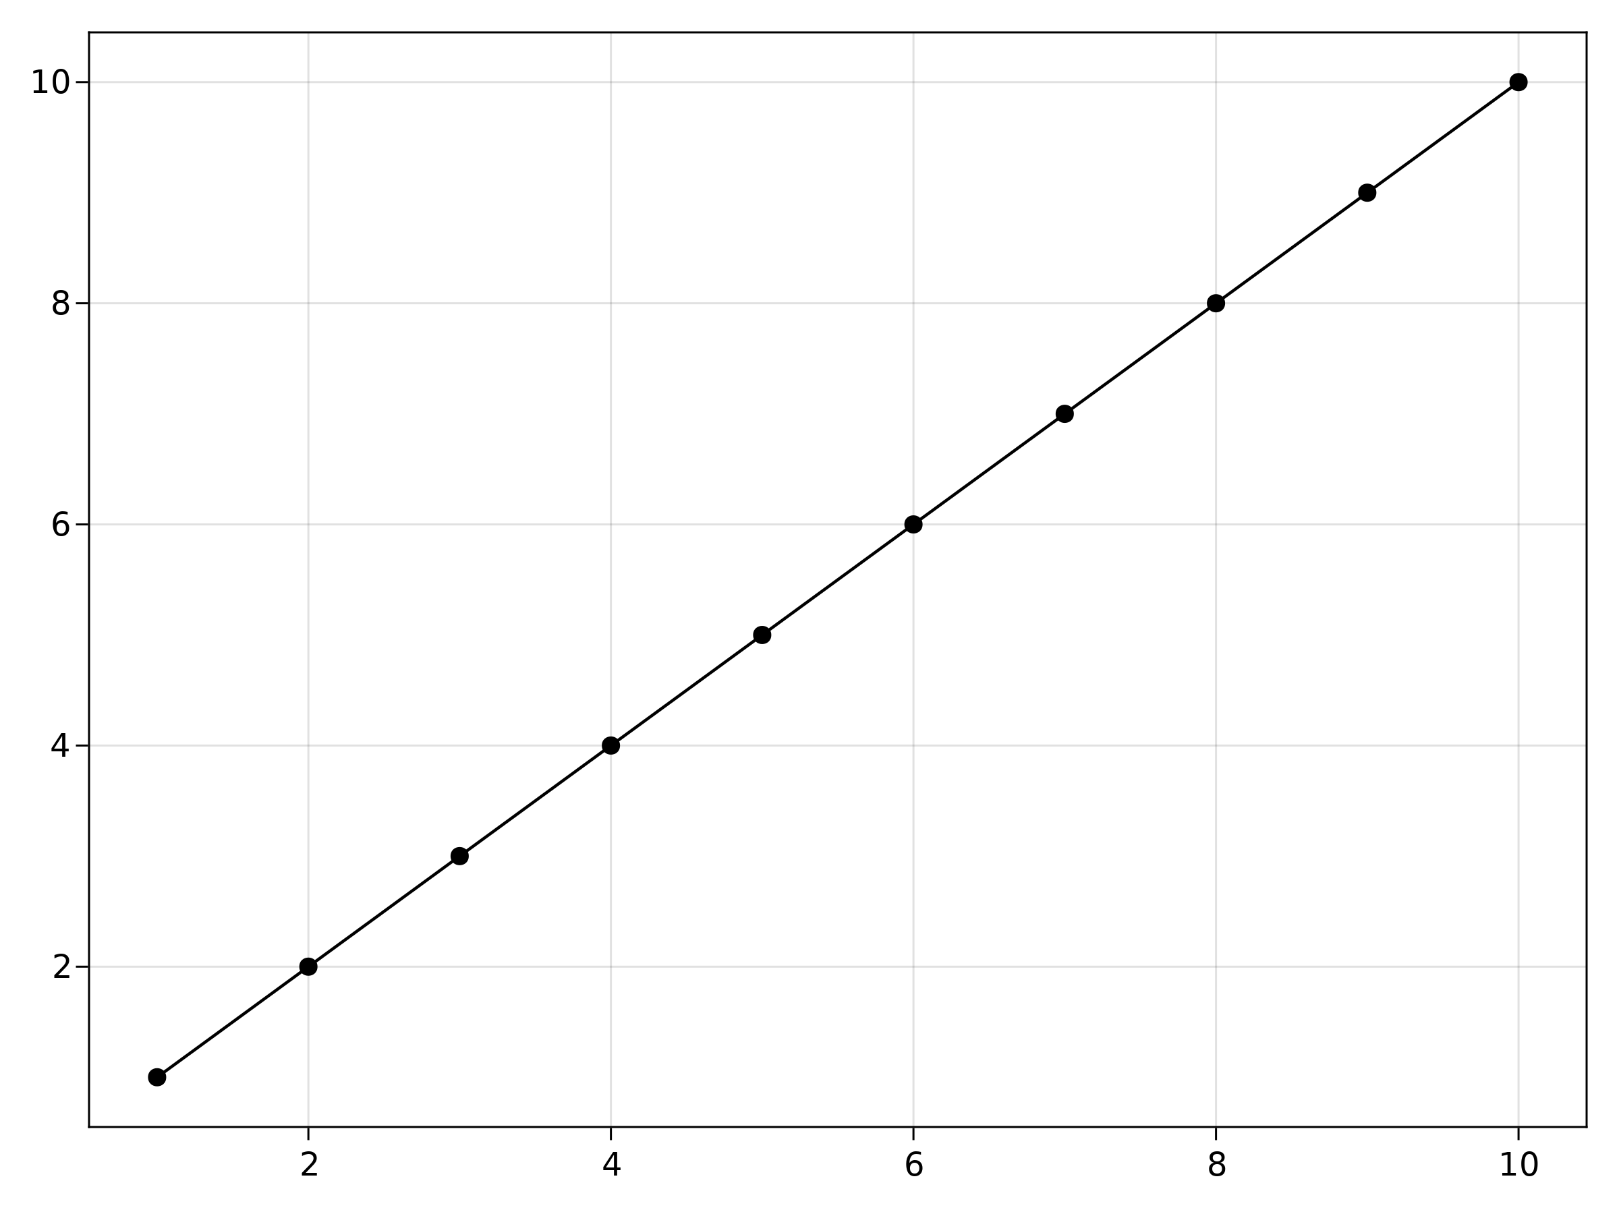

Figure 3: First plot.

Note that the previous plot is the default output, which we probably need to tweak by using axis names and labels.

Also note that every plotting function like scatterlines creates and returns a new Figure, Axis and plot object in a collection called FigureAxisPlot. These are known as the non-mutating methods. On the other hand, the mutating methods (e.g. scatterlines!, note the !) just return a plot object which can be appended into a given axis or the current_figure().

The next question that one might have is: how do I change the color or the marker type? This can be done via attributes, which we do in the next section.

## Attributes

A custom plot can be created by using attributes. The attributes can be set through keyword arguments. A list of attributes for every plotting object can be viewed via:

fig, ax, pltobj = scatterlines(1:10)  
pltobj.attributes

Attributes with 14 entries:  
 color => black  
 colormap => viridis  
 colorrange => Automatic()  
 inspectable => true  
 linestyle => nothing  
 linewidth => 1.5  
 marker => Circle{T} where T  
 markercolor => black  
 markercolormap => viridis  
 markercolorrange => Automatic()  
 markersize => 9  
 model => Float32[1.0 0.0 0.0 0.0; 0.0 1.0 0.0 0.0; 0.0 0.0 1.0 0.0; 0.0 0.0 0.0 1.0]  
 strokecolor => black  
 strokewidth => 0

Or as a Dict calling pltobject.attributes.attributes.

Asking for help in the REPL as ?lines or help(lines) for any given plotting function will show you their corresponding attributes plus a short description on how to use that specific function. For example, for lines:

help(lines)

lines(positions)  
 lines(x, y)  
 lines(x, y, z)  
  
 Creates a connected line plot for each element in (x, y, z), (x, y) or  
 positions.  
  
 │ Tip  
 │  
 │ You can separate segments by inserting NaNs.  
  
 lines has the following function signatures:  
  
 (Vector, Vector)  
 (Vector, Vector, Vector)  
 (Matrix)  
  
 Available attributes for Lines{T} where T are:  
  
 ambient  
 color  
 colormap  
 colorrange  
 cycle  
 diffuse  
 inspectable  
 lightposition  
 linestyle  
 linewidth  
 nan_color  
 overdraw  
 shininess  
 specular  
 ssao  
 transparency  
 visible

Not only the plot objects have attributes, also the Axis and Figure objects do. For example, for Figure, we have backgroundcolor, resolution, font and fontsize and the figure_padding which changes the amount of space around the figure content, see the grey area in the plot, Figure (Figure 4). It can take one number for all sides, or a tuple of four numbers for left, right, bottom and top.

Axis has a lot more, some of them are backgroundcolor, xgridcolor and title. For a full list just type help(Axis).

Hence, for our next plot we will call several attributes at once as follows:

lines(1:10, (1:10).^2; color=:black, linewidth=2, linestyle=:dash,  
 figure=(; figure_padding=5, resolution=(600, 400), font="sans",  
 backgroundcolor=:grey90, fontsize=16),  
 axis=(; xlabel="x", ylabel="x²", title="title",  
 xgridstyle=:dash, ygridstyle=:dash))  
current_figure()

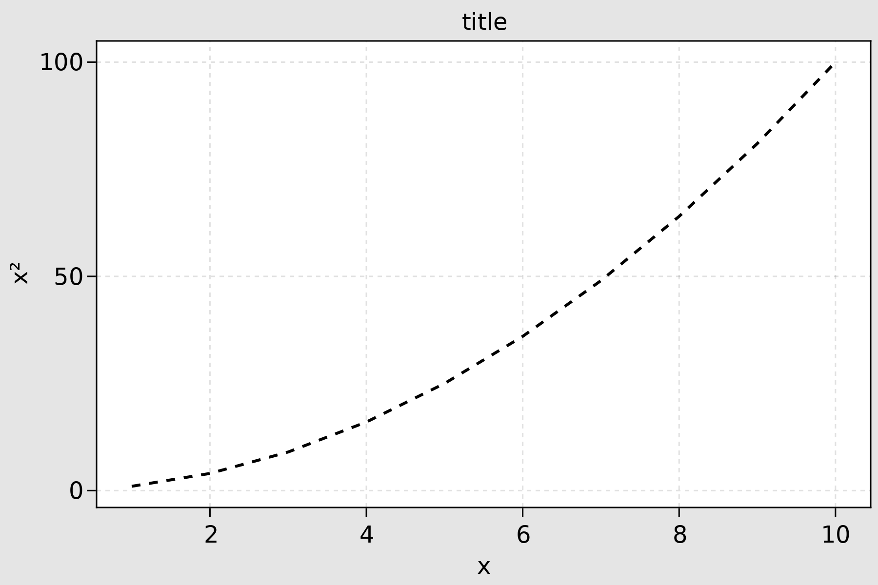

Figure 4: Custom plot.

This example has already most of the attributes that most users will normally use. Probably, a legend will also be good to have. Which for more than one function will make more sense. So, let’s append another mutation plot object and add the corresponding legends by calling axislegend. This will collect all the labels you might have passed to your plotting functions and by default will be located in the right top position. For a different one, the position=:ct argument is called, where :ct means let’s put our label in the center and at the top, see Figure Figure 5:

lines(1:10, (1:10).^2; label="x²", linewidth=2, linestyle=nothing,  
 figure=(; figure_padding=5, resolution=(600, 400), font="sans",  
 backgroundcolor=:grey90, fontsize=16),  
 axis=(; xlabel="x", title="title", xgridstyle=:dash,  
 ygridstyle=:dash))  
scatterlines!(1:10, (10:-1:1).^2; label="Reverse(x)²")  
axislegend("legend"; position=:ct)  
current_figure()

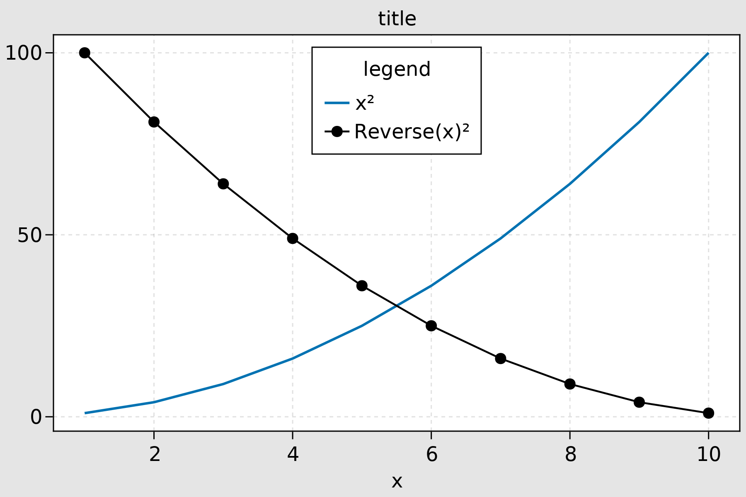

Figure 5: Custom plot legend.

Other positions are also available by combining left(l), center(c), right(r) and bottom(b), center(c), top(t). For instance, for left top, use :lt.

However, having to write this much code just for two lines is cumbersome. So, if you plan on doing a lot of plots with the same general aesthetics, then setting a theme will be better. We can do this with set_theme!() as the following example illustrates.

Plotting the previous figure should take the new default settings defined by set_theme!(kwargs):

set_theme!(; resolution=(600, 400),  
 backgroundcolor=(:orange, 0.5), fontsize=16, font="sans",  
 Axis=(backgroundcolor=:grey90, xgridstyle=:dash, ygridstyle=:dash),  
 Legend=(bgcolor=(:red, 0.2), framecolor=:dodgerblue))  
lines(1:10, (1:10).^2; label="x²", linewidth=2, linestyle=nothing,  
 axis=(; xlabel="x", title="title"))  
scatterlines!(1:10, (10:-1:1).^2; label="Reverse(x)²")  
axislegend("legend"; position=:ct)  
current_figure()  
set_theme!()  
caption = "Set theme example."

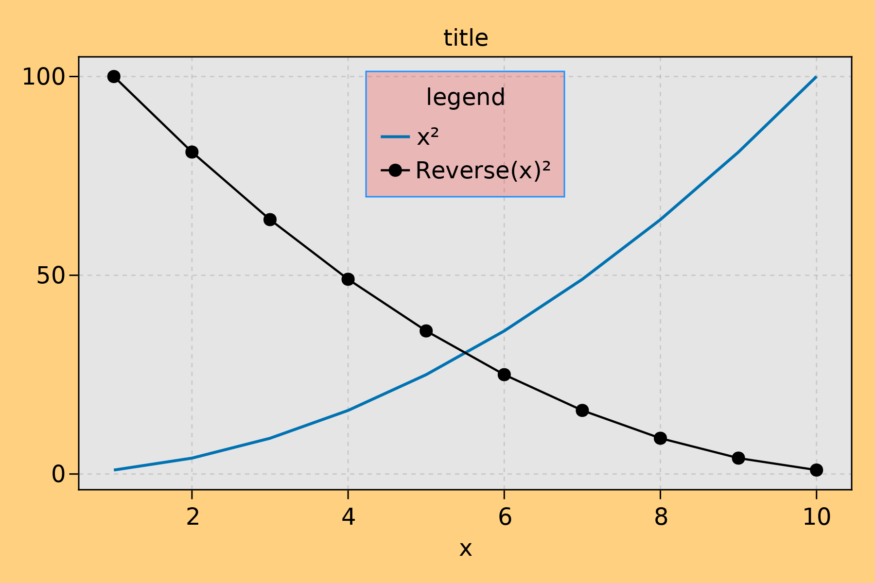

Figure 6: Set theme example.

Note that the last line is set_theme!(), which will reset the default settings of Makie. For more on themes please go to Section 5.3.

Before moving on into the next section, it’s worthwhile to see an example where an array of attributes are passed at once to a plotting function. For this example, we will use the scatter plotting function to do a bubble plot.

The data for this could be an array with 100 rows and 3 columns, here we generated these at random from a normal distribution. Here, the first column could be the positions in the x axis, the second one the positions in y and the third one an intrinsic associated value for each point. The later could be represented in a plot by a different color or with a different marker size. In a bubble plot we can do both.

using Random: seed!  
seed!(28)  
xyvals = randn(100, 3)  
xyvals[1:5, :]

5×3 Matrix{Float64}:  
 -0.294668 1.27304 1.20005  
 -0.8177 1.28339 -0.408239  
 -0.936189 1.50032 1.65924  
 -0.334106 0.395313 -1.4814  
 1.81839 0.351304 0.261416

Next, the corresponding plot can be seen in Figure 7:

fig, ax, pltobj = scatter(xyvals[:, 1], xyvals[:, 2]; color=xyvals[:, 3],  
 label="Bubbles", colormap=:plasma, markersize=15 * abs.(xyvals[:, 3]),  
 figure=(; resolution=(600, 400)), axis=(; aspect=DataAspect()))  
limits!(-3, 3, -3, 3)  
Legend(fig[1, 2], ax, valign=:top)  
Colorbar(fig[1, 2], pltobj, height=Relative(3 / 4))  
fig  
caption = "Bubble plot."

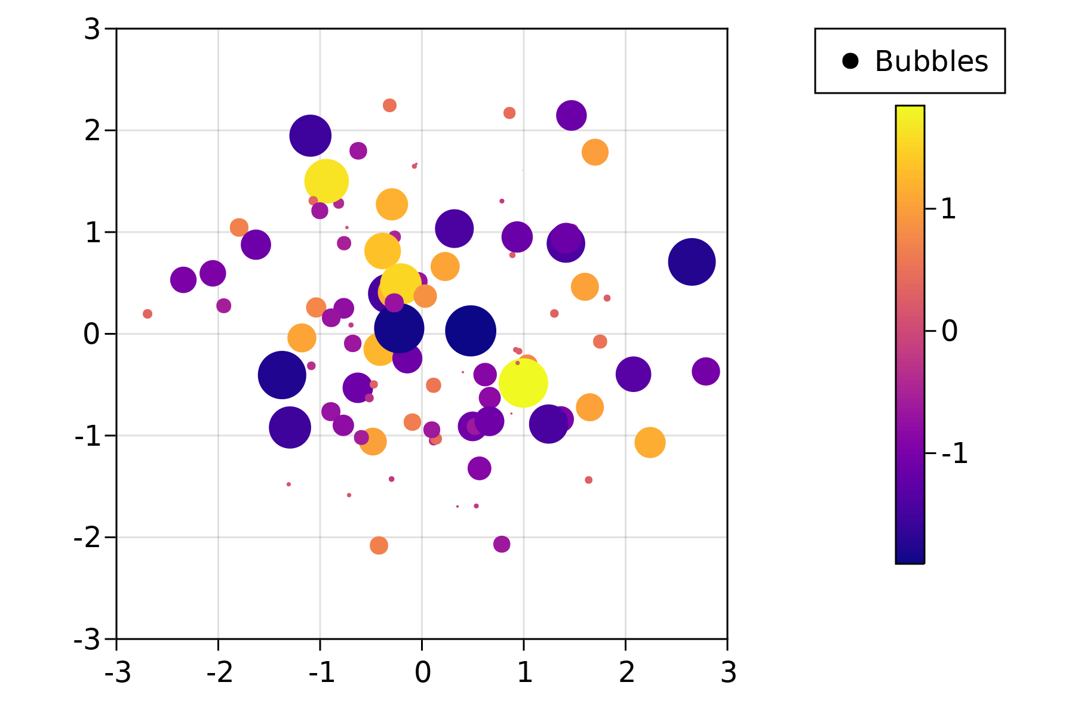

Figure 7: Bubble plot.

where we have decomposed the tuple FigureAxisPlot into fig, ax, pltobj, in order to be able to add a Legend and Colorbar outside of the plotted object. We will discuss layout options in more detail in Section 5.6.

We have done some basic but still interesting examples to show how to use Makie.jl and by now you might be wondering: what else can we do? What are all the possible plotting functions available in Makie.jl? To answer this question, a *cheat sheet* is shown in Figure 8. These work especially well with CairoMakie.jl backend.

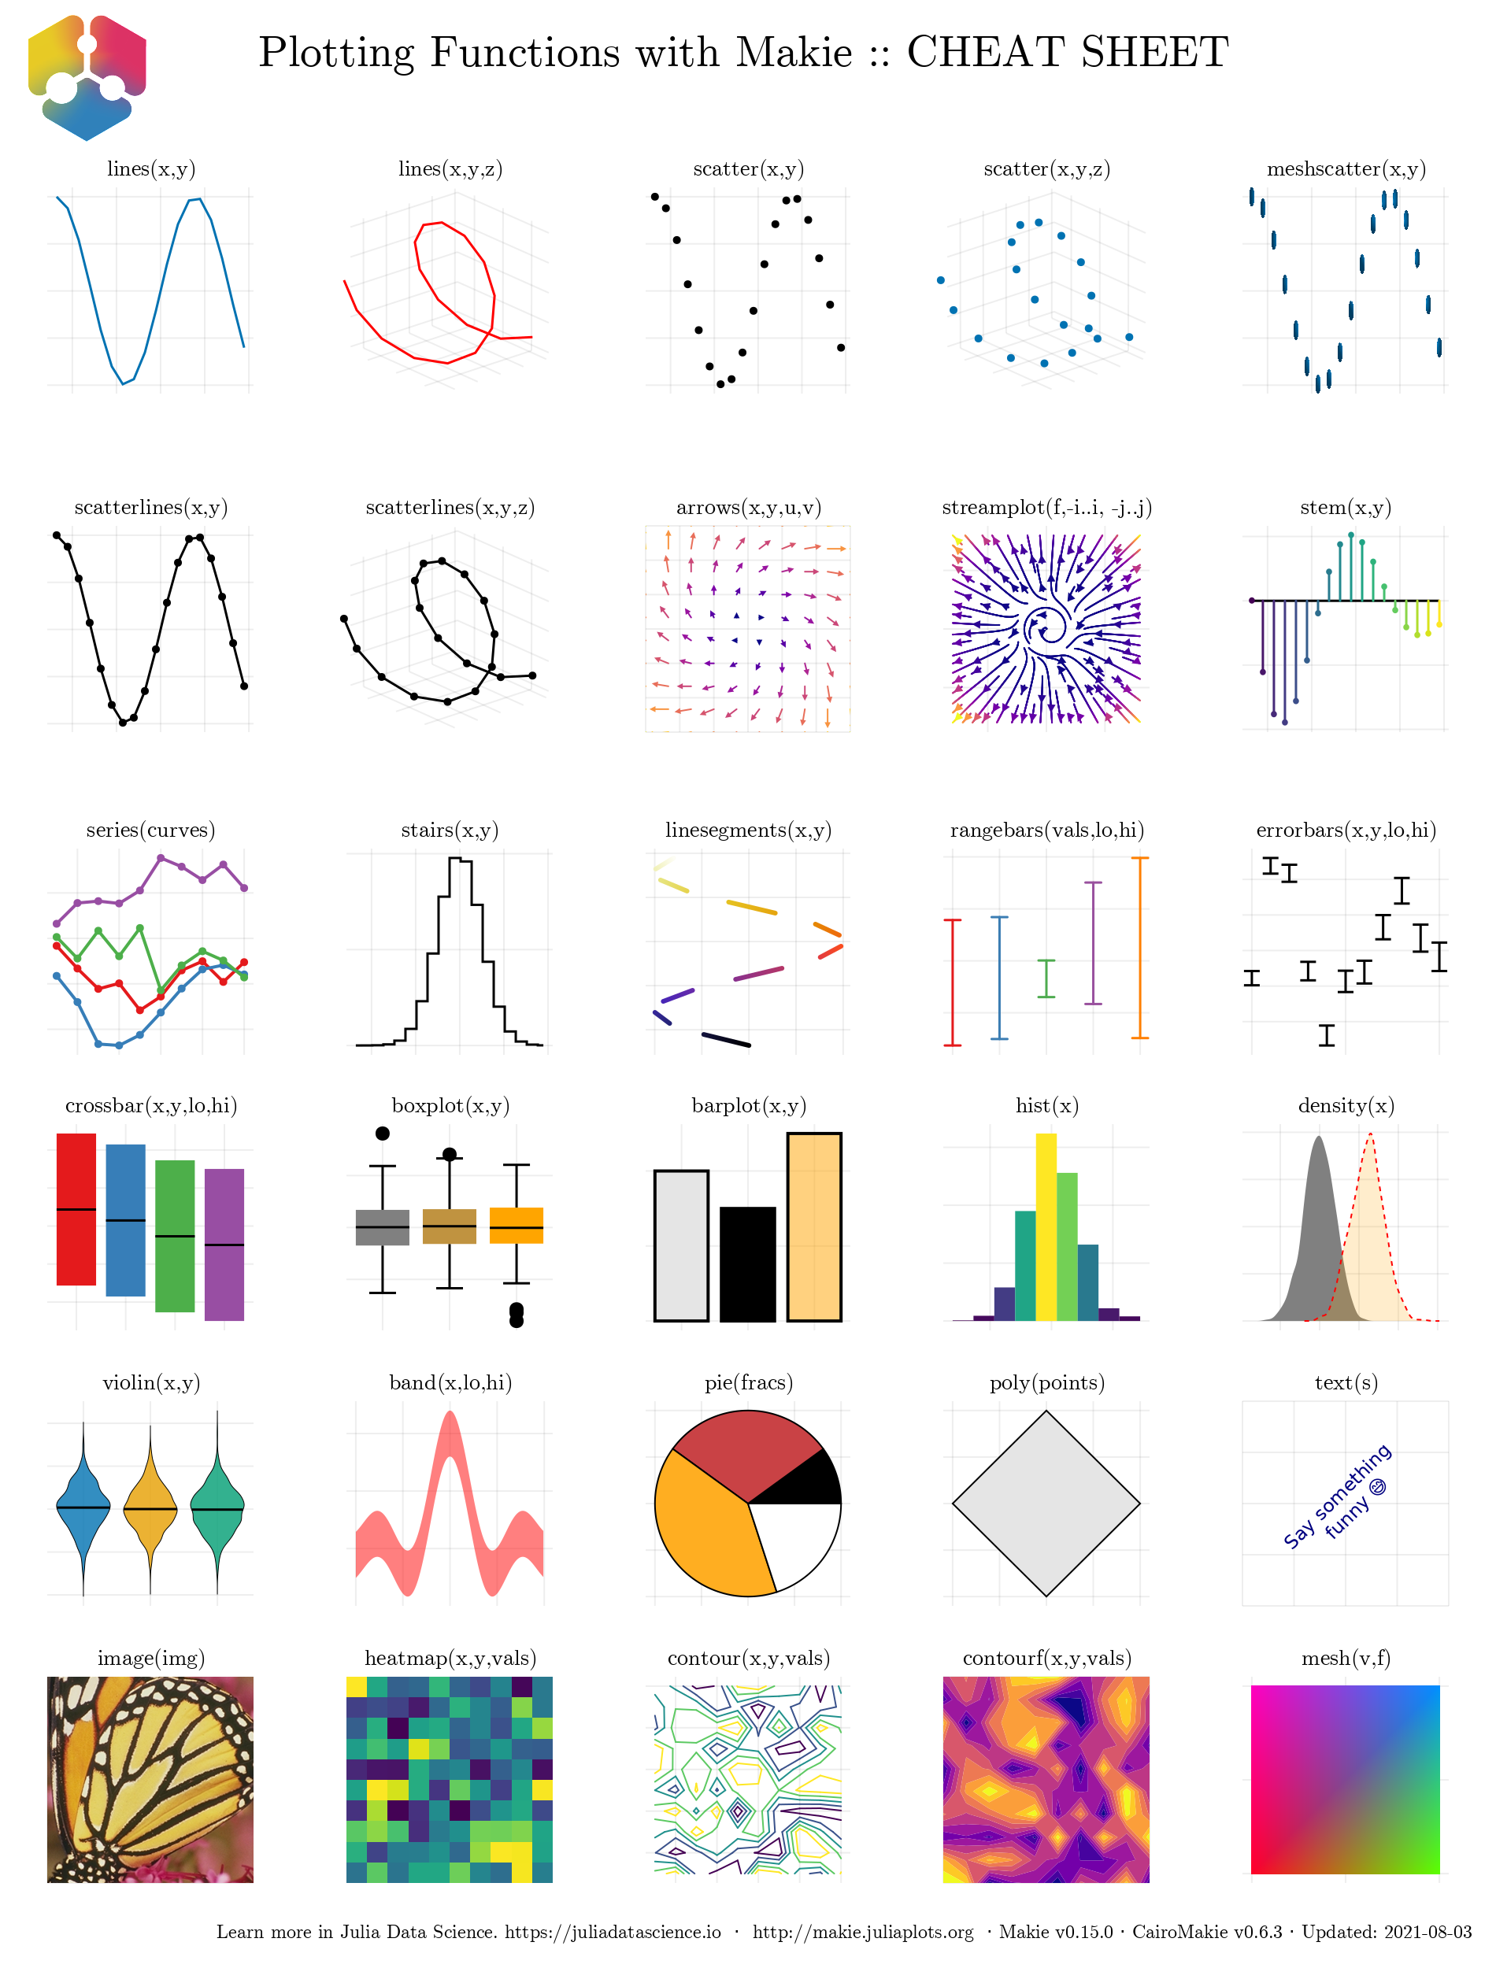

Figure 8: Plotting functions: Cheat Sheet. Output given by Cairomakie.

For completeness, in Figure 9, we show the corresponding functions *cheat sheet* for GLMakie.jl, which supports mostly 3D plots. Those will be explained in detail in Section 5.7.

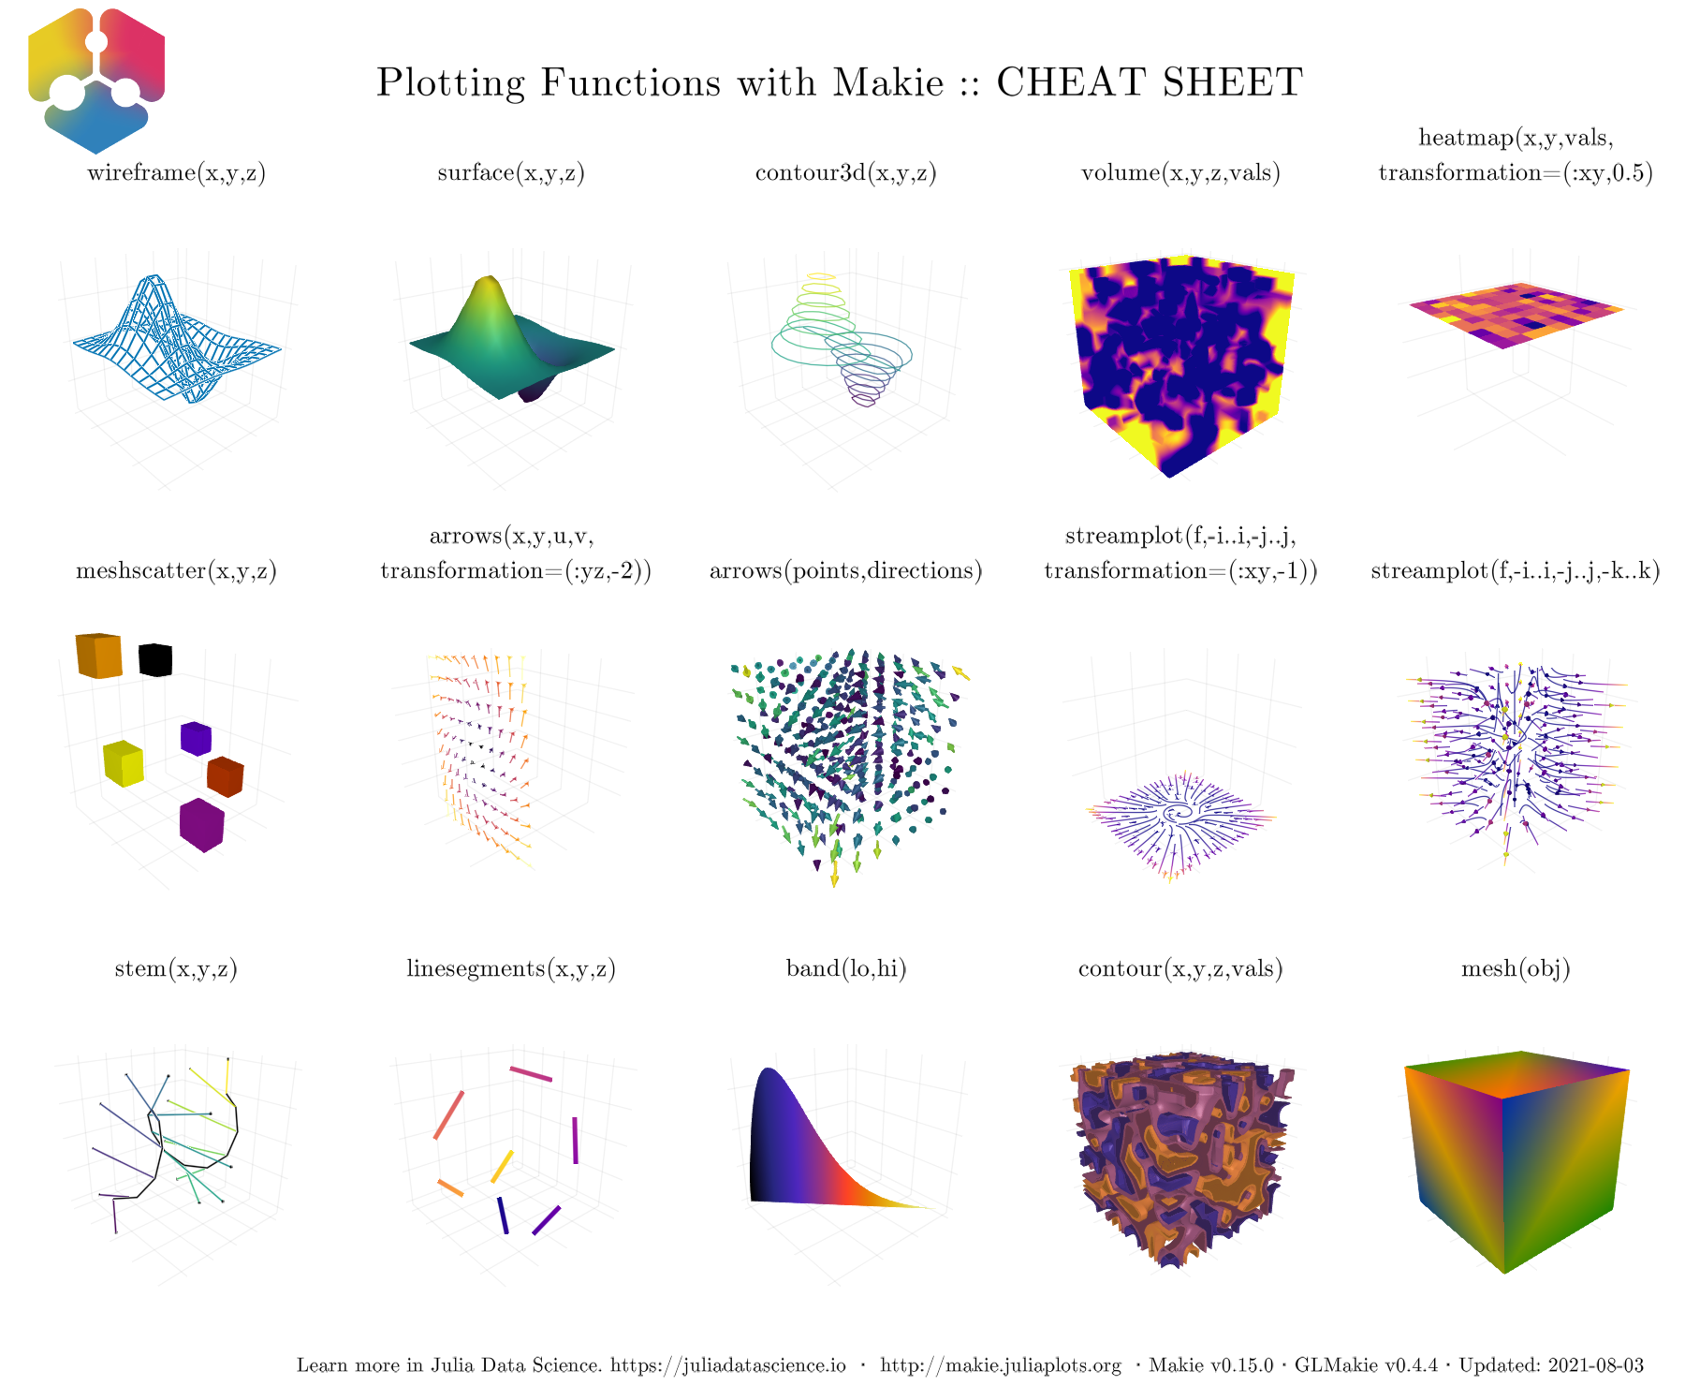

Figure 9: Plotting functions: Cheat Sheet. Output given by GLMakie.

Now, that we have an idea of all the things we can do, let’s go back and continue with the basics. It’s time to learn how to change the general appearance of our plots.

## Themes

There are several ways to affect the general appearance of your plots. Either, you could use a [predefined theme](http://makie.juliaplots.org/stable/documentation/theming/predefined_themes/index.html) or your own custom theme. For example, use the predefined dark theme via with_theme(your_plot_function, theme_dark()). Or, build your own with Theme(kwargs) or even update the one that is active with update_theme!(kwargs).

You can also do set_theme!(theme; kwargs...) to change the current default theme to theme and override or add attributes given by kwargs. If you do this and want to reset all previous settings just do set_theme!() with no arguments. See the following examples, where we had prepared a test plotting function with different characteristics, such that most attributes for each theme can be appreciated.

using Random: seed!  
seed!(123)  
y = cumsum(randn(6, 6), dims=2)

6×6 Matrix{Float64}:  
 1.19027 2.17124 1.2823 0.56489 0.842615 -0.0284417  
 2.04818 1.9727 2.29991 1.52484 3.04876 3.39449  
 1.14265 1.41647 2.00887 1.02933 -0.748397 -0.904251  
 0.459416 0.265187 0.633189 0.893591 -2.03947 0.293544  
 -0.396679 -0.736045 -1.01718 -1.48567 -0.70341 -1.70176  
 -0.664713 -1.50859 -2.24348 -3.12437 -0.810794 -0.743838

A matrix of size (20, 20) with random entries, so that we can plot a heatmap. The range in $x$ and $y$ is also specified.

using Random: seed!  
seed!(13)  
xv = yv = LinRange(-3, 0.5, 20)  
matrix = randn(20, 20)  
matrix[1:6, 1:6] # first 6 rows and columns

6×6 Matrix{Float64}:  
 -0.410261 0.755685 1.84697 0.0645615 1.53034 0.557182  
 -2.06413 1.2311 0.330232 -0.793936 -1.10552 -2.1084  
 0.0749639 -3.42235 0.392709 2.47305 -1.10597 0.962373  
 0.803344 1.78866 -0.81155 -1.70707 0.00106256 0.297236  
 -1.24842 1.4372 1.11774 -0.952159 -0.0887516 0.0106082  
 -1.43937 1.31755 0.631643 0.261686 -0.402386 0.233161

Hence, our plotting function looks like follows:

function demo_themes(y, xv, yv, matrix)  
 fig, _ = series(y; labels=["$i" for i = 1:6], markersize=10,  
 color=:Set1, figure=(; resolution=(600, 300)),  
 axis=(; xlabel="time (s)", ylabel="Amplitude",  
 title="Measurements"))  
 hmap = heatmap!(xv, yv, matrix; colormap=:plasma)  
 limits!(-3.1, 8.5, -6, 5.1)  
 axislegend("legend"; merge=true)  
 Colorbar(fig[1, 2], hmap)  
 fig  
end

Note that the series function has been used to plot several lines and scatters at once with their corresponding labels. Also, a heatmap with their colorbar has been included. Currently, there are two dark themes, one called theme_dark() and the other one theme_black(), see Figures.

with_theme(theme_dark()) do  
 demo_themes(y, xv, yv, matrix)  
end  
with_theme(theme_black()) do  
 demo_themes(y, xv, yv, matrix)  
end

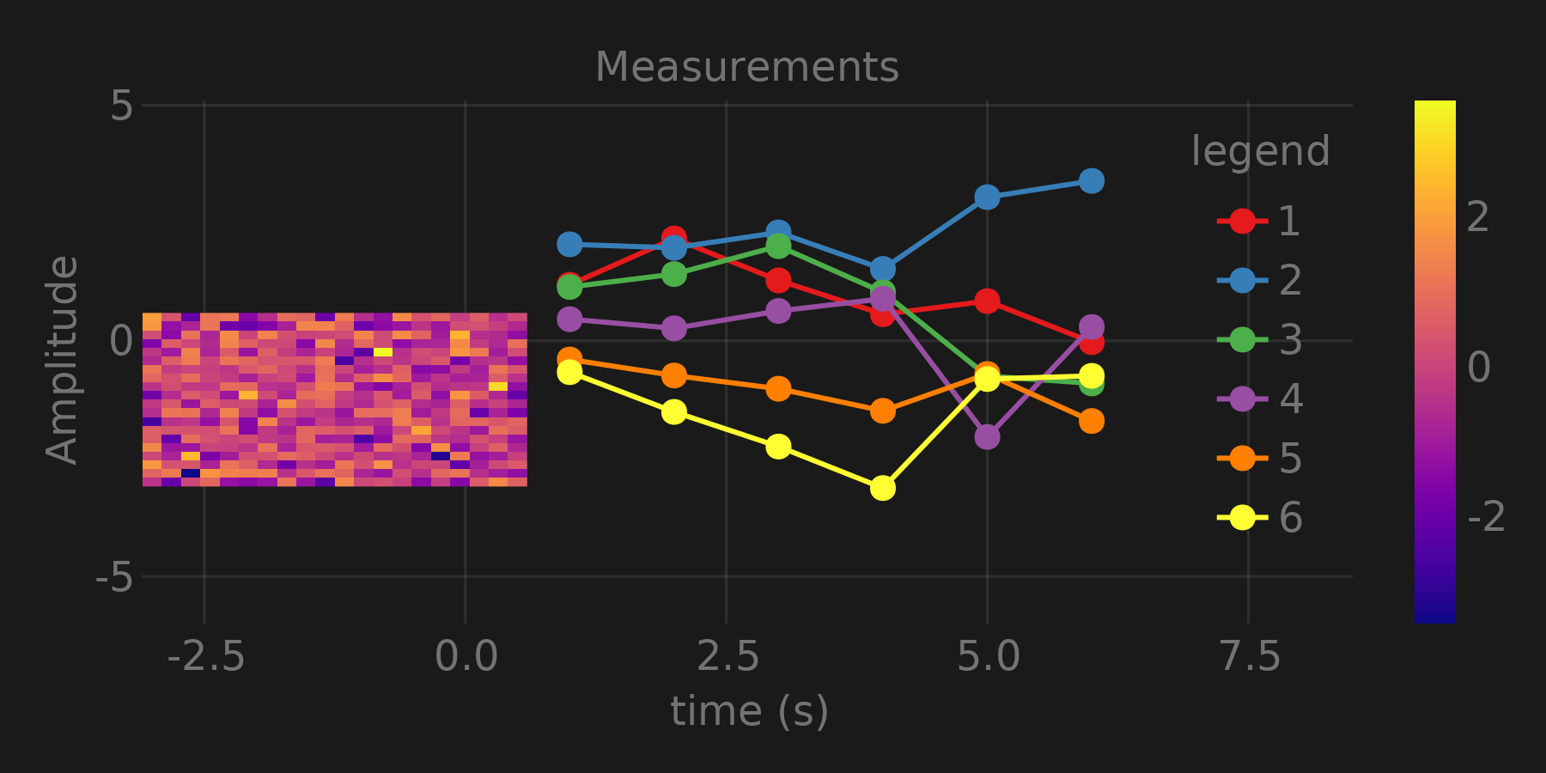

Figure 10: Theme dark.

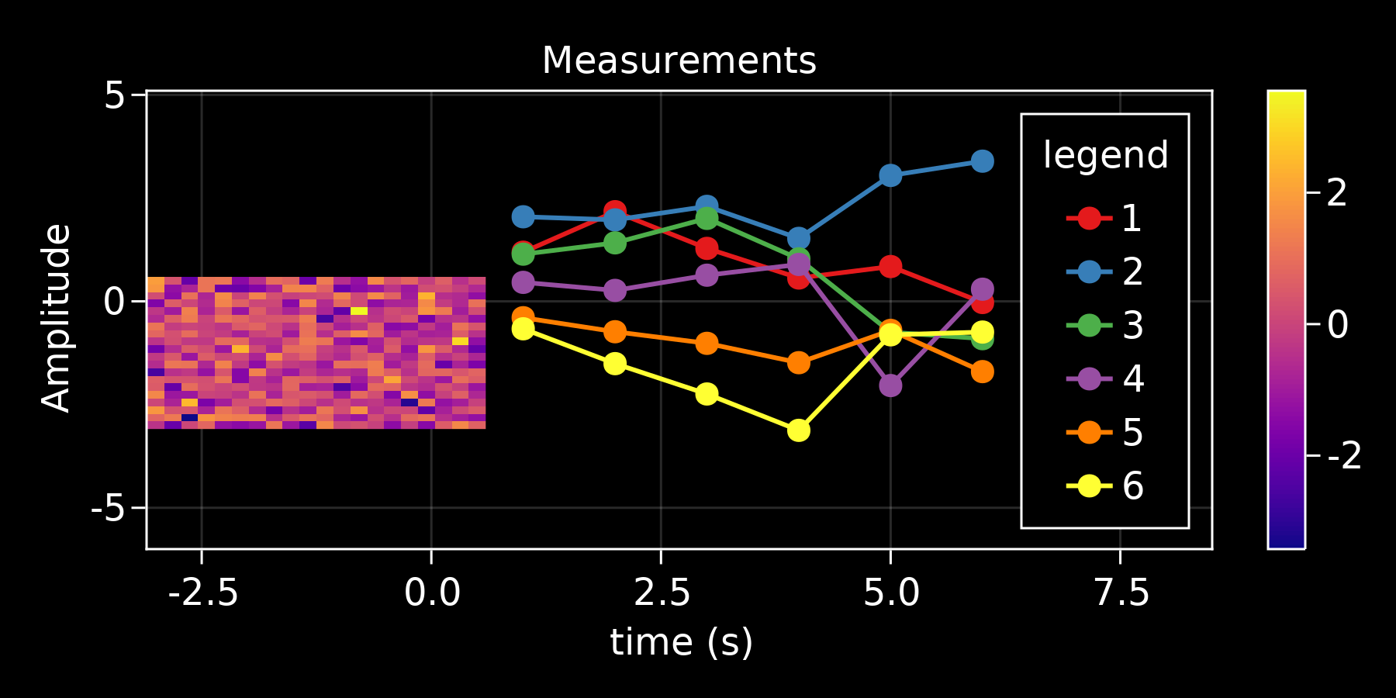

Figure 11: Theme black.

And three more white-ish themes called, theme_ggplot2(), theme_minimal() and theme_light(). Useful for more standard publication type plots.

with_theme(theme_ggplot2()) do  
 demo_themes(y, xv, yv, matrix)  
end  
with_theme(theme_minimal()) do  
 demo_themes(y, xv, yv, matrix)  
end  
with_theme(theme_light()) do  
 demo_themes(y, xv, yv, matrix)  
end

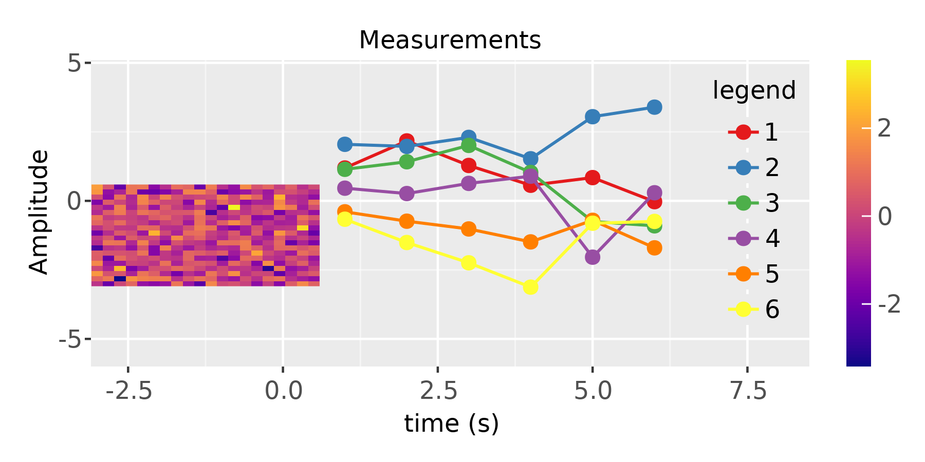

Figure 12: Theme ggplot2.

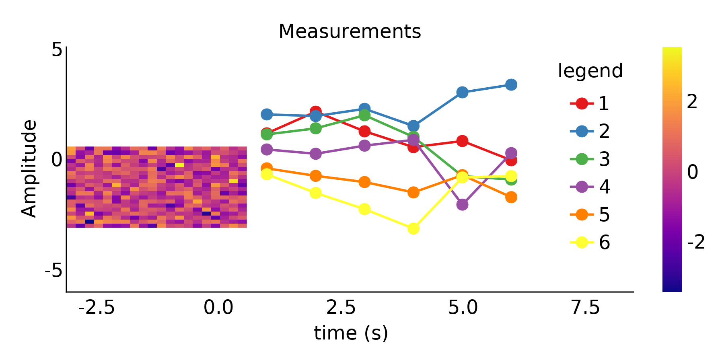

Figure 13: Theme minimal.

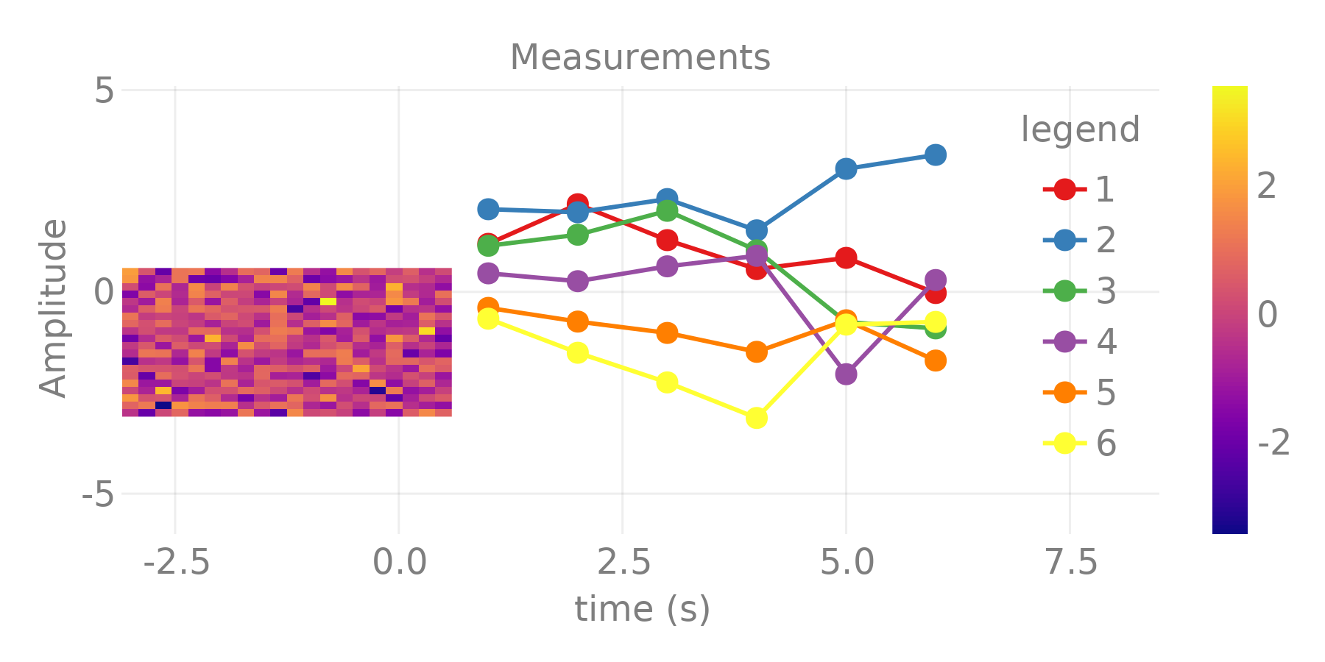

Figure 14: Theme light.

Another alternative is defining a custom Theme by doing with_theme(your_plot, your_theme()). For instance, the following theme could be a simple version for a publication quality template:

publication_theme() = Theme(  
 fontsize=16, font="CMU Serif",  
 Axis=(xlabelsize=20, xgridstyle=:dash, ygridstyle=:dash,  
 xtickalign=1, ytickalign=1, yticksize=10, xticksize=10,  
 xlabelpadding=-5, xlabel="x", ylabel="y"),  
 Legend=(framecolor=(:black, 0.5), bgcolor=(:white, 0.5)),  
 Colorbar=(ticksize=16, tickalign=1, spinewidth=0.5),  
)

Which, for simplicity we use it to plot scatterlines and a heatmap.

function plot_with_legend_and_colorbar()  
 fig, ax, _ = scatterlines(1:10; label="line")  
 hm = heatmap!(ax, LinRange(6, 9, 15), LinRange(2, 5, 15), randn(15, 15);  
 colormap=:Spectral_11)  
 axislegend("legend"; position=:lt)  
 Colorbar(fig[1, 2], hm, label="values")  
 ax.title = "my custom theme"  
 fig  
end

Then, using the previously define Theme the output is shown in Figure (Figure 15).

with_theme(plot_with_legend_and_colorbar, publication_theme())

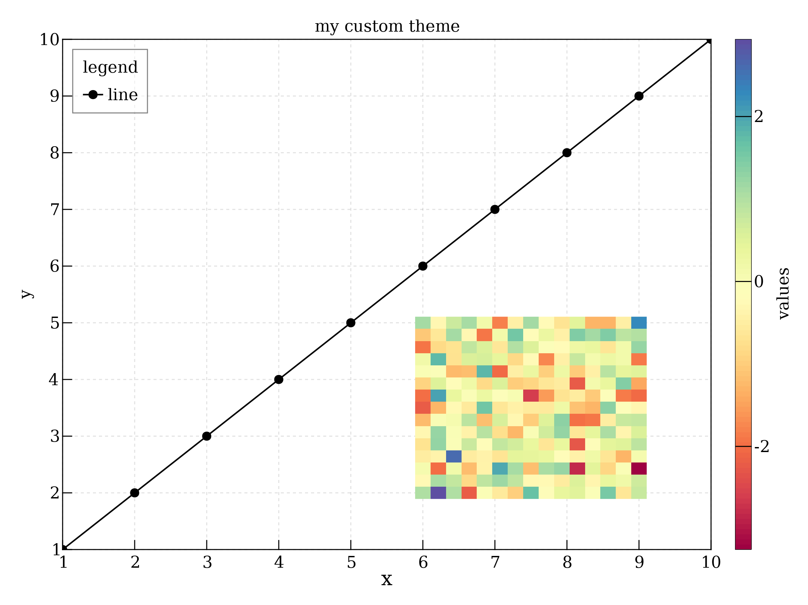

Figure 15: Themed plot with Legend and Colorbar.

Now, if something needs to be changed after set_theme!(your_theme), we can do it with update_theme!(resolution=(500, 400), fontsize=18), for example. Another approach will be to pass additional arguments to the with_theme function:

fig = (resolution=(600, 400), figure_padding=1, backgroundcolor=:grey90)  
ax = (; aspect=DataAspect(), xlabel=L"x", ylabel=L"y")  
cbar = (; height=Relative(4 / 5))  
with_theme(publication_theme(); fig..., Axis=ax, Colorbar=cbar) do  
 plot_with_legend_and_colorbar()  
end

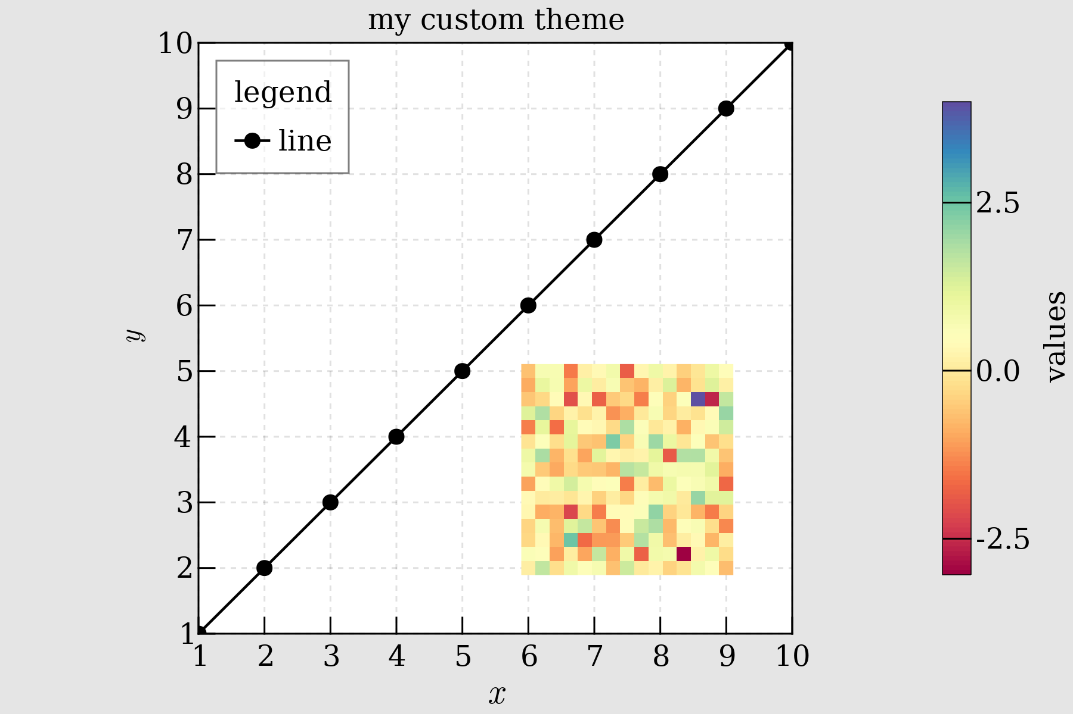

Figure 16: Theme with extra args.

Now, let’s move on and do a plot with LaTeX strings and a custom theme.

## Using LaTeXStrings.jl

LaTeX support in Makie.jl is also available via LaTeXStrings.jl:

using LaTeXStrings

Simple use cases are shown below (Figure 17). A basic example includes LaTeX strings for x-y labels and legends:

function LaTeX_Strings()  
 x = 0:0.05:4π  
 lines(x, x -> sin(3x) / (cos(x) + 2) / x; label=L"\frac{\sin(3x)}{x(\cos(x)+2)}",  
 figure=(; resolution=(600, 400)), axis=(; xlabel=L"x"))  
 lines!(x, x -> cos(x) / x; label=L"\cos(x)/x")  
 lines!(x, x -> exp(-x); label=L"e^{-x}")  
 limits!(-0.5, 13, -0.6, 1.05)  
 axislegend(L"f(x)")  
 current_figure()  
end

with_theme(LaTeX_Strings, publication_theme())

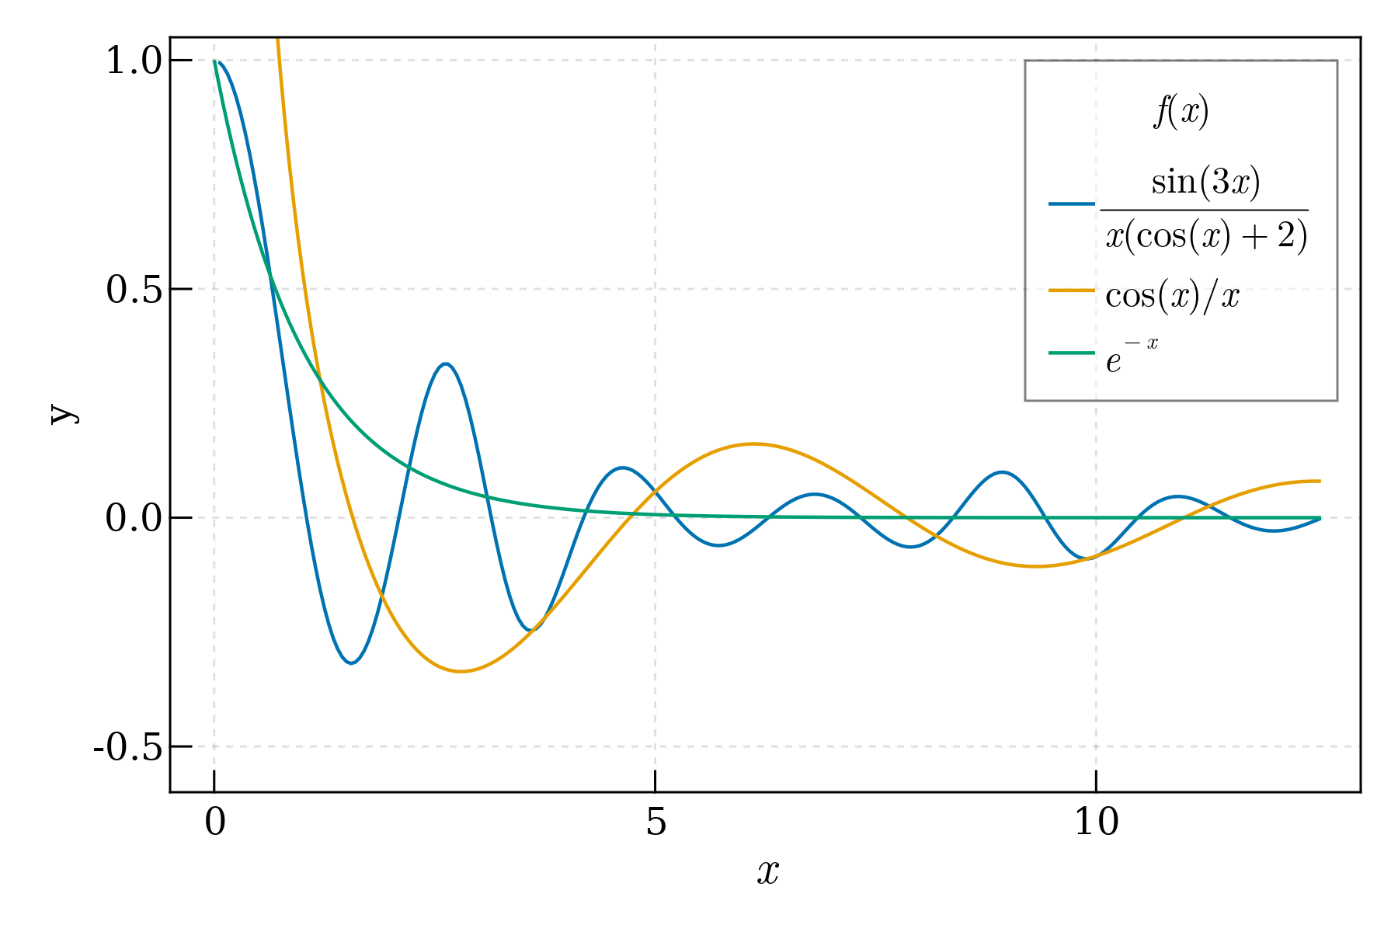

Figure 17: Plot with LaTeX strings.

A more involved example will be one with some equation as text and increasing legend numbering for curves in a plot:

function multiple_lines()  
 x = collect(0:10)  
 fig = Figure(resolution=(600, 400), font="CMU Serif")  
 ax = Axis(fig[1, 1], xlabel=L"x", ylabel=L"f(x,a)")  
 for i = 0:10  
 lines!(ax, x, i .* x; label=latexstring("$(i) x"))  
 end  
 axislegend(L"f(x)"; position=:lt, nbanks=2, labelsize=14)  
 text!(L"f(x,a) = ax", position=(4, 80))  
 fig  
end  
multiple_lines()

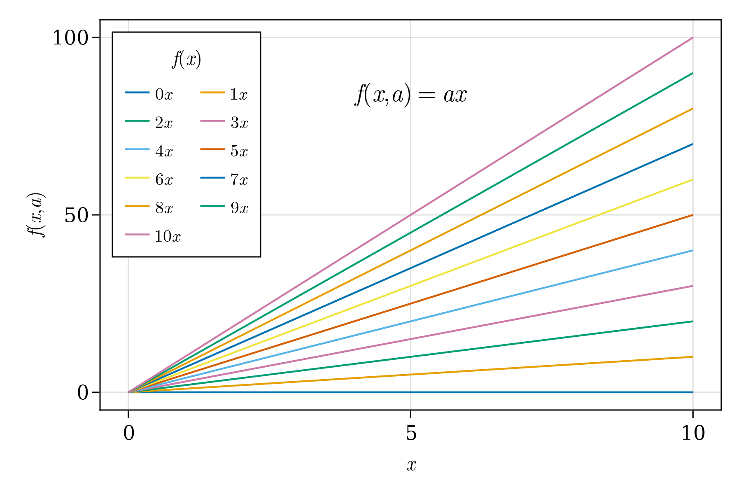

Figure 18: Multiple lines.

But, some lines have repeated colors, so thats no good. Adding some markers and line styles usually helps. So, let’s do that using [Cycles](http://makie.juliaplots.org/stable/documentation/theming/index.html#cycles) for these types. Setting covary=true allows to cycle all elements together:

function multiple_scatters_and_lines()  
 x = collect(0:10)  
 cycle = Cycle([:color, :linestyle, :marker], covary=true)  
 set_theme!(Lines=(cycle=cycle,), Scatter=(cycle=cycle,))  
 fig = Figure(resolution=(600, 400), font="CMU Serif")  
 ax = Axis(fig[1, 1], xlabel=L"x", ylabel=L"f(x,a)")  
 for i in x  
 lines!(ax, x, i .* x; label=latexstring("$(i) x"))  
 scatter!(ax, x, i .* x; markersize=13, strokewidth=0.25,  
 label=latexstring("$(i) x"))  
 end  
 axislegend(L"f(x)"; merge=true, position=:lt, nbanks=2, labelsize=14)  
 text!(L"f(x,a) = ax", position=(4, 80))  
 set_theme!() # reset to default theme  
 fig  
end  
multiple_scatters_and_lines()

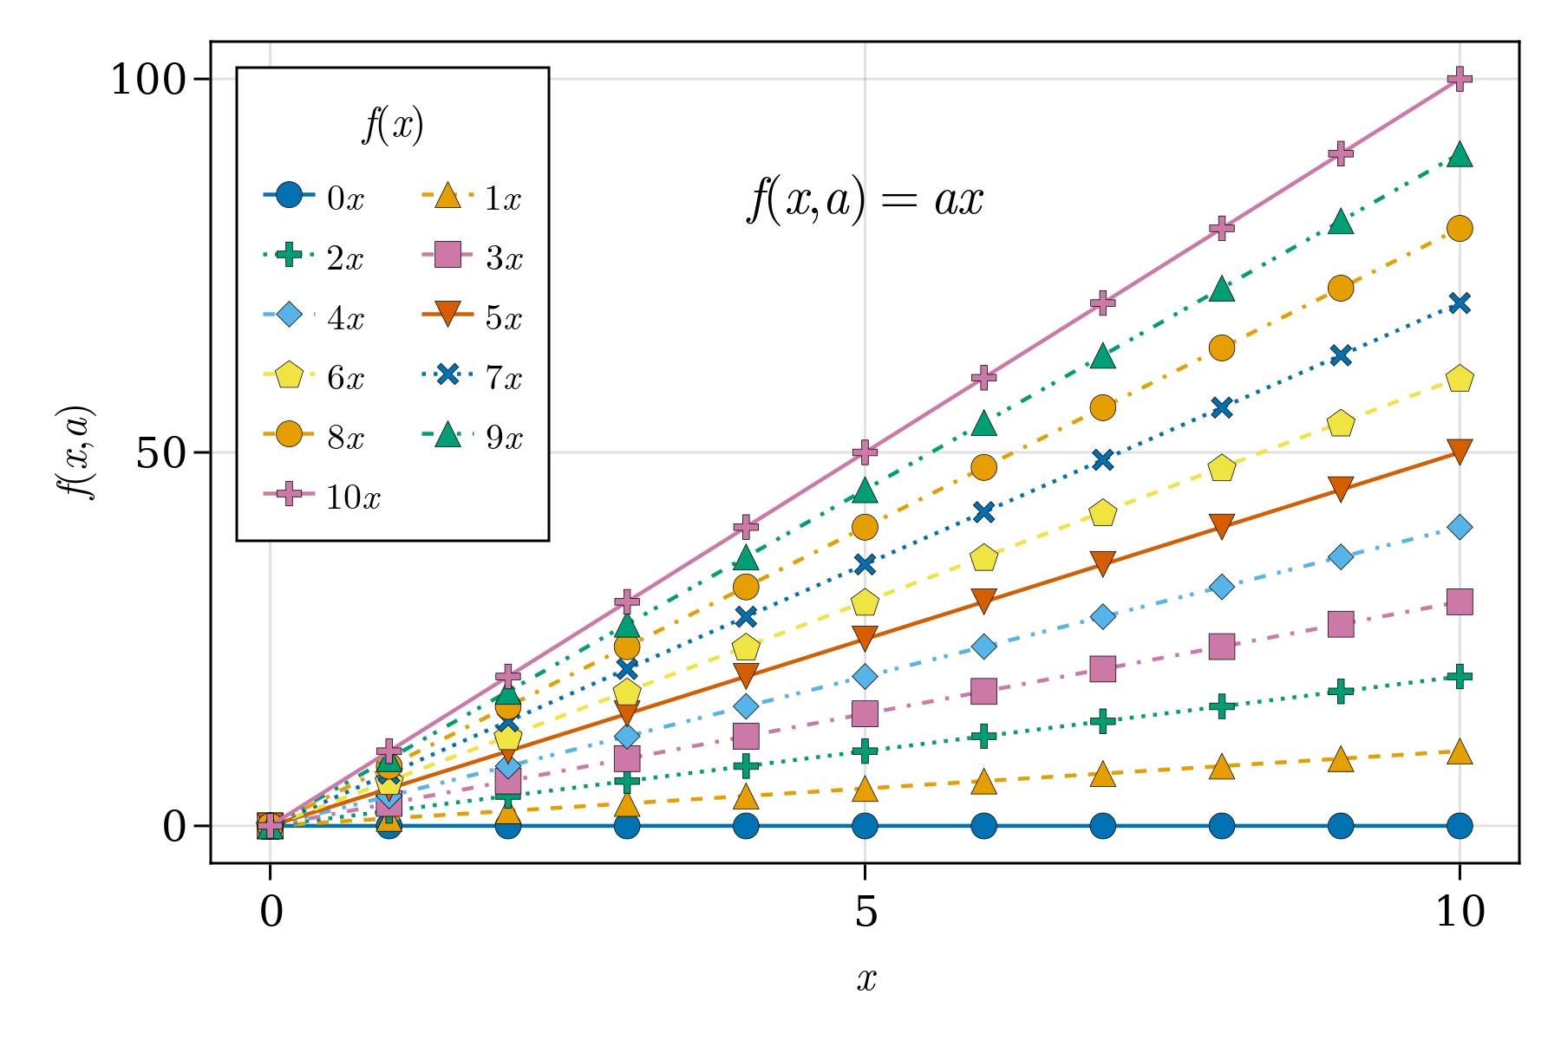

Figure 19: Multiple Scatters and Lines.

And voilà. A publication quality plot is here. What more can we ask for? Well, what about different default colors or palettes. In our next section, we will see how to use again [Cycles](http://makie.juliaplots.org/stable/documentation/theming/index.html#cycles) and know a little bit more about them, plus some additional keywords in order to achieve this.

## Colors and Colormaps

Choosing an appropiate set of colors or colorbar for your plot is an essential part when presenting results. Using [Colors.jl](https://github.com/JuliaGraphics/Colors.jl) is supported in Makie.jl so that you can use [named colors](https://juliagraphics.github.io/Colors.jl/latest/namedcolors/) or pass RGB or RGBA values. Additionally, colormaps from [ColorSchemes.jl](https://github.com/JuliaGraphics/ColorSchemes.jl) and [PerceptualColourMaps.jl](https://github.com/peterkovesi/PerceptualColourMaps.jl) can also be used. It is worth knowing that you can reverse a colormap by doing Reverse(:colormap_name) and obtain a transparent color or colormap with color=(:red,0.5) and colormap=(:viridis, 0.5).

Different use cases will be shown next. Then we will difine a custom theme with new colors and a colorbar palette.

By default Makie.jl has a predefined set of colors in order to cycle trough them automatically. As shown in the previous figures, where no specific color was set. Overwriting these defaults is done by calling the keyword color in the plotting function and specifying a new color via a Symbol or String. See this in action in the following example:

function set_colors_and_cycle()  
 # Epicycloid lines  
 x(r, k, θ) = r * (k .+ 1.0) .* cos.(θ) .- r * cos.((k .+ 1.0) .* θ)  
 y(r, k, θ) = r * (k .+ 1.0) .* sin.(θ) .- r * sin.((k .+ 1.0) .* θ)  
 θ = LinRange(0, 6.2π, 1000)  
 axis = (; xlabel=L"x(\theta)", ylabel=L"y(\theta)",  
 title="Epicycloid", aspect=DataAspect())  
 figure = (; resolution=(600, 400), font="CMU Serif")  
 fig, ax, _ = lines(x(1, 1, θ), y(1, 1, θ); color="firebrick1", # string  
 label=L"1.0", axis=axis, figure=figure)  
 lines!(ax, x(4, 2, θ), y(4, 2, θ); color=:royalblue1, #symbol  
 label=L"2.0")  
 for k = 2.5:0.5:5.5  
 lines!(ax, x(2k, k, θ), y(2k, k, θ); label=latexstring("$(k)")) #cycle  
 end  
 Legend(fig[1, 2], ax, latexstring("k, r = 2k"), merge=true)  
 fig  
end  
set_colors_and_cycle()

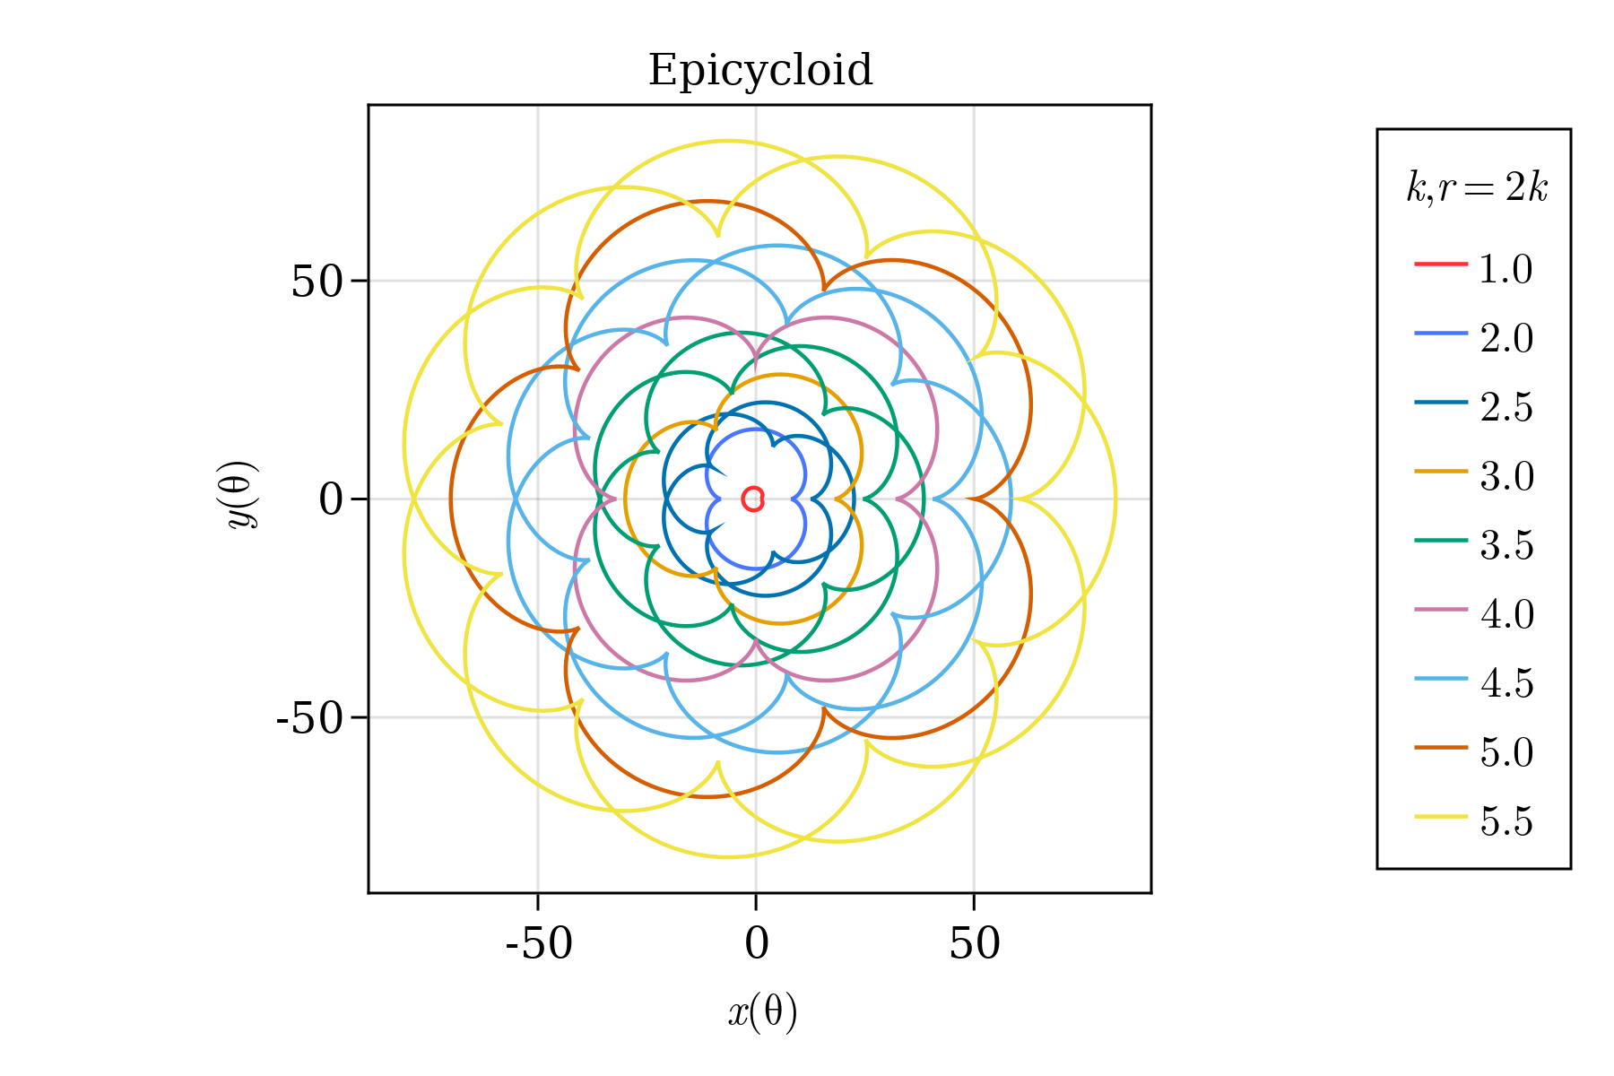

Figure 20: Set colors and cycle.

Where, in the first two lines we have used the keyword color to specify our color. The rest is using the default cycle set of colors. Later, we will learn how to do a custom cycle.

Regarding colormaps, we are already familiar with the keyword colormap for heatmaps and scatters. Here, we show that a colormap can also be specified via a Symbol or a String, similar to colors. Or, even a vector of RGB colors. Let’s do our first an example by calling colormaps as a Symbol, String and cgrad for categorical values. See ?cgrad for more information.

figure = (; resolution=(600, 400), font="CMU Serif")  
axis = (; xlabel=L"x", ylabel=L"y", aspect=DataAspect())  
fig, ax, pltobj = heatmap(rand(20, 20); colorrange=(0, 1),  
 colormap=Reverse(:viridis), axis=axis, figure=figure)  
Colorbar(fig[1, 2], pltobj, label = "Reverse colormap Sequential")  
fig

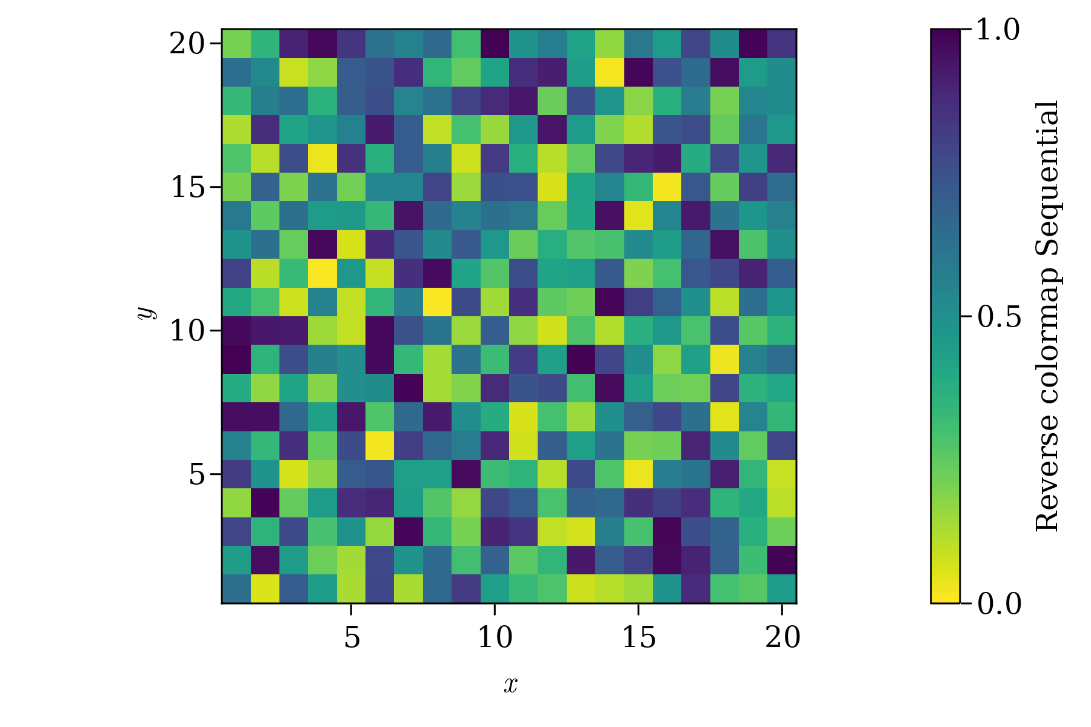

Figure 21: Reverse colormap sequential and colorrange.

When setting a colorrange usually the values outside this range are colored with the first and last color from the colormap. However, sometimes is better to specify the color you want at both ends. We do that with highclip and lowclip:

using ColorSchemes

figure = (; resolution=(600, 400), font="CMU Serif")  
axis = (; xlabel=L"x", ylabel=L"y", aspect=DataAspect())  
fig, ax, pltobj=heatmap(randn(20, 20); colorrange=(-2, 2),  
 colormap="diverging_rainbow_bgymr_45_85_c67_n256",  
 highclip=:black, lowclip=:white, axis=axis, figure=figure)  
Colorbar(fig[1, 2], pltobj, label = "Diverging colormap")  
fig

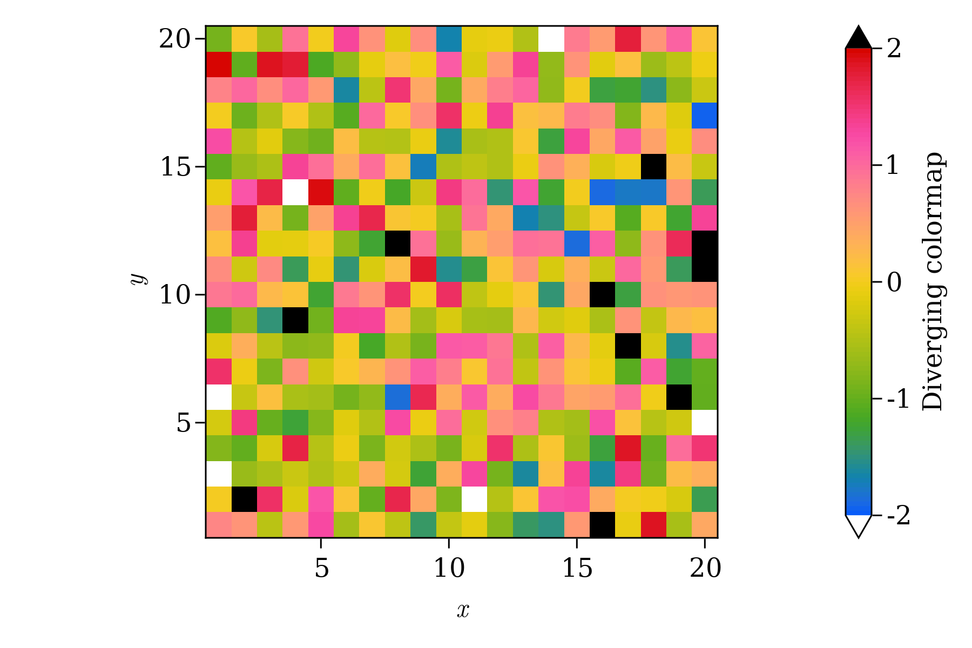

Figure 22: Diverging Colormap with low and high clip.

But we mentioned that also RGB vectors are valid options. For our next example you could pass the custom colormap *perse* or use cgrad to force a categorical Colorbar.

using Colors, ColorSchemes

figure = (; resolution=(600, 400), font="CMU Serif")  
axis = (; xlabel=L"x", ylabel=L"y", aspect=DataAspect())  
cmap = ColorScheme(range(colorant"red", colorant"green", length=3))  
mygrays = ColorScheme([RGB{Float64}(i, i, i) for i in [0.0, 0.5, 1.0]])  
fig, ax, pltobj = heatmap(rand(-1:1, 20, 20);  
 colormap=cgrad(mygrays, 3, categorical=true, rev=true), # cgrad and Symbol, mygrays,  
 axis=axis, figure=figure)  
cbar = Colorbar(fig[1, 2], pltobj, label="Categories")  
cbar.ticks = ([-0.66, 0, 0.66], ["-1", "0", "1"])  
fig

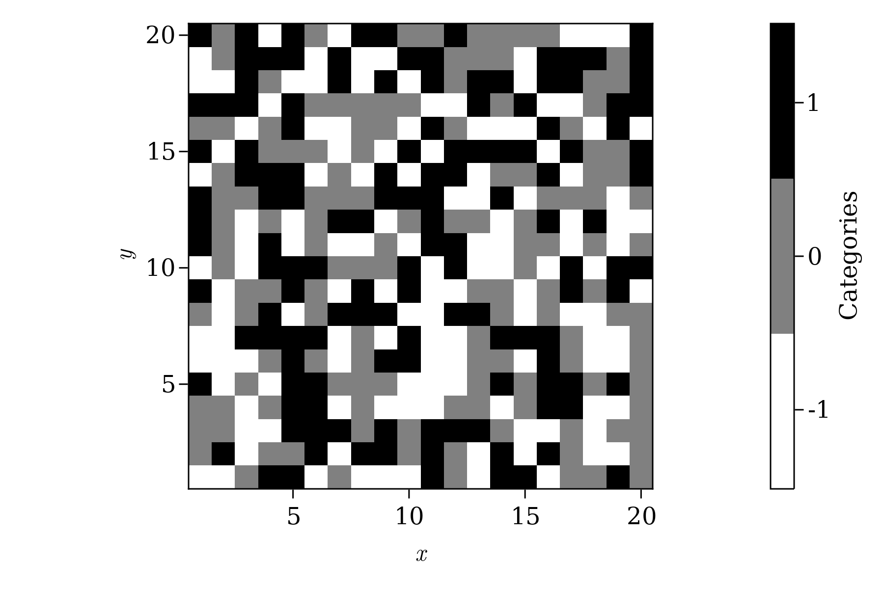

Figure 23: Categorical Colormap.

Lastly, the ticks in the colorbar for the categorial case are not centered by default in each color. This is fixed by passing custom ticks, as in cbar.ticks = (positions, ticks). The last situation is when passing a tuple of two colors to colormap as symbols, strings or a mix. You will get an interpolated colormap between these two colors.

Also, hexadecimal coded colors are also accepted. So, on top or our heatmap let’s put one semi-transparent point using this.

figure = (; resolution=(600, 400), font="CMU Serif")  
axis = (; xlabel=L"x", ylabel=L"y", aspect=DataAspect())  
fig, ax, pltobj = heatmap(rand(20, 20); colorrange=(0, 1),  
 colormap=(:red, "black"), axis=axis, figure=figure)  
scatter!(ax, [11], [11], color=("#C0C0C0", 0.5), markersize=150)  
Colorbar(fig[1, 2], pltobj, label="2 colors")  
fig

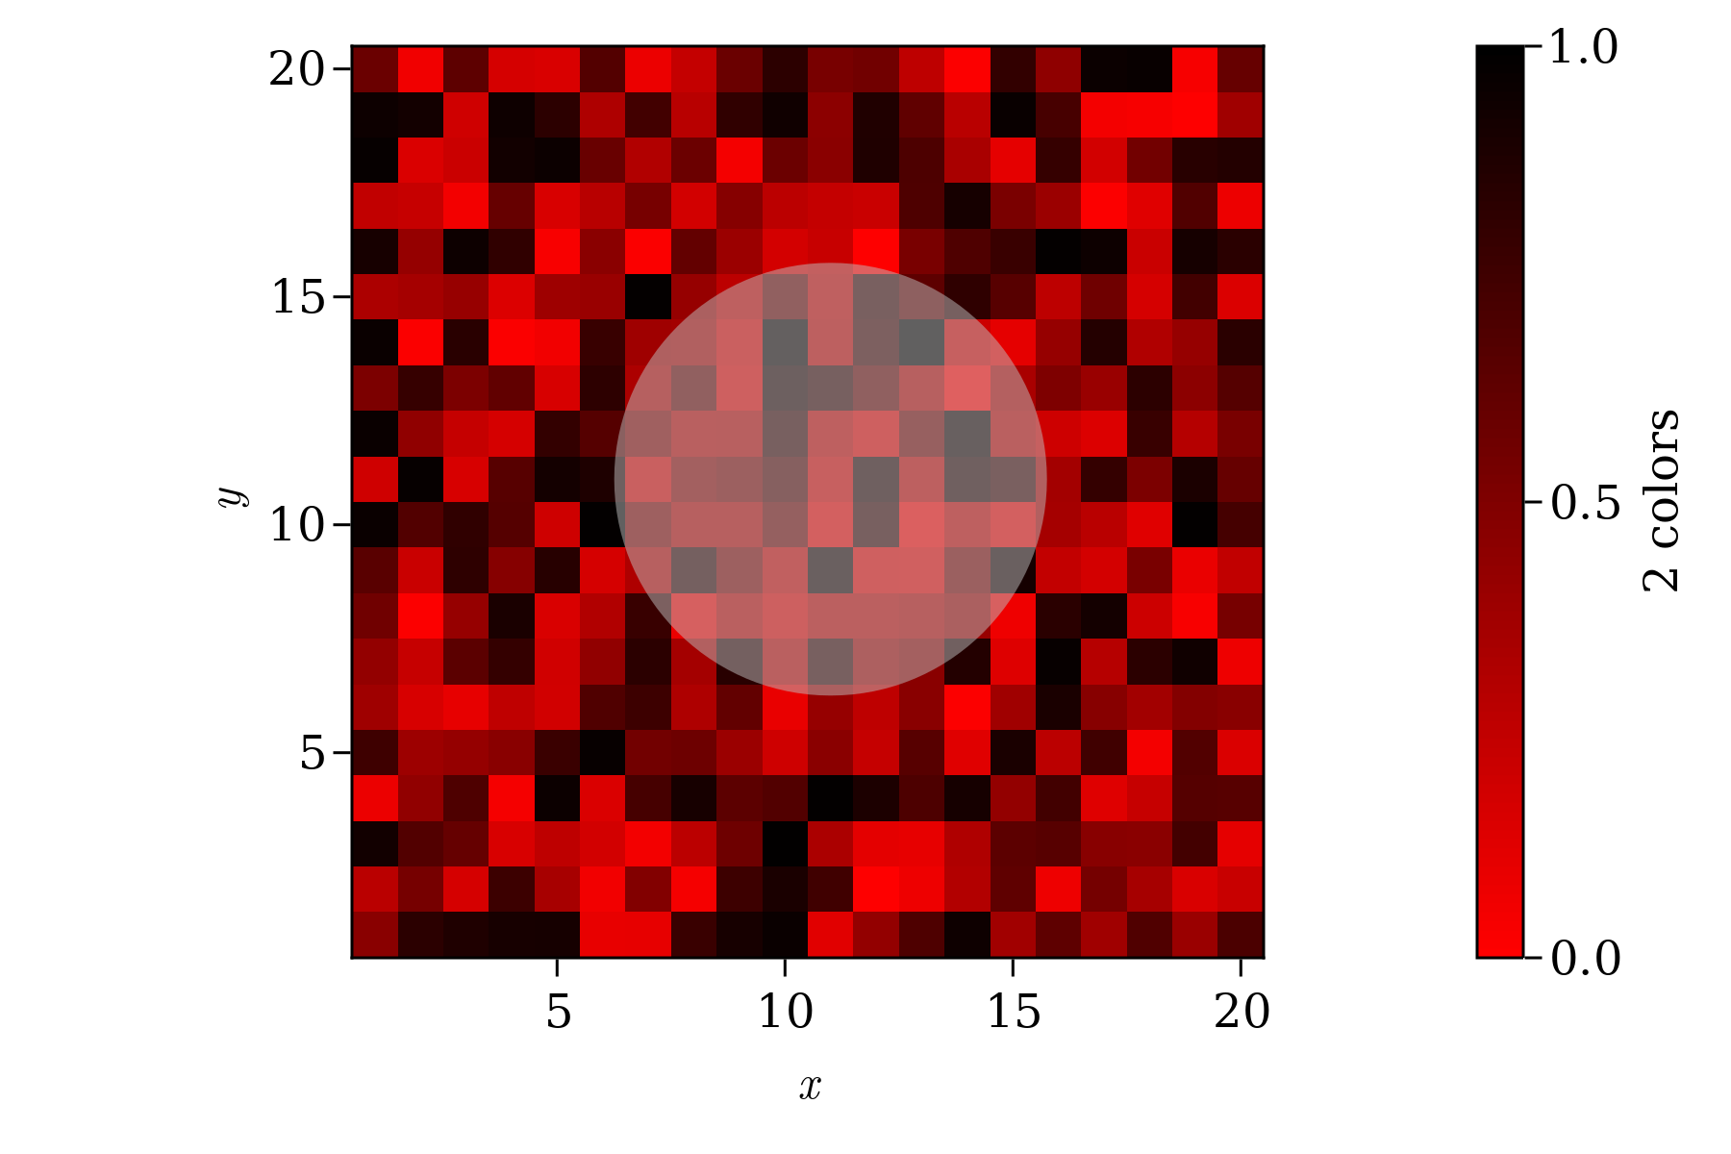

Figure 24: Colormap from two colors.

### Custom cycle

Here, we could define a global Theme with a new cycle for colors, however that is **not the recommend way** to do it. It’s better to define a new theme and use as shown before. Lets define a new one with a cycle for :color, :linestyle, :marker and a new colormap default. Lets add this new attributes to our previous publication_theme.

function new_cycle_theme()  
 # https://nanx.me/ggsci/reference/pal_locuszoom.html  
 my_colors = ["#D43F3AFF", "#EEA236FF", "#5CB85CFF", "#46B8DAFF",  
 "#357EBDFF", "#9632B8FF", "#B8B8B8FF"]  
 cycle = Cycle([:color, :linestyle, :marker], covary=true) # alltogether  
 my_markers = [:circle, :rect, :utriangle, :dtriangle, :diamond,  
 :pentagon, :cross, :xcross]  
 my_linestyle = [nothing, :dash, :dot, :dashdot, :dashdotdot]  
 Theme(  
 fontsize=16, font="CMU Serif",  
 colormap=:linear_bmy_10_95_c78_n256,  
 palette=(color=my_colors, marker=my_markers, linestyle=my_linestyle),  
 Lines=(cycle=cycle,), Scatter=(cycle=cycle,),  
 Axis=(xlabelsize=20, xgridstyle=:dash, ygridstyle=:dash,  
 xtickalign=1, ytickalign=1, yticksize=10, xticksize=10,  
 xlabelpadding=-5, xlabel="x", ylabel="y"),  
 Legend=(framecolor=(:black, 0.5), bgcolor=(:white, 0.5)),  
 Colorbar=(ticksize=16, tickalign=1, spinewidth=0.5),  
 )  
end

And apply it to a plotting function like the following:

function scatters_and_lines()  
 x = collect(0:10)  
 xh = LinRange(4, 6, 25)  
 yh = LinRange(70, 95, 25)  
 h = randn(25, 25)  
 fig = Figure(resolution=(600, 400), font="CMU Serif")  
 ax = Axis(fig[1, 1], xlabel=L"x", ylabel=L"f(x,a)")  
 for i in x  
 lines!(ax, x, i .* x; label=latexstring("$(i) x"))  
 scatter!(ax, x, i .* x; markersize=13, strokewidth=0.25,  
 label=latexstring("$(i) x"))  
 end  
 hm = heatmap!(xh, yh, h)  
 axislegend(L"f(x)"; merge=true, position=:lt, nbanks=2, labelsize=14)  
 Colorbar(fig[1, 2], hm, label="new default colormap")  
 limits!(ax, -0.5, 10.5, -5, 105)  
 colgap!(fig.layout, 5)  
 fig  
end

with_theme(scatters_and_lines, new_cycle_theme())

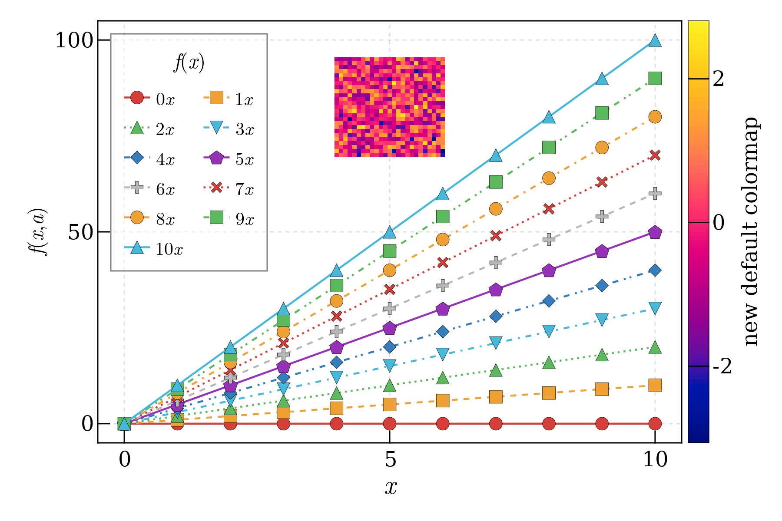

Figure 25: Custom theme with new cycle and colormap.

At this point you should be able to have **complete control** over your colors, line styles, markers and colormaps for your plots. Next, we will dive into how to manage and control **layouts**.

## Layouts

A complete *canvas/layout* is defined by Figure, which can be filled with content after creation. We will start with a simple arrangement of one Axis, one Legend and one Colorbar. For this task we can think of the canvas as an arrangement of rows and columns in indexing a Figure much like a regular Array/Matrix. The Axis content will be in *row 1, column 1*, e.g. fig[1, 1], the Colorbar in *row 1, column 2*, namely fig[1, 2]. And the Legend in *row 2* and across *column 1 and 2*, namely fig[2, 1:2].

function first_layout()  
 seed!(123)  
 x, y, z = randn(6), randn(6), randn(6)  
 fig = Figure(resolution=(600, 400), backgroundcolor=:grey90)  
 ax = Axis(fig[1, 1], backgroundcolor=:white)  
 pltobj = scatter!(ax, x, y; color=z, label="scatters")  
 lines!(ax, x, 1.1y; label="line")  
 Legend(fig[2, 1:2], ax, "labels", orientation=:horizontal)  
 Colorbar(fig[1, 2], pltobj, label="colorbar")  
 fig  
end  
first_layout()

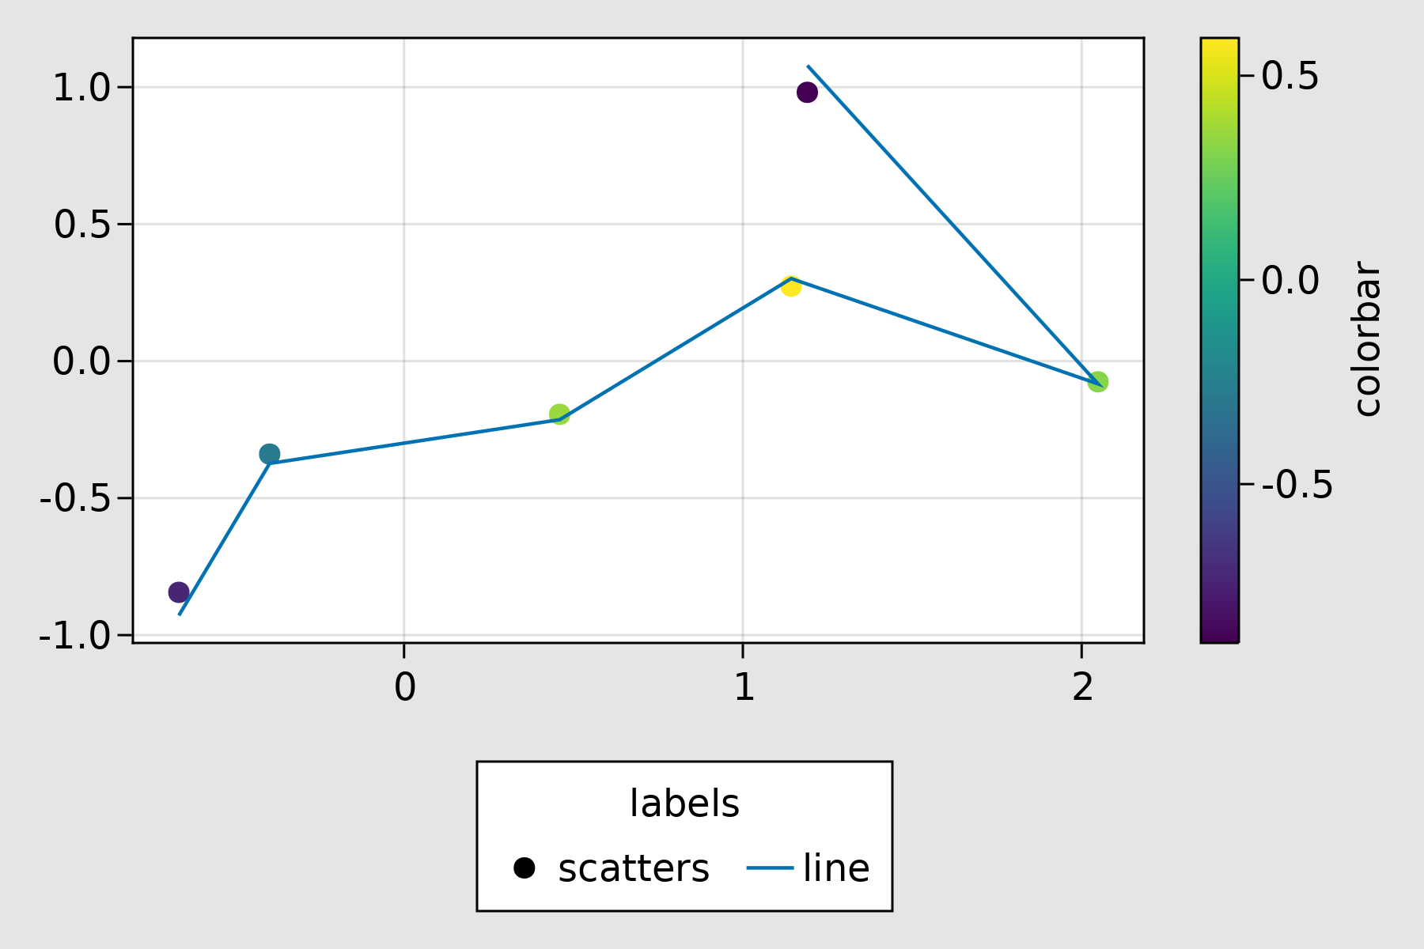

Figure 26: First Layout.

This does look good already, it could be better. We could fix spacing problems using the following keywords and methods:

* figure_padding=(left, right, bottom, top)
* padding=(left, right, bottom, top)

Taking into account the actual size for a Legend or Colorbar is done by

* tellheight=true or false
* tellwidth=true or false

*Setting these to true will take into account the actual size (height or width) for a Legend or Colorbar*. Consequently, things will be resized accordingly.

The space between columns and rows is specified as

* colgap!(fig.layout, col, separation)
* rowgap!(fig.layout, row, separation)

*Column gap* (colgap!), if col is given then the gap will be applied to that specific column. *Row gap* (rowgap!) ,if row is given then the gap will be applied to that specific row.

Also, we will see how to put content into the **protrusions**, *i.e.* the space reserved for *title: x and y; either ticks or label*. We do this by plotting into fig[i, j, protrusion] where *protrusion* can be Left(), Right(), Bottom() and Top(), or for each corner TopLeft(), TopRight(), BottomRight(), BottomLeft(). See below how these options are being used:

function first_layout_fixed()  
 seed!(123)  
 x, y, z = randn(6), randn(6), randn(6)  
 fig = Figure(figure_padding=(0, 3, 5, 2), resolution=(600, 400),  
 backgroundcolor=:grey90, font="CMU Serif")  
 ax = Axis(fig[1, 1], xlabel=L"x", ylabel=L"y",  
 title="Layout example", backgroundcolor=:white)  
 pltobj = scatter!(ax, x, y; color=z, label="scatters")  
 lines!(ax, x, 1.1y, label="line")  
 Legend(fig[2, 1:2], ax, "Labels", orientation=:horizontal,  
 tellheight=true, titleposition=:left)  
 Colorbar(fig[1, 2], pltobj, label="colorbar")  
 # additional aesthetics  
 Box(fig[1, 1, Right()], color=(:slateblue1, 0.35))  
 Label(fig[1, 1, Right()], "protrusion", textsize=18,  
 rotation=pi / 2, padding=(3, 3, 3, 3))  
 Label(fig[1, 1, TopLeft()], "(a)", textsize=18, padding=(0, 3, 8, 0))  
 colgap!(fig.layout, 5)  
 rowgap!(fig.layout, 5)  
 fig  
end  
first_layout_fixed()

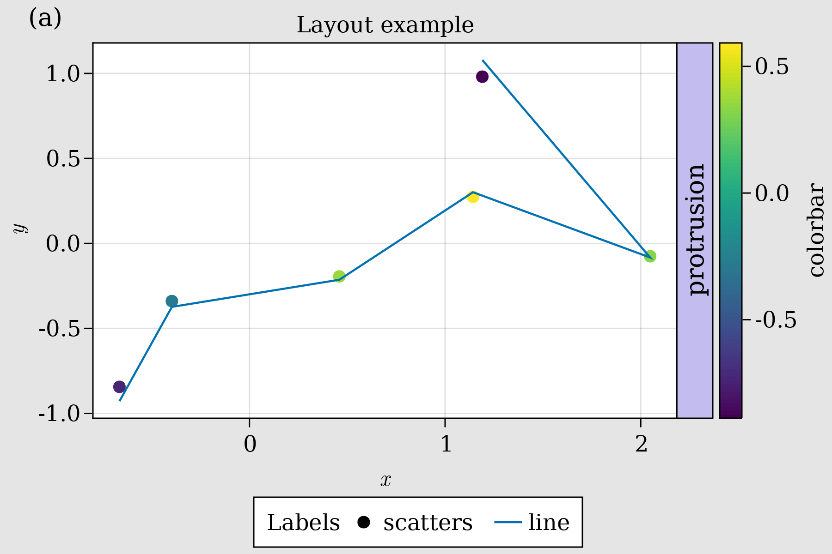

Figure 27: First Layout Fixed.

Here, having the label (a) in the TopLeft() is probably not necessary, this will only make sense for more than two plots. For our next example let’s keep using the previous tools and some more to create a richer and complex figure.

You can hide decorations and axis’ spines with:

* hidedecorations!(ax; kwargs...)
* hidexdecorations!(ax; kwargs...)
* hideydecorations!(ax; kwargs...)
* hidespines!(ax; kwargs...)

Remember, we can always ask for help to see what kind of arguments we can use, e.g.,

help(hidespines!)

hidespines!(la::Axis, spines::Symbol... = (:l, :r, :b, :t)...)  
  
 Hide all specified axis spines. Hides all spines by default, otherwise  
 choose with the symbols :l, :r, :b and :t.  
  
 hidespines! has the following function signatures:  
  
 (Vector, Vector)  
 (Vector, Vector, Vector)  
 (Matrix)  
  
 Available attributes for Combined{Makie.MakieLayout.hidespines!, T} where T  
 are:

Alternatively, for decorations

help(hidedecorations!)

hidedecorations!(la::Axis)  
  
 Hide decorations of both x and y-axis: label, ticklabels, ticks and grid.  
  
 hidedecorations! has the following function signatures:  
  
 (Vector, Vector)  
 (Vector, Vector, Vector)  
 (Matrix)  
  
 Available attributes for Combined{Makie.MakieLayout.hidedecorations!, T}  
 where T are:

For elements that **you don’t want to hide**, just pass them with false, i.e. hideydecorations!(ax; ticks=false, grid=false).

Synchronizing your Axis is done via:

* linkaxes!, linkyaxes! and linkxaxes!

This could be useful when shared axis are desired. Another way of getting shared axis will be by setting limits!.

Setting limits at once or independently for each axis is done by calling

* limits!(ax; l, r, b, t), where l is left, r right, b bottom, and t top.

You can also do ylims!(low, high) or xlims!(low, high), and even open ones by doing ylims!(low=0) or xlims!(high=1).

Now, the example:

function complex_layout_double_axis()  
 seed!(123)  
 x = LinRange(0, 1, 10)  
 y = LinRange(0, 1, 10)  
 z = rand(10, 10)  
 fig = Figure(resolution=(600, 400), font="CMU Serif", backgroundcolor=:grey90)  
 ax1 = Axis(fig, xlabel=L"x", ylabel=L"y")  
 ax2 = Axis(fig, xlabel=L"x")  
 heatmap!(ax1, x, y, z; colorrange=(0, 1))  
 series!(ax2, abs.(z[1:4, :]); labels=["lab $i" for i = 1:4], color=:Set1_4)  
 hm = scatter!(10x, y; color=z[1, :], label="dots", colorrange=(0, 1))  
 hideydecorations!(ax2, ticks=false, grid=false)  
 linkyaxes!(ax1, ax2)  
 #layout  
 fig[1, 1] = ax1  
 fig[1, 2] = ax2  
 Label(fig[1, 1, TopLeft()], "(a)", textsize=18, padding=(0, 6, 8, 0))  
 Label(fig[1, 2, TopLeft()], "(b)", textsize=18, padding=(0, 6, 8, 0))  
 Colorbar(fig[2, 1:2], hm, label="colorbar", vertical=false, flipaxis=false)  
 Legend(fig[1, 3], ax2, "Legend")  
 colgap!(fig.layout, 5)  
 rowgap!(fig.layout, 5)  
 fig  
end  
complex_layout_double_axis()

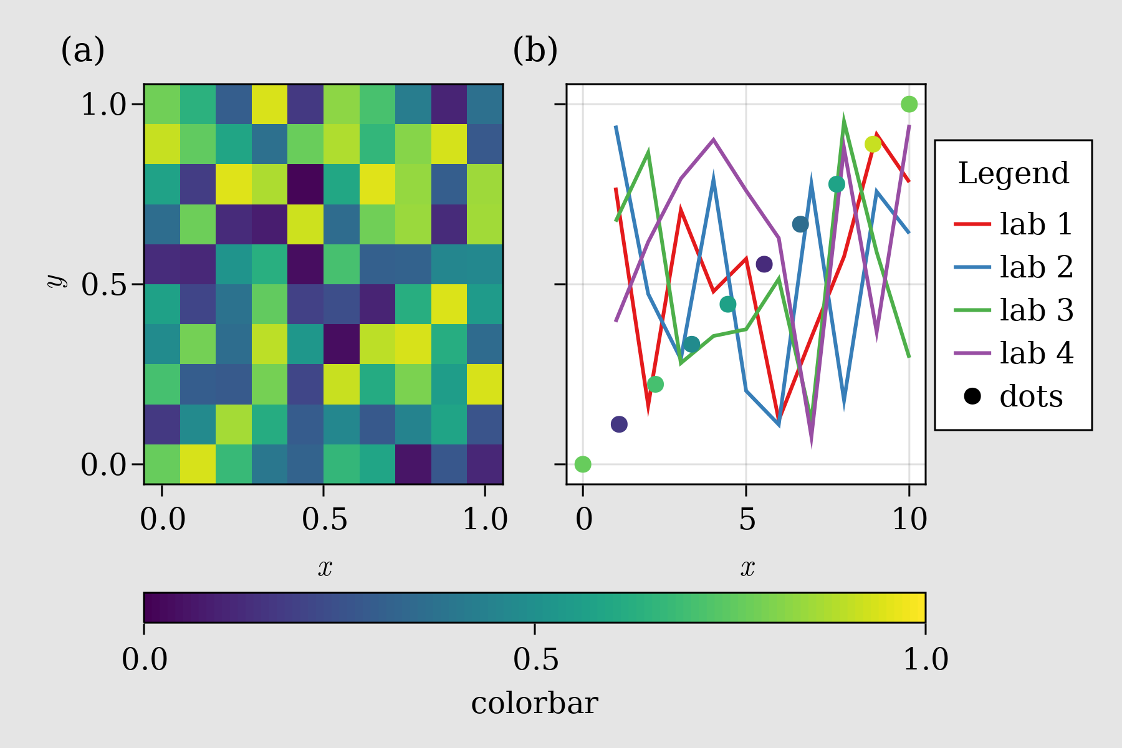

Figure 28: Complex layout double axis.

So, now our Colorbar needs to be horizontal and the bar ticks need to be in the lower part. This is done by setting vertical=false and flipaxis=false. Additionally, note that we can call many Axis into fig, or even Colorbar’s and Legend’s, and then afterwards build the layout.

Another common layout is a grid of squares for heatmaps:

function squares_layout()  
 seed!(123)  
 letters = reshape(collect('a':'d'), (2, 2))  
 fig = Figure(resolution=(600, 400), fontsize=14, font="CMU Serif",  
 backgroundcolor=:grey90)  
 axs = [Axis(fig[i, j], aspect=DataAspect()) for i = 1:2, j = 1:2]  
 hms = [heatmap!(axs[i, j], randn(10, 10), colorrange=(-2, 2))  
 for i = 1:2, j = 1:2]  
 Colorbar(fig[1:2, 3], hms[1], label="colorbar")  
 [Label(fig[i, j, TopLeft()], "($(letters[i, j]))", textsize=16,  
 padding=(-2, 0, -20, 0)) for i = 1:2, j = 1:2]  
 colgap!(fig.layout, 5)  
 rowgap!(fig.layout, 5)  
 fig  
end  
squares_layout()

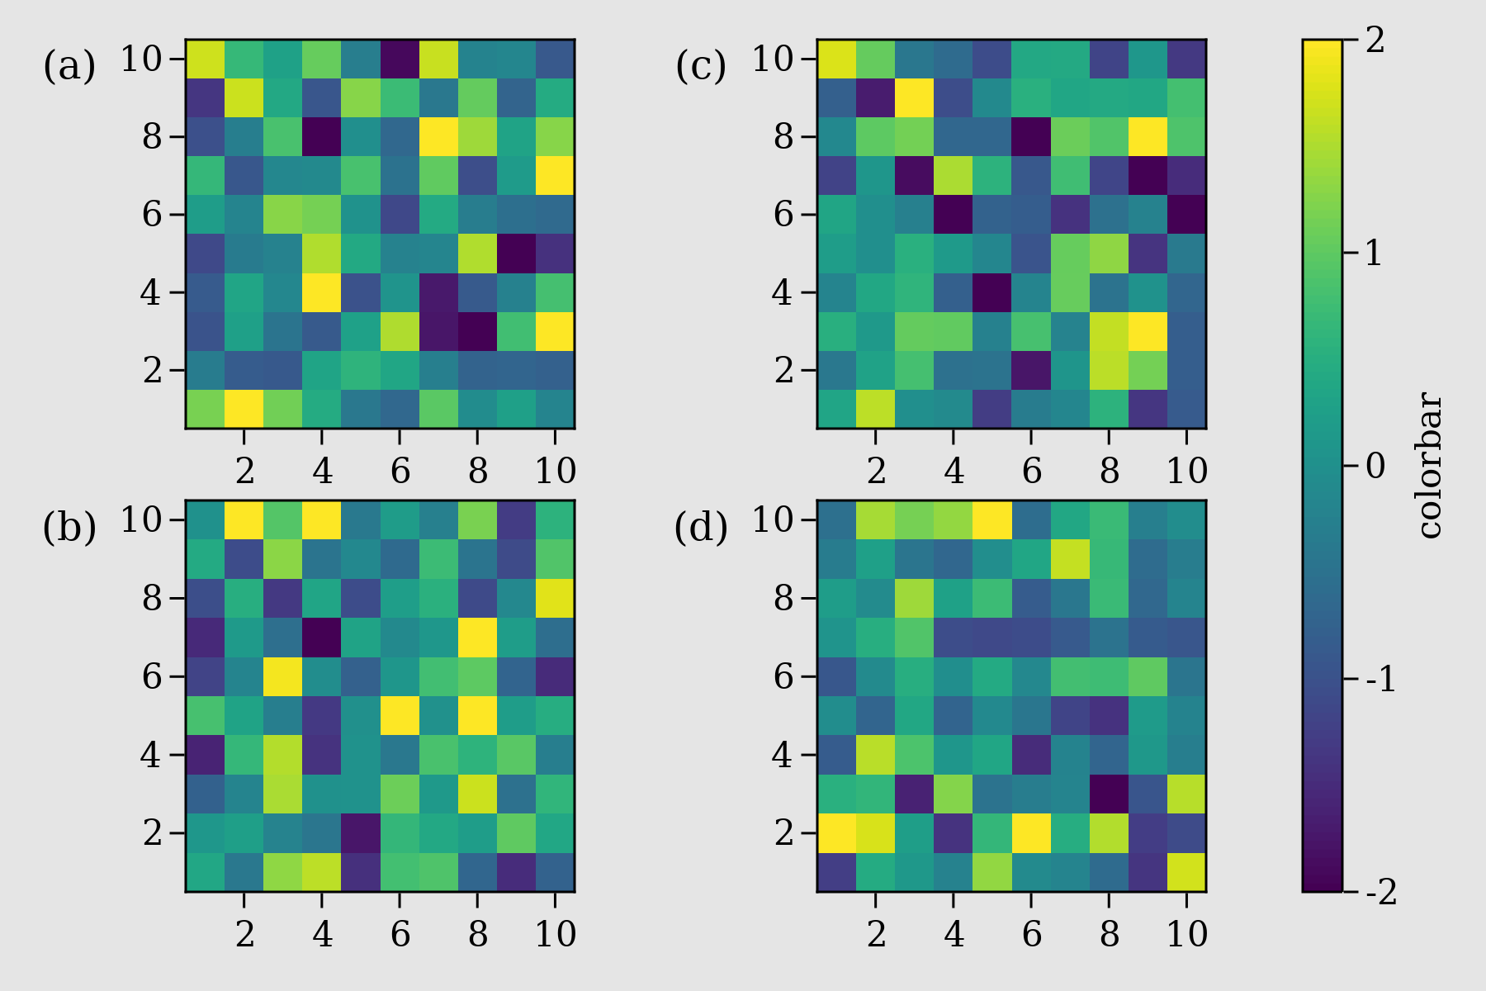

Figure 29: Squares layout.

where all labels are in the **protrusions** and each Axis has an AspectData() ratio. The Colorbar is located in the third column and expands from row 1 up to row 2.

The next case uses the so called Mixed() **alignmode**, which is especially useful when dealing with large empty spaces between Axis due to long ticks. Also, the Dates module from Julia’s standard library will be needed it for this example.

using Dates

function mixed_mode_layout()  
 seed!(123)  
 longlabels = ["$(today() - Day(1))", "$(today())", "$(today() + Day(1))"]  
 fig = Figure(resolution=(600, 400), fontsize=12,  
 backgroundcolor=:grey90, font="CMU Serif")  
 ax1 = Axis(fig[1, 1])  
 ax2 = Axis(fig[1, 2], xticklabelrotation=pi / 2, alignmode=Mixed(bottom=0),  
 xticks=([1, 5, 10], longlabels))  
 ax3 = Axis(fig[2, 1:2])  
 ax4 = Axis(fig[3, 1:2])  
 axs = [ax1, ax2, ax3, ax4]  
 [lines!(ax, 1:10, rand(10)) for ax in axs]  
 hidexdecorations!(ax3; ticks=false, grid=false)  
 Box(fig[2:3, 1:2, Right()], color=(:slateblue1, 0.35))  
 Label(fig[2:3, 1:2, Right()], "protrusion", rotation=pi / 2, textsize=14,  
 padding=(3, 3, 3, 3))  
 Label(fig[1, 1:2, Top()], "Mixed alignmode", textsize=16,  
 padding=(0, 0, 15, 0))  
 colsize!(fig.layout, 1, Auto(2))  
 rowsize!(fig.layout, 2, Auto(0.5))  
 rowsize!(fig.layout, 3, Auto(0.5))  
 rowgap!(fig.layout, 1, 15)  
 rowgap!(fig.layout, 2, 0)  
 colgap!(fig.layout, 5)  
 fig  
end  
mixed_mode_layout()

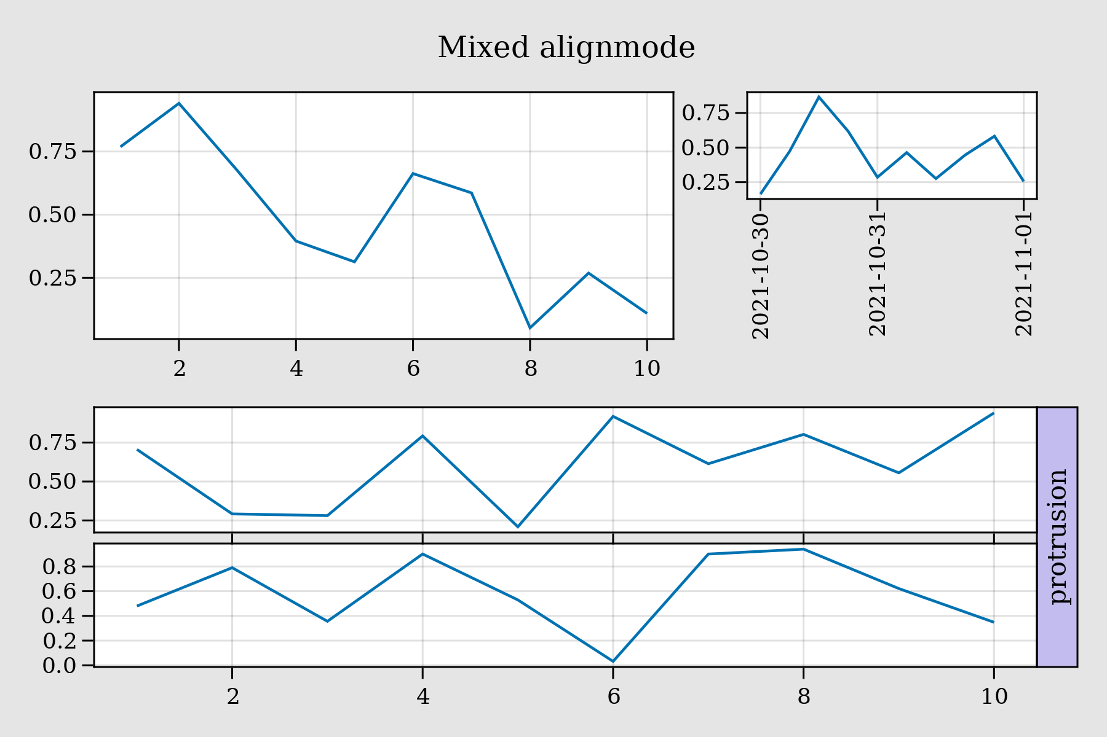

Figure 30: Mixed mode layout.

Here, the argument alignmode=Mixed(bottom=0) is shifting the bounding box to the bottom, so that this will align with the panel on the left filling the space.

Also, see how colsize! and rowsize! are being used for different columns and rows. You could also put a number instead of Auto() but then everything will be fixed. And, additionally, one could also give a height or width when defining the Axis, as in Axis(fig, heigth=50) which will be fixed as well.

### Nested Axis (*subplots*)

It is also possible to define a set of Axis (*subplots*) explicitly, and use it to build a main figure with several rows and columns. For instance, the following its a “complicated” arrangement of Axis:

function nested_sub_plot!(fig)  
 color = rand(RGBf0)  
 ax1 = Axis(fig[1, 1], backgroundcolor=(color, 0.25))  
 ax2 = Axis(fig[1, 2], backgroundcolor=(color, 0.25))  
 ax3 = Axis(fig[2, 1:2], backgroundcolor=(color, 0.25))  
 ax4 = Axis(fig[1:2, 3], backgroundcolor=(color, 0.25))  
 return (ax1, ax2, ax3, ax4)  
end

which, when used to build a more complex figure by doing several calls, we obtain:

function main_figure()  
 fig = Figure()  
 Axis(fig[1, 1])  
 nested_sub_plot!(fig[1, 2])  
 nested_sub_plot!(fig[1, 3])  
 nested_sub_plot!(fig[2, 1:3])  
 fig  
end  
main_figure()

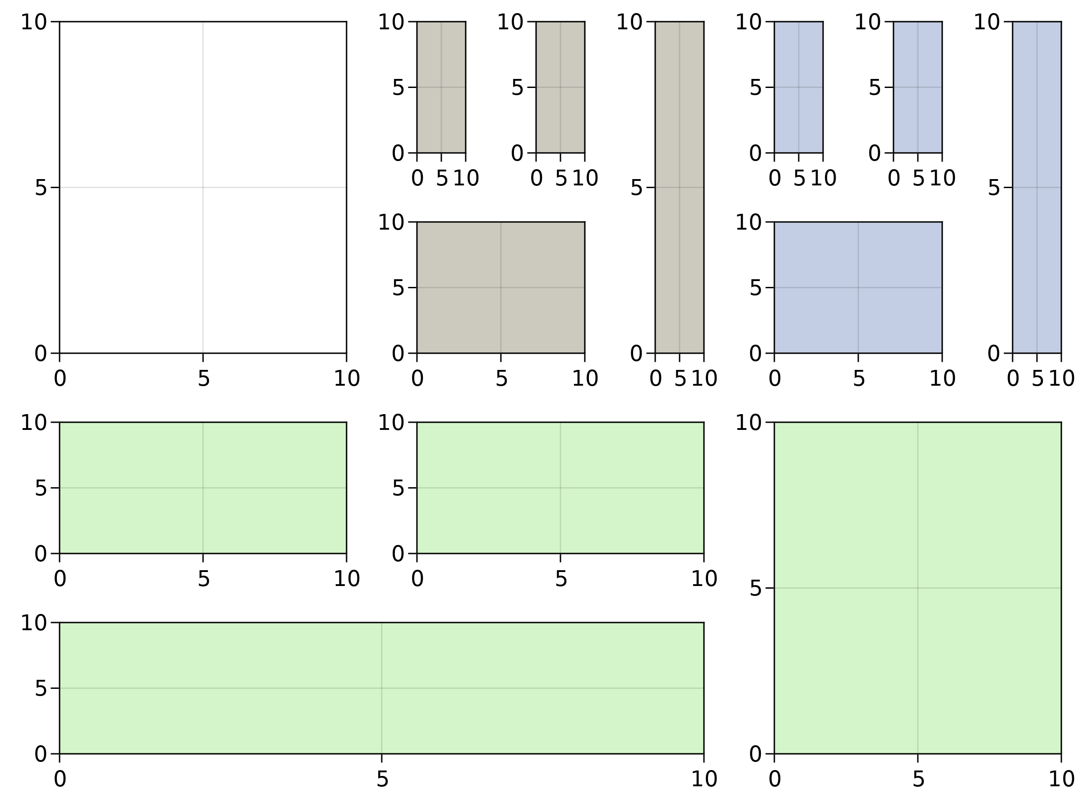

Figure 31: Main figure.

Note that different subplot functions can be called here. Also, each Axis here is an independent part of Figure. So that, if you need to do some rowgap!’s or colsize!’s operations, you will need to do it in each one of them independently or to all of them together.

For grouped Axis (*subplots*) we can use GridLayout() which, then, could be used to composed a more complicated Figure.

### Nested GridLayout

By using GridLayout() we can group subplots, allowing more freedom to build complex figures. Here, using our previous nested_sub_plot! we define three sub-groups and one normal Axis:

function nested_Grid_Layouts()  
 fig = Figure(backgroundcolor=RGBf0(0.96, 0.96, 0.96))  
 ga = fig[1, 1] = GridLayout()  
 gb = fig[1, 2] = GridLayout()  
 gc = fig[1, 3] = GridLayout()  
 gd = fig[2, 1:3] = GridLayout()  
 gA = Axis(ga[1, 1])  
 nested_sub_plot!(gb)  
 axsc = nested_sub_plot!(gc)  
 nested_sub_plot!(gd)  
 [hidedecorations!(axsc[i], grid=false, ticks=false) for i = 1:length(axsc)]  
 colgap!(gc, 5)  
 rowgap!(gc, 5)  
 rowsize!(fig.layout, 2, Auto(0.5))  
 colsize!(fig.layout, 1, Auto(0.5))  
 fig  
end  
nested_Grid_Layouts()

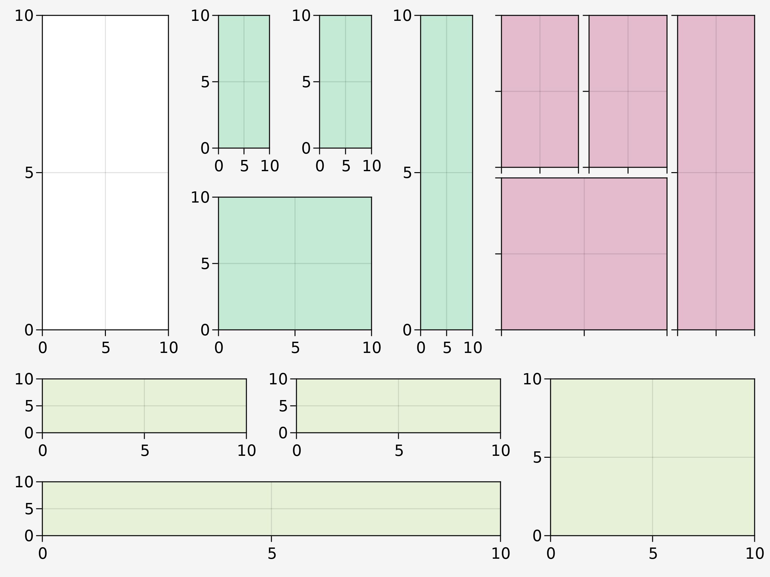

Figure 32: Nested Grid Layouts.

Now, using rowgap! or colsize! over each group is possible and rowsize!, colsize! can also be applied to the set of GridLayout()s.

### Inset plots

Currently, doing inset plots is a little bit tricky. Here, we show two possible ways of doing it by initially defining auxiliary functions. The first one is by doing a BBox, which lives in the whole Figure space:

function add_box_inset(fig; left=100, right=250, bottom=200, top=300,  
 bgcolor=:grey90)  
 inset_box = Axis(fig, bbox=BBox(left, right, bottom, top),  
 xticklabelsize=12, yticklabelsize=12, backgroundcolor=bgcolor)  
 # bring content upfront  
 translate!(inset_box.scene, 0, 0, 10)  
 elements = keys(inset_box.elements)  
 filtered = filter(ele -> ele != :xaxis && ele != :yaxis, elements)  
 foreach(ele -> translate!(inset_box.elements[ele], 0, 0, 9), filtered)  
 return inset_box  
end

Then, the inset is easily done, as in:

function figure_box_inset()  
 fig = Figure(resolution=(600, 400))  
 ax = Axis(fig[1, 1], backgroundcolor=:white)  
 inset_ax1 = add_box_inset(fig; left=100, right=250, bottom=200, top=300,  
 bgcolor=:grey90)  
 inset_ax2 = add_box_inset(fig; left=500, right=600, bottom=100, top=200,  
 bgcolor=(:white, 0.65))  
 lines!(ax, 1:10)  
 lines!(inset_ax1, 1:10)  
 scatter!(inset_ax2, 1:10, color=:black)  
 fig  
end  
figure_box_inset()

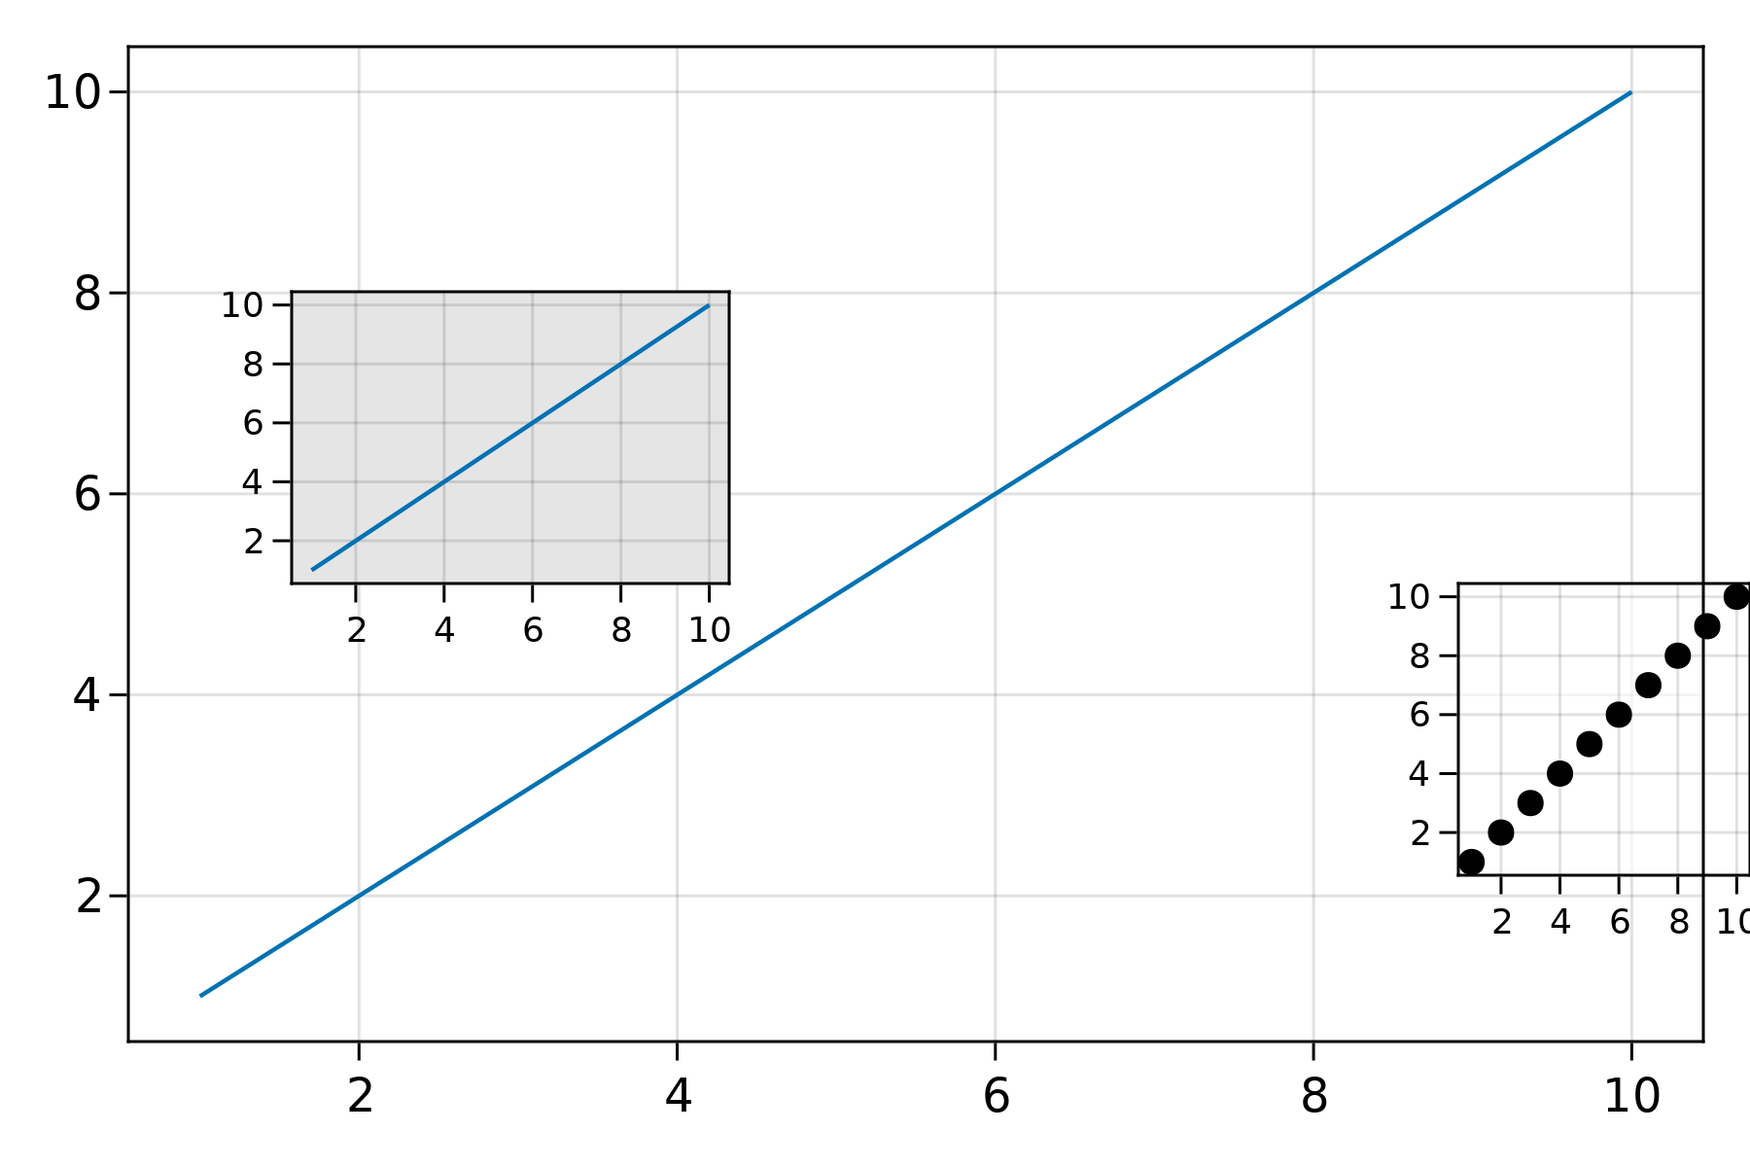

Figure 33: Figure box inset.

where the Box dimensions are bound by the Figure’s resolution. Note, that an inset can be also outside the Axis. The other approach, is by defining a new Axis into a position fig[i, j] specifying his width, height, halign and valign. We do that in the following function:

function add_axis_inset(; pos=fig[1, 1], halign=0.1, valign=0.5,  
 width=Relative(0.5), height=Relative(0.35), bgcolor=:lightgray)  
 inset_box = Axis(pos, width=width, height=height,  
 halign=halign, valign=valign, xticklabelsize=12, yticklabelsize=12,  
 backgroundcolor=bgcolor)  
 # bring content upfront  
 translate!(inset_box.scene, 0, 0, 10)  
 elements = keys(inset_box.elements)  
 filtered = filter(ele -> ele != :xaxis && ele != :yaxis, elements)  
 foreach(ele -> translate!(inset_box.elements[ele], 0, 0, 9), filtered)  
 return inset_box  
end

See that in the following example the Axis with gray background will be rescaled if the total figure size changes. The *insets* are bound by the Axis positioning.

function figure_axis_inset()  
 fig = Figure(resolution=(600, 400))  
 ax = Axis(fig[1, 1], backgroundcolor=:white)  
 inset_ax1 = add_axis_inset(; pos=fig[1, 1], halign=0.1, valign=0.65,  
 width=Relative(0.3), height=Relative(0.3), bgcolor=:grey90)  
 inset_ax2 = add_axis_inset(; pos=fig[1, 1], halign=1, valign=0.25,  
 width=Relative(0.25), height=Relative(0.3), bgcolor=(:white, 0.65))  
 lines!(ax, 1:10)  
 lines!(inset_ax1, 1:10)  
 scatter!(inset_ax2, 1:10, color=:black)  
 fig  
end  
figure_axis_inset()

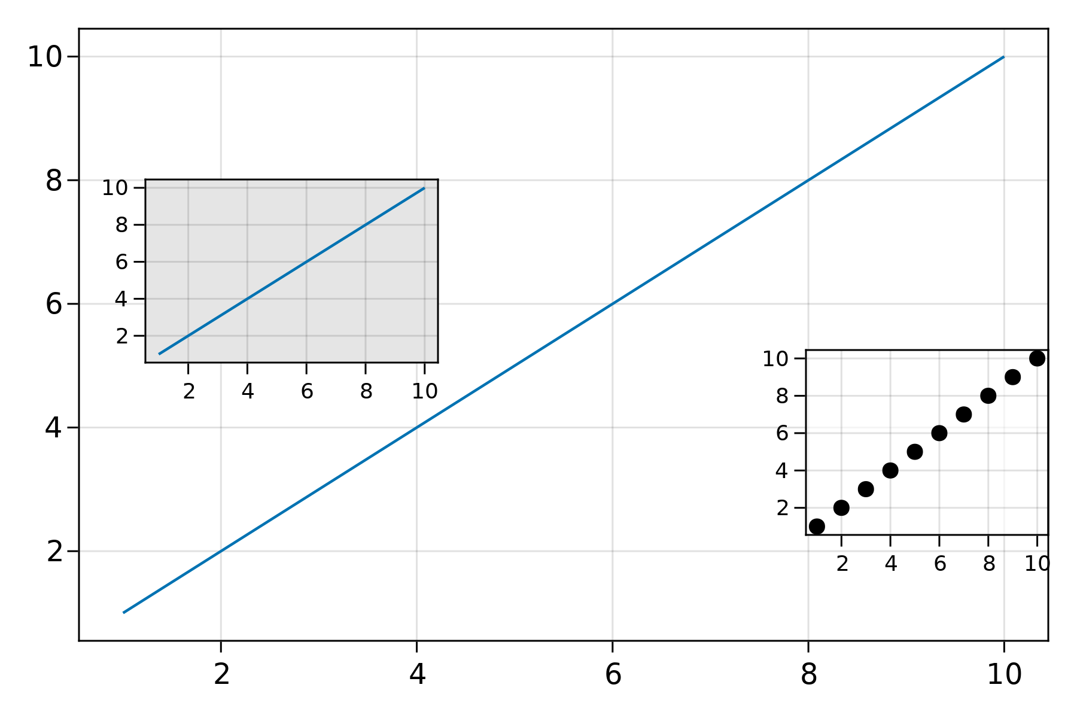

Figure 34: Figure axis inset.

And this should cover most used cases for layouting with Makie. Now, let’s do some nice 3D examples with GLMakie.jl.

## GLMakie.jl

CairoMakie.jl supplies all our needs for static 2D images. But sometimes we want interactivity, especially when we are dealing with 3D images. Visualizing data in 3D is also a common practice to gain insight from your data. This is where GLMakie.jl might be helpful, since it uses [OpenGL](http://www.opengl.org/) as a backend that adds interactivity and responsiveness to plots. Like before, a simple plot includes, of course, lines and points. So, we will start with those and since we already know how layouts work, we will put that into practice.

### Scatters and Lines

For scatter plots we have two options, the first one is scatter(x, y, z) and the second one is meshscatter(x, y, z). In the first one markers don’t scale in the axis directions, but in the later they do because they are actual geometries in 3D space. See the next example:

using GLMakie  
GLMakie.activate!()

function scatters_in_3D()  
 seed!(123)  
 xyz = randn(10, 3)  
 x, y, z = xyz[:, 1], xyz[:, 2], xyz[:, 3]  
 fig = Figure(resolution=(1600, 400))  
 ax1 = Axis3(fig[1, 1]; aspect=(1, 1, 1), perspectiveness=0.5)  
 ax2 = Axis3(fig[1, 2]; aspect=(1, 1, 1), perspectiveness=0.5)  
 ax3 = Axis3(fig[1, 3]; aspect=:data, perspectiveness=0.5)  
 scatter!(ax1, x, y, z; markersize=50)  
 meshscatter!(ax2, x, y, z; markersize=0.25)  
 hm = meshscatter!(ax3, x, y, z; markersize=0.25,  
 marker=FRect3D(Vec3f(0), Vec3f(1)), color=1:size(xyz)[2],  
 colormap=:plasma, transparency=false)  
 Colorbar(fig[1, 4], hm, label="values", height=Relative(0.5))  
 fig  
end  
scatters_in_3D()

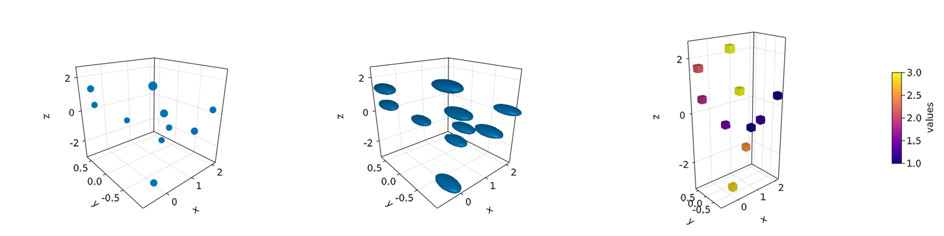

Figure 35: Scatters in 3D.

Note also, that a different geometry can be passed as markers, i.e., a square/rectangle and we can assign a colormap for them as well. In the middle panel one could get perfect spheres by doing aspect = :data as in the right panel.

And doing lines or scatterlines is also straightforward:

function lines_in_3D()  
 seed!(123)  
 xyz = randn(10, 3)  
 x, y, z = xyz[:, 1], xyz[:, 2], xyz[:, 3]  
 fig = Figure(resolution=(1600, 400))  
 ax1 = Axis3(fig[1, 1]; aspect=(1, 1, 1), perspectiveness=0.5)  
 ax2 = Axis3(fig[1, 2]; aspect=(1, 1, 1), perspectiveness=0.5)  
 ax3 = Axis3(fig[1, 3]; aspect=:data, perspectiveness=0.5)  
 lines!(ax1, x, y, z; color=1:size(xyz)[2], linewidth=3)  
 scatterlines!(ax2, x, y, z; markersize=50)  
 hm = meshscatter!(ax3, x, y, z; markersize=0.2, color=1:size(xyz)[2])  
 lines!(ax3, x, y, z; color=1:size(xyz)[2])  
 Colorbar(fig[2, 1], hm; label="values", height=15, vertical=false,  
 flipaxis=false, ticksize=15, tickalign=1, width=Relative(3.55 / 4))  
 fig  
end  
lines_in_3D()

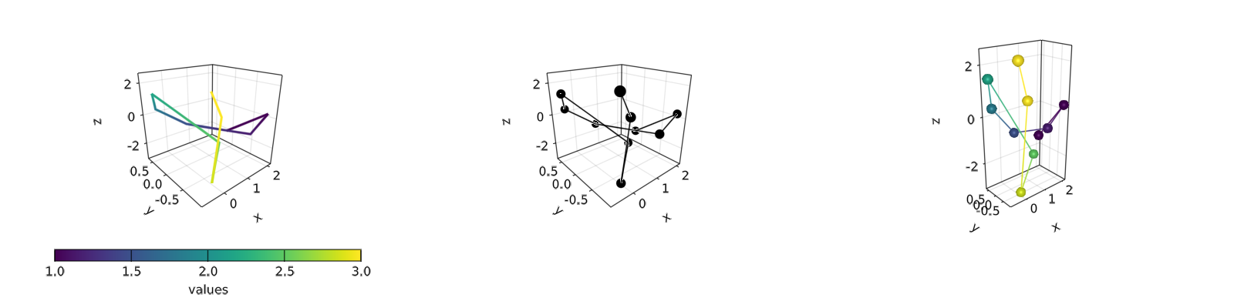

Figure 36: Lines in 3D.

Plotting a surface is also easy to do as well as a wireframe and contour lines in 3D.

### Surfaces, wireframe, contour, contourf and contour3d

To show these cases we’ll use the following peaks function:

function peaks(; n=49)  
 x = LinRange(-3, 3, n)  
 y = LinRange(-3, 3, n)  
 a = 3 * (1 .- x') .^ 2 .* exp.(-(x' .^ 2) .- (y .+ 1) .^ 2)  
 b = 10 * (x' / 5 .- x' .^ 3 .- y .^ 5) .* exp.(-x' .^ 2 .- y .^ 2)  
 c = 1 / 3 * exp.(-(x' .+ 1) .^ 2 .- y .^ 2)  
 return (x, y, a .- b .- c)  
end

The output for the different plotting functions is

function plot_peaks_function()  
 x, y, z = peaks()  
 x2, y2, z2 = peaks(; n=15)  
 fig = Figure(resolution=(1600, 400), fontsize=26)  
 axs = [Axis3(fig[1, i]; aspect=(1, 1, 1)) for i = 1:3]  
 hm = surface!(axs[1], x, y, z)  
 wireframe!(axs[2], x2, y2, z2)  
 contour3d!(axs[3], x, y, z; levels=20)  
 Colorbar(fig[1, 4], hm, height=Relative(0.5))  
 fig  
end  
plot_peaks_function()

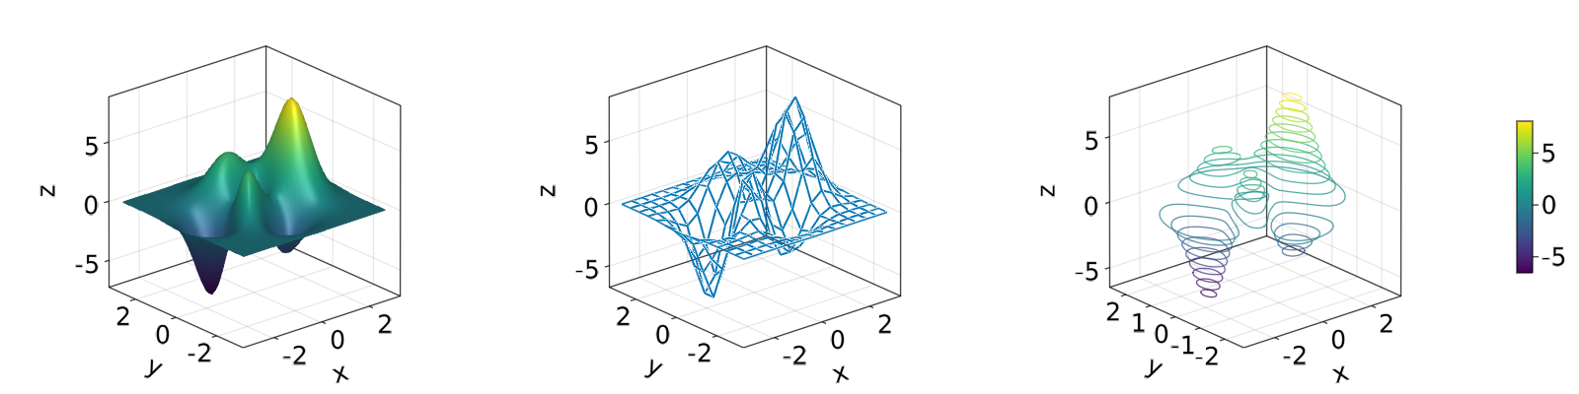

Figure 37: Plot peaks function.

But, it can also be plotted with a heatmap(x, y, z), contour(x, y, z) or contourf(x, y, z):

function heatmap_contour_and_contourf()  
 x, y, z = peaks()  
 fig = Figure(resolution=(1600, 400), fontsize=26)  
 axs = [Axis(fig[1, i]; aspect=DataAspect()) for i = 1:3]  
 hm = heatmap!(axs[1], x, y, z)  
 contour!(axs[2], x, y, z; levels=20)  
 contourf!(axs[3], x, y, z)  
 Colorbar(fig[1, 4], hm, height=Relative(0.5))  
 fig  
end  
heatmap_contour_and_contourf()

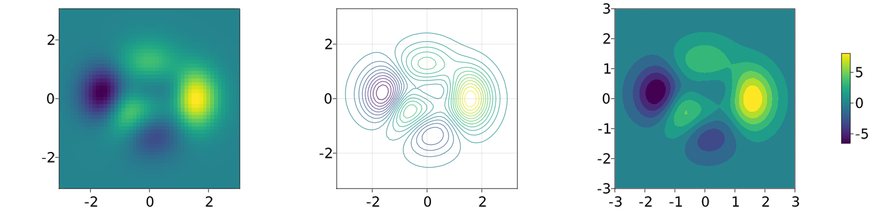

Figure 38: Heatmap contour and contourf.

Additionally, by changing Axis to an Axis3, these plots will be automatically be in the x-y plane:

function heatmap_contour_and_contourf_in_a_3d_plane()  
 x, y, z = peaks()  
 fig = Figure(resolution=(1600, 400), fontsize=26)  
 axs = [Axis3(fig[1, i]) for i = 1:3]  
 hm = heatmap!(axs[1], x, y, z)  
 contour!(axs[2], x, y, z; levels=20)  
 contourf!(axs[3], x, y, z)  
 Colorbar(fig[1, 4], hm, height=Relative(0.5))  
 fig  
end  
heatmap_contour_and_contourf_in_a_3d_plane()

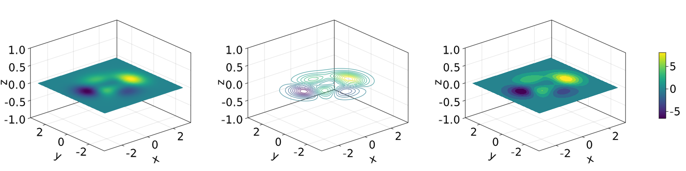

Figure 39: Heatmap contour and contourf in a 3d plane.

Something else that is easy to do is to mix all these plotting functions into just one plot, namely:

using TestImages

function mixing_surface_contour3d_contour_and_contourf()  
 img = testimage("coffee.png")  
 x, y, z = peaks()  
 cmap = :Spectral_11  
 fig = Figure(resolution=(1200, 800), fontsize=26)  
 ax1 = Axis3(fig[1, 1]; aspect=(1, 1, 1), elevation=pi / 6, xzpanelcolor=(:black, 0.75),  
 perspectiveness=0.5, yzpanelcolor=:black, zgridcolor=:grey70,  
 ygridcolor=:grey70, xgridcolor=:grey70)  
 ax2 = Axis3(fig[1, 3]; aspect=(1, 1, 1), elevation=pi / 6, perspectiveness=0.5)  
 hm = surface!(ax1, x, y, z; colormap=(cmap, 0.95), shading=true)  
 contour3d!(ax1, x, y, z .+ 0.02; colormap=cmap, levels=20, linewidth=2)  
 xmin, ymin, zmin = minimum(ax1.finallimits[])  
 xmax, ymax, zmax = maximum(ax1.finallimits[])  
 contour!(ax1, x, y, z; colormap=cmap, levels=20, transformation=(:xy, zmax))  
 contourf!(ax1, x, y, z; colormap=cmap, transformation=(:xy, zmin))  
 Colorbar(fig[1, 2], hm, width=15, ticksize=15, tickalign=1, height=Relative(0.35))  
 # transformations into planes  
 heatmap!(ax2, x, y, z; colormap=:viridis, transformation=(:yz, 3.5))  
 contourf!(ax2, x, y, z; colormap=:CMRmap, transformation=(:xy, -3.5))  
 contourf!(ax2, x, y, z; colormap=:bone_1, transformation=(:xz, 3.5))  
 image!(ax2, -3 .. 3, -3 .. 2, rotr90(img); transformation=(:xy, 3.8))  
 xlims!(ax2, -3.8, 3.8)  
 ylims!(ax2, -3.8, 3.8)  
 zlims!(ax2, -3.8, 3.8)  
 fig  
end  
mixing_surface_contour3d_contour_and_contourf()

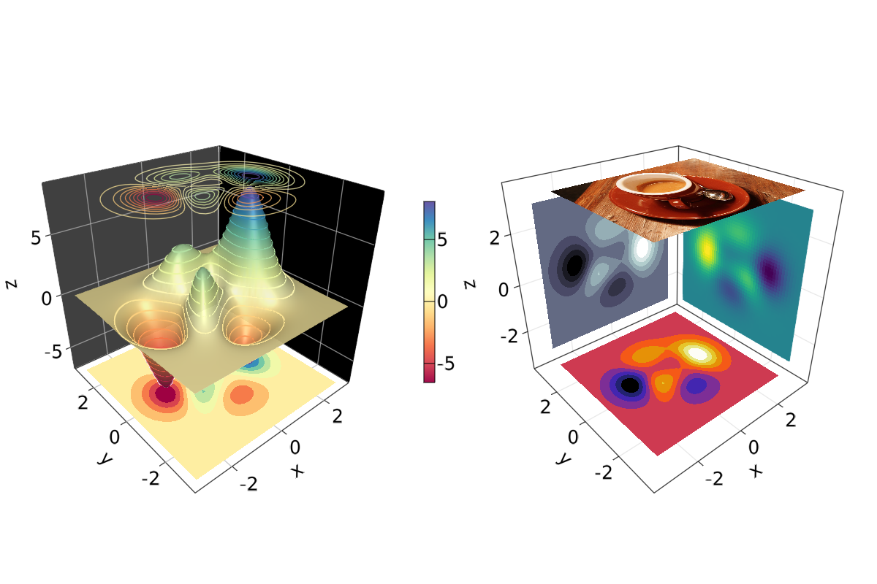

Figure 40: Mixing surface, contour3d, contour and contourf.

Not bad, right? From there is clear that any heatmap’s, contour’s, contourf’s or image can be plotted into any plane.

### Arrows and Streamplots

arrows and streamplot are plots that might be useful when we want to know the directions that a given variable will follow. See a demonstration below[18]:

using LinearAlgebra

function arrows_and_streamplot_in_3d()  
 ps = [Point3f(x, y, z) for x = -3:1:3 for y = -3:1:3 for z = -3:1:3]  
 ns = map(p -> 0.1 * rand() * Vec3f(p[2], p[3], p[1]), ps)  
 lengths = norm.(ns)  
 flowField(x, y, z) = Point(-y + x * (-1 + x^2 + y^2)^2, x + y * (-1 + x^2 + y^2)^2,  
 z + x * (y - z^2))  
 fig = Figure(resolution=(1200, 800), fontsize=26)  
 axs = [Axis3(fig[1, i]; aspect=(1, 1, 1), perspectiveness=0.5) for i = 1:2]  
 arrows!(axs[1], ps, ns, color=lengths, arrowsize=Vec3f0(0.2, 0.2, 0.3),  
 linewidth=0.1)  
 streamplot!(axs[2], flowField, -4 .. 4, -4 .. 4, -4 .. 4, colormap=:plasma,  
 gridsize=(7, 7), arrow_size=0.25, linewidth=1)  
 fig  
end  
arrows_and_streamplot_in_3d()

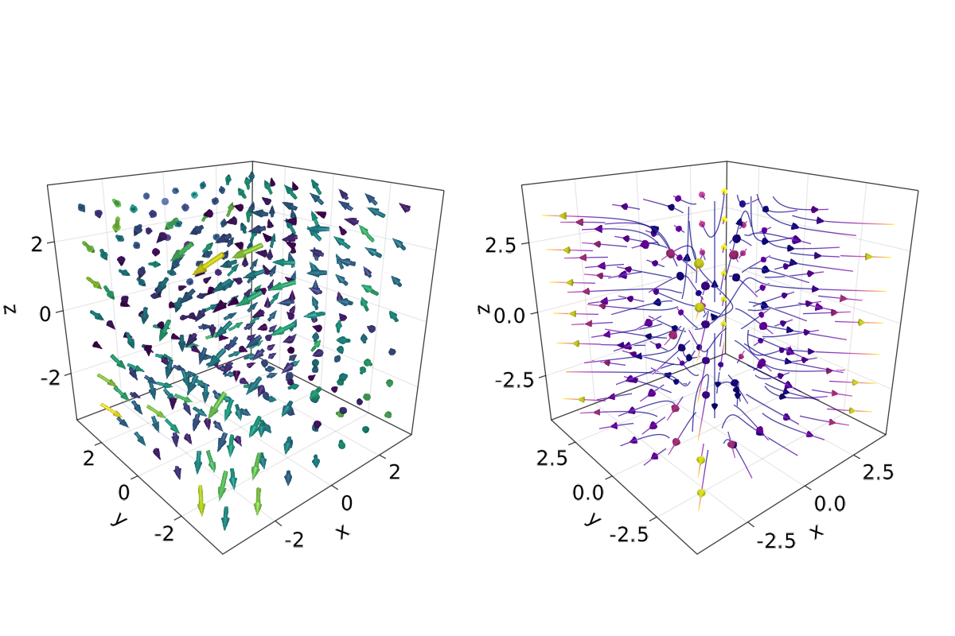

Figure 41: Arrows and streamplot in 3d.

Other interesting examples are a mesh(obj), a volume(x, y, z, vals), and a contour(x, y, z, vals).

### Meshes and Volumes

Drawing Meshes comes in handy when you want to plot geometries, like a Sphere or a Rectangle, i. e. FRect3D. Another approach to visualize points in 3D space is by calling the functions volume and contour, which implements [ray tracing](https://en.wikipedia.org/wiki/Ray_tracing_(graphics)) to simulate a wide variety of optical effects. See the next examples:

using GeometryBasics

function mesh_volume_contour()  
 # mesh objects  
 rectMesh = FRect3D(Vec3f(-0.5), Vec3f(1))  
 recmesh = GeometryBasics.mesh(rectMesh)  
 sphere = Sphere(Point3f(0), 1)  
 # https://juliageometry.github.io/GeometryBasics.jl/stable/primitives/  
 spheremesh = GeometryBasics.mesh(Tesselation(sphere, 64))  
 # uses 64 for tesselation, a smoother sphere  
 colors = [rand() for v in recmesh.position]  
 # cloud points for volume  
 x = y = z = 1:10  
 vals = randn(10, 10, 10)  
 fig = Figure(resolution=(1600, 400))  
 axs = [Axis3(fig[1, i]; aspect=(1, 1, 1), perspectiveness=0.5) for i = 1:3]  
 mesh!(axs[1], recmesh; color=colors, colormap=:rainbow, shading=false)  
 mesh!(axs[1], spheremesh; color=(:white, 0.25), transparency=true)  
 volume!(axs[2], x, y, z, vals; colormap=Reverse(:plasma))  
 contour!(axs[3], x, y, z, vals; colormap=Reverse(:plasma))  
 fig  
end  
mesh_volume_contour()

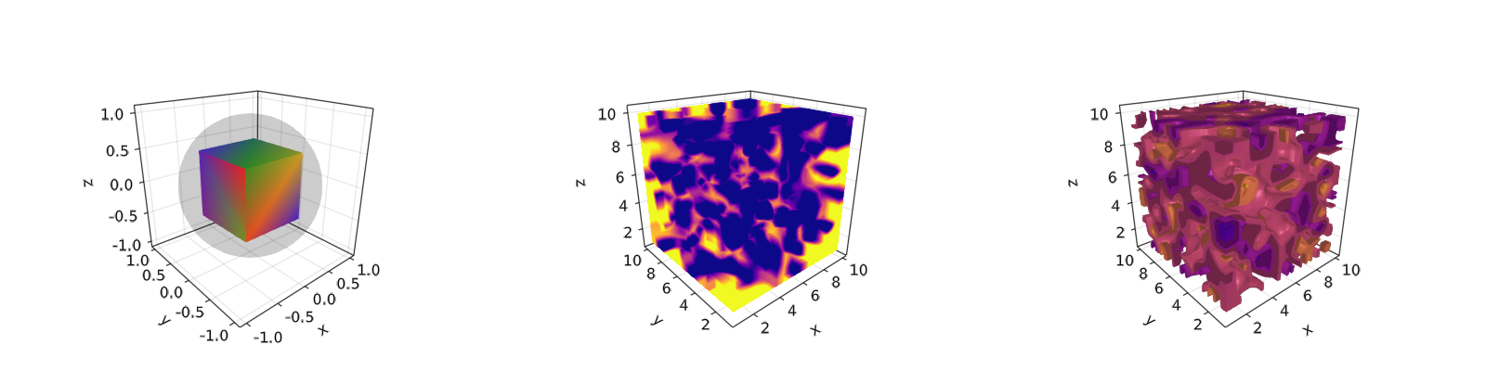

Figure 42: Mesh volume contour.

Note that here we are plotting two meshes in the same axis, one transparent sphere and a cube. So far, we have covered most of the 3D use-cases. Another example is ?linesegments.

Taking as reference the previous example one can do the following custom plot with spheres and rectangles:

using GeometryBasics, Colors

For the spheres let’s do a rectangular grid. Also, we will use a different color for each one of them. Additionally, we can mix spheres and a rectangular plane. Next, we define all the necessary data.

seed!(123)  
spheresGrid = [Point3f(i,j,k) for i in 1:2:10 for j in 1:2:10 for k in 1:2:10]  
colorSphere = [RGBA(i * 0.1, j * 0.1, k * 0.1, 0.75) for i in 1:2:10 for j in 1:2:10 for k in 1:2:10]  
spheresPlane = [Point3f(i,j,k) for i in 1:2.5:20 for j in 1:2.5:10 for k in 1:2.5:4]  
cmap = get(colorschemes[:plasma], LinRange(0, 1, 50))  
colorsPlane = cmap[rand(1:50,50)]  
rectMesh = FRect3D(Vec3f(-1, -1, 2.1), Vec3f(22, 11, 0.5))  
recmesh = GeometryBasics.mesh(rectMesh)  
colors = [RGBA(rand(4)...) for v in recmesh.position]

Then, the plot is simply done with:

function grid_spheres_and_rectangle_as_plate()  
 fig = with_theme(theme_dark()) do  
 fig = Figure(resolution=(1200, 800))  
 ax1 = Axis3(fig[1, 1]; aspect=:data, perspectiveness=0.5, azimuth=0.72)  
 ax2 = Axis3(fig[1, 2]; aspect=:data, perspectiveness=0.5)  
 meshscatter!(ax1, spheresGrid; color = colorSphere, markersize = 1,  
 shading=false)  
 meshscatter!(ax2, spheresPlane; color=colorsPlane, markersize = 0.75,  
 lightposition=Vec3f(10, 5, 2), ambient=Vec3f(0.95, 0.95, 0.95),  
 backlight=1.0f0)  
 mesh!(recmesh; color=colors, colormap=:rainbow, shading=false)  
 limits!(ax1, 0, 10, 0, 10, 0, 10)  
 fig  
 end  
 fig  
end  
grid_spheres_and_rectangle_as_plate()

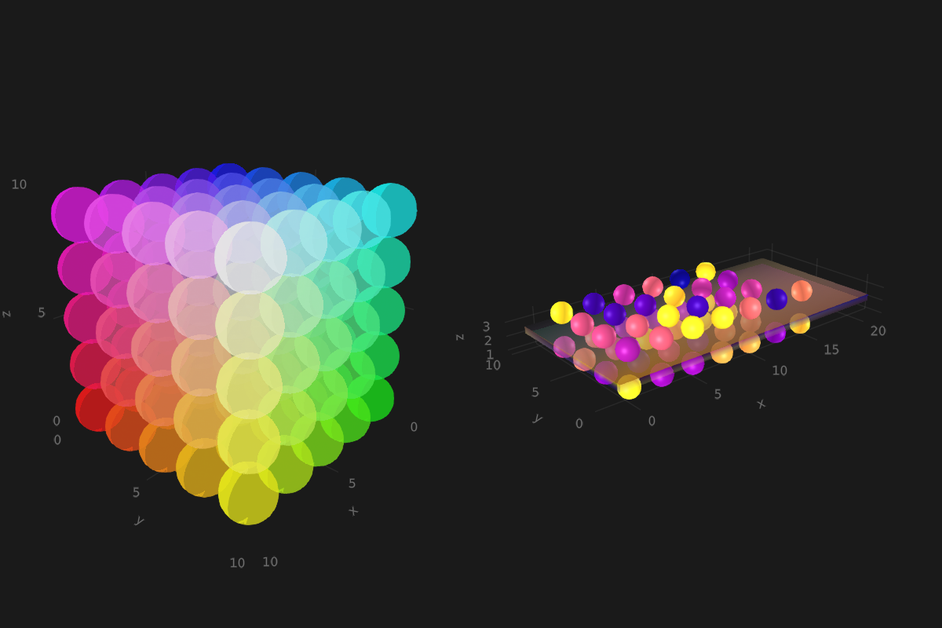

Figure 43: Grid spheres and rectangle as plate.

Here, the rectangle is semi-transparent due to the alpha channel added to the RGB color. The rectangle function is quite versatile, for instance 3D boxes are easy do implement which in turn could be used for plotting a 3D histogram. See our next example, where we are using again our peaks function and some additional definitions:

x, y, z = peaks(; n=15)  
δx = (x[2] - x[1]) / 2  
δy = (y[2] - y[1]) / 2  
cbarPal = :Spectral_11  
ztmp = (z .- minimum(z)) ./ (maximum(z .- minimum(z)))  
cmap = get(colorschemes[cbarPal], ztmp)  
cmap2 = reshape(cmap, size(z))  
ztmp2 = abs.(z) ./ maximum(abs.(z)) .+ 0.15

here $δx,δy$ are used to specified our boxes size. cmap2 will be the color for each box and ztmp2 will be used as a transparency parameter. See the output in the next figure.

function histogram_or_bars_in_3d()  
 fig = Figure(resolution=(1200, 800), fontsize=26)  
 ax1 = Axis3(fig[1, 1]; aspect=(1, 1, 1), elevation=π/6,  
 perspectiveness=0.5)  
 ax2 = Axis3(fig[1, 2]; aspect=(1, 1, 1), perspectiveness=0.5)  
 rectMesh = FRect3D(Vec3f0(-0.5, -0.5, 0), Vec3f0(1, 1, 1))  
 meshscatter!(ax1, x, y, 0*z, marker = rectMesh, color = z[:],  
 markersize = Vec3f.(2δx, 2δy, z[:]), colormap = :Spectral_11,  
 shading=false)  
 limits!(ax1, -3.5, 3.5, -3.5, 3.5, -7.45, 7.45)  
 meshscatter!(ax2, x, y, 0*z, marker = rectMesh, color = z[:],  
 markersize = Vec3f.(2δx, 2δy, z[:]), colormap = (:Spectral_11, 0.25),  
 shading=false, transparency=true)  
 for (idx, i) in enumerate(x), (idy, j) in enumerate(y)  
 rectMesh = FRect3D(Vec3f(i - δx, j - δy, 0), Vec3f(2δx, 2δy, z[idx, idy]))  
 recmesh = GeometryBasics.mesh(rectMesh)  
 lines!(ax2, recmesh; color=(cmap2[idx, idy], ztmp2[idx, idy]))  
 end  
 fig  
end  
histogram_or_bars_in_3d()

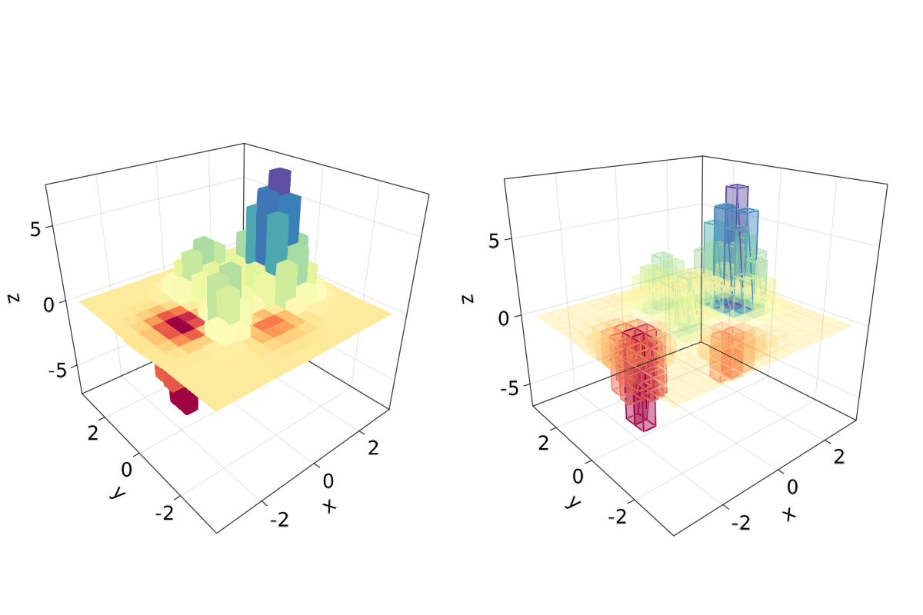

Figure 44: Histogram or bars in 3d.

Note, that you can also call lines or wireframe over a mesh object.

### Filled Line and Band

For our last example we will show how to do a filled curve in 3D with band and some linesegments:

function filled_line_and_linesegments_in_3D()  
 xs = LinRange(-3, 3, 10)  
 lower = [Point3f(i, -i, 0) for i in LinRange(0, 3, 100)]  
 upper = [Point3f(i, -i, sin(i) * exp(-(i + i))) for i in range(0, 3, length=100)]  
 fig = Figure(resolution=(1200, 800))  
 axs = [Axis3(fig[1, i]; elevation=pi/6, perspectiveness=0.5) for i = 1:2]  
 band!(axs[1], lower, upper, color=repeat(norm.(upper), outer=2), colormap=:CMRmap)  
 lines!(axs[1], upper, color=:black)  
 linesegments!(axs[2], cos.(xs), xs, sin.(xs), linewidth=5, color=1:length(xs))  
 fig  
end  
filled_line_and_linesegments_in_3D()

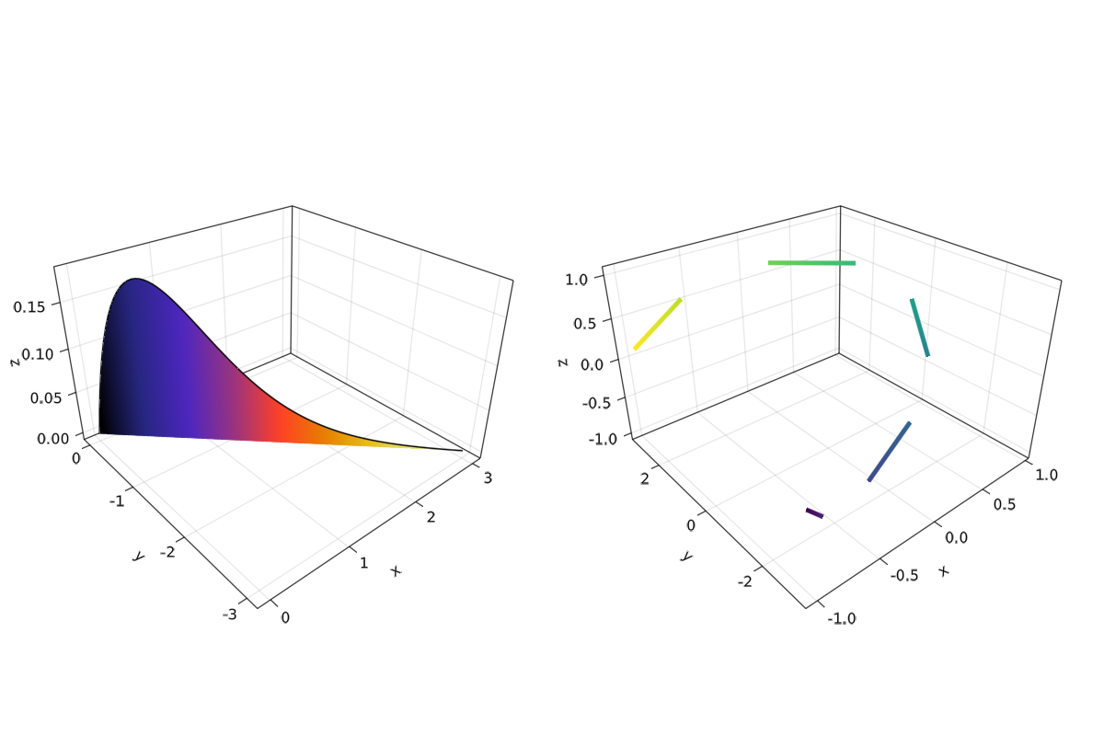

Figure 45: Filled line and linesegments in 3D.

Finally, our journey doing 3D plots has come to an end. You can combine everything we exposed here to create amazing 3D images!

# Appendix

## Packages Versions

This book is built with Julia 1.6.3 and the following packages:

Books 1.1.3  
CSV 0.9.10  
CairoMakie 0.6.6  
CategoricalArrays 0.10.1  
ColorSchemes 3.15.0  
Colors 0.12.8  
DataFrames 1.2.2  
Distributions 0.25.23  
FileIO 1.11.2  
GLMakie 0.4.7  
GeometryBasics 0.4.1  
ImageMagick 1.2.1  
LaTeXStrings 1.2.1  
Makie 0.15.3  
QuartzImageIO 0.7.4  
Reexport 1.2.2  
StatsBase 0.33.12  
TestImages 1.6.2  
XLSX 0.7.8

Build: 2021-10-31 21:58 UTC

## Notation

In this book, we try to keep notation as consistent as possible. This makes reading and writing code easier. We can define the notation into three parts.

### Julia Style Guide

Firstly, we attempt to stick to the conventions from the [Julia Style Guide](https://docs.julialang.org/en/v1/manual/style-guide/). Most importantly, we write functions not scripts (see also Section 1.3). Furthermore, we use naming conventions consistent with Julia base/, meaning:

* Use camelcase for modules: module JuliaDataScience, struct MyPoint. (Note that camelcase is so called because the capitalization of words, as in “iPad” or “CamelCase,” makes the word look like a camel.)
* Write function names in lowercase letters and separate the words by underscores. It is also allowed to omit the separator when naming functions. For example, these function names are all in line with the conventions: my_function, myfunction and string2int.

Also, we avoid brackets in conditionals, that is, we write if a == b instead of if (a == b) and use 4 spaces per indentation level.

### BlueStyle

The [Blue Style Guide](https://github.com/invenia/BlueStyle) adds multiple conventions on top of the default Julia Style Guide. Some of these rules might sound pedantic, but we found that they make the code more readable.

From the style guide, we attempt to adhere specifically to:

* At most 92 characters per line in code (in Markdown files, longer lines are allowed).
* When loading code via using, load at most one module per line.
* No trailing whitespace. Trailing whitespace makes inspecting changes in code more difficult since they do not change the behavior of the code but do show up as changes.
* Avoid extraneous spaces inside brackets. So, write string(1, 2) instead of string( 1 , 2 ).
* Global variables should be avoided.
* Try to limit function names to one or two words.
* Use the semicolon to clarify whether an argument is a keyword argument or not. For example, func(x; y=3) instead of func(x, y=3).
* Avoid using multiple spaces to align things. So, write
* a = 1  
  lorem = 2
* instead of
* a = 1  
  lorem = 2
* Whenever appropriate, surround binary operators with a space, for example, 1 == 2 or y = x + 1.
* Indent triple-quotes and triple-backticks:
* s = """  
   my long text:  
   [...]  
   the end.  
   """
* Do not omit zeros in floats (even though Julia allows it). Hence, write 1.0 instead of 1. and write 0.1 instead of .1.
* Use in in for loops and not = or ∈ (even though Julia allows it).

### Our additions

* In text, we reference the function call M.foo(3, 4) as M.foo and not M.foo(...) or M.foo().
* When talking about packages, like the DataFrames package, we explicitly write DataFrames.jl each time. This makes it easier to recognize that we are talking about a package.
* For filenames, we stick to “file.txt” and not file.txt or file.txt, because it is consistent with the code.
* For column names in tables, like the column x, we stick to column :x, because it is consistent with the code.
* Do not use Unicode symbols in inline code. This is simply a bug in the PDF generation that we have to workaround for now.
* The line before each code block ends with a colon (:) to indicate that the line belongs to the code block.

#### Loading of symbols

Prefer to load symbols explicitly, that is, prefer using A: foo over using A when not using the REPL (see also, *JuMP Style Guide*, 2021). In this context, a symbol means an identifier to an object. For example, even if it doesn’t look like it normally, internally DataFrame, π and CSV are all symbols. We notice this when we use an introspective method from Julia such as isdefined:

isdefined(Main, :π)

true

Next to being explicit when using using, also prefer using A: foo over import A: foo because the latter makes it easy to accidentally extend foo. Note that this isn’t just advice for Julia: implicit loading of symbols via from <module> import * is also discouraged in Python (van Rossum et al., 2001).

The reason why being explicit is important is related to semantic versioning. With semantic versioning (<http://semver.org>), the version number is related to whether a package is so-called *breaking* or not. For example, a non-breaking update for package A is when the package goes from version 0.2.2 to 0.2.3. With such a non-breaking version update, you don’t need to worry that your package will break, that is, throw an error or change behavior. If package A goes from 0.2 to 1.0, then that’s a breaking update and you can expect that you need some changes in your package to make A work again. **However**, exporting extra symbols is considered a non-breaking change. So, with implicit loading of symbols, **non-breaking changes can break your package**. That’s why it’s good practice to explicitly load symbols.

# References

Bezanson, J., Edelman, A., Karpinski, S., & Shah, V. B. (2017). Julia: A fresh approach to numerical computing. *SIAM Review*, *59*(1), 65–98.

Chen, M., Mao, S., & Liu, Y. (2014). Big data: A survey. *Mobile Networks and Applications*, *19*(2), 171–209.

Domo. (2018). *Data never sleeps 6.0*. <https://www.domo.com/assets/downloads/18_domo_data-never-sleeps-6+verticals.pdf>

Fitzgerald, S., Jimenez, D. Z., S., F., Yorifuji, Y., Kumar, M., Wu, L., Carosella, G., Ng, S., Parker, P., R. Carter, & Whalen, M. (2020). IDC FutureScape: Worldwide digital transformation 2021 predictions. *IDC FutureScape*.

Gantz, J., & Reinsel, D. (2012). The digital universe in 2020: Big data, bigger digital shadows, and biggest growth in the far east. *IDC iView: IDC Analyze the Future*, *2007*(2012), 1–16.

*JuMP style guide*. (2021). <https://jump.dev/JuMP.jl/v0.21/developers/style/#using-vs.-import>

Khan, N., Yaqoob, I., Hashem, I. A. T., Inayat, Z., Mahmoud Ali, W. K., Alam, M., Shiraz, M., & Gani, A. (2014). Big data: Survey, technologies, opportunities, and challenges. *The Scientific World Journal*, *2014*.

Meng, X.-L. (2019). Data science: An artificial ecosystem. *Harvard Data Science Review*, *1*(1). <https://doi.org/10.1162/99608f92.ba20f892>

Perkel, J. M. (2019). Julia: Come for the syntax, stay for the speed. *Nature*, *572*(7767), 141–142. <https://doi.org/10.1038/d41586-019-02310-3>

Storopoli, J. (2021). *Bayesian statistics with julia and turing*. <https://storopoli.io/Bayesian-Julia>

tanmay bakshi. (2021). *Baking Knowledge into Machine Learning ModelsChris Rackauckas on TechLifeSkills w/ Tanmay Ep.55*. <https://youtu.be/moyPIhvw4Nk>

TEDx Talks. (2020). *A programming language to heal the planet together: Julia | Alan Edelman | TEDxMIT*. <https://youtu.be/qGW0GT1rCvs>

van Rossum, G., Warsaw, B., & Coghlan, N. (2001). *Style guide for Python code* (PEP No. 8). <https://www.python.org/dev/peps/pep-0008/>

Wickham, H. (2011). The split-apply-combine strategy for data analysis. *Journal of Statistical Software*, *40*(1), 1–29.

1. 1 exabyte (EB) = 1,000,000 terabyte (TB).
2. no C++ or FORTRAN API calls.
3. and sometimes milliseconds.
4. numba, or even Rcpp or cython?
5. have a look at some deep learning libraries in GitHub and you’ll be surprised that Python is only 25%-33% of the codebase.
6. this is mostly a Python ecosystem problem, and while R doesn’t suffer heavily from this, it’s not blue skies either.
7. or with little effort necessary.
8. sometimes even faster than C.
9. a petaflop is one thousand trillion, or one quadrillion, operations per second.
10. LLVM stands for **L**ow **L**evel **V**irtual **M**achine, you can find more at the LLVM website (<http://llvm.org>).
11. if you like to learn more about how Julia is designed you should definitely check Bezanson et al. (2017).
12. please note that the Julia results depicted above do not include compile time.
13. or, that the memory address pointers to the elements in the column are stored next to each other
14. it is easier because first and last also work on many other collections, so you need to remember less.
15. According to Bogumił Kamiński (lead developer and maintainer of DataFrames.jl) on Discourse (<https://discourse.julialang.org/t/pull-dataframes-columns-to-the-front/60327/5>).
16. thanks to Sudete on Discourse (<https://discourse.julialang.org/t/pull-dataframes-columns-to-the-front/60327/4>) for this suggestion.
17. also notice that regular data (up to 10 000 rows) is not big data (more than 100 000 rows). So, if you are dealing primarily with big data please exercise caution in capping your categorical values.
18. we are using the LinearAlgebra module from Julia’s standard library.